4. Phylogeny
4.1. Sequence comparison
The first question the biologist asks himself when he has obtained a sequence is: “Are there one or more sequences in the database that resemble mine? ". The answer to this question requires defining the resemblance between sequences. The alignment of two sequences is the basis of this comparison. Sequence comparison is the computational task most used by biologists. It is about the extent to which two genomic sequences resemble each other. Thus, if two sequences are very similar and if one is known to be coding, the hypothesis that the second is also can be put forward. A biologist who has a new sequence is first interested in browsing these databases, in order to find similar sequences and to inherit the knowledge associated with them to the new sequence. It is also by comparing genome sequences of current species that it is possible to reconstruct phylogenetic trees which account for of evolutionary history. Confused by the variety of life, among man's first biological activities was classification. Biologists were involved in the question of obtaining a hierarchical classification of all species consistent with their evolutionary relationship, also known as the tree of life. This has made tree construction a central activity for biologists, but also for understanding the functional similarities of organisms. Evolution requires three basic ingredients: reproduction, variation, and selection. Figure 5 defines evolution by genetic variability, its mechanism by mutation, its explanation by ecological variability and its objective for adaptation, with some examples.

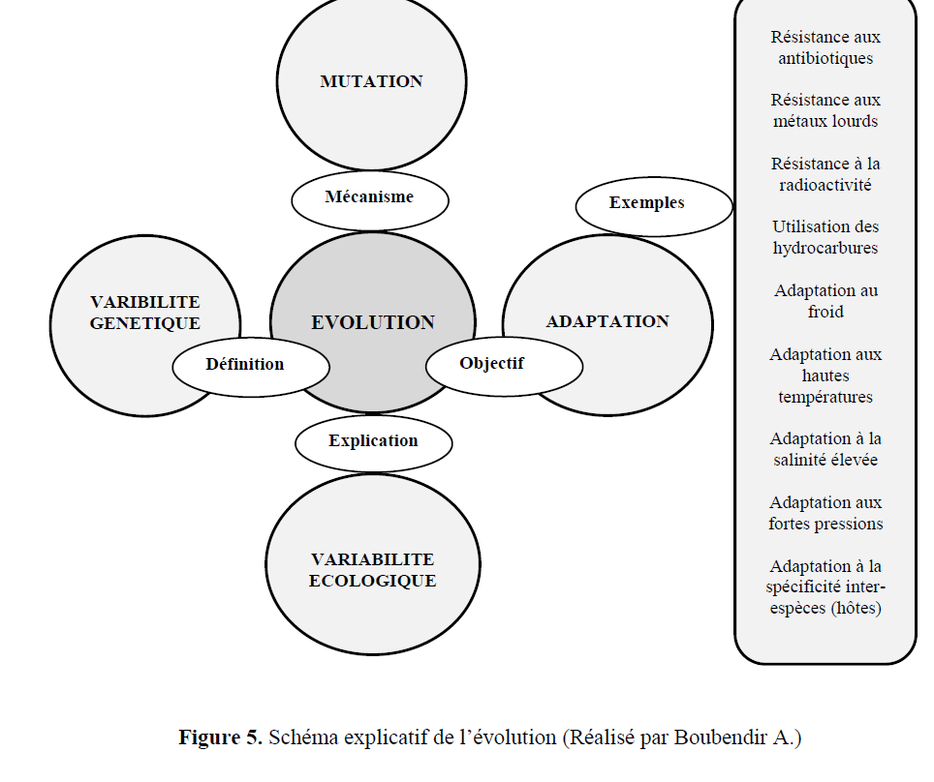
Figure 5. Explanatory diagram of evolution (Produced by Boubendir A.)
4.2. Phylogeny data
Phylogeny was named by Ernst Haeckel, it is a Latin word composed of “fulon” (tribe, race) and “genus” (birth, origin), so phylogeny basically means the common ancestor (origin) of a group of genes or other sequences. Phylogeny is based on the principle of comparing specific characters for a set of individuals. These characters are generally homologous and belong to contemporary organisms. We can divide the data that will be used for the construction of phylogenetic trees into two distinct groups: - Data linked to phenotypic characteristics. - Molecular data such as DNA or protein sequences. 4.2.1. Phenotypic data Include observable characters (in different states: morphological, biochemical and physiological) and binary patterns (such as presence of a given character / absence of this same character). In the case of bacteria, for example, the characters can be: - Biochemical and enzymatic, - Antigenic - Sensitivity to antibiotics - Sensitivities to phages, - Electrophoretic profiles of enzyme systems, etc.
4.2.2. Molecular data In this case, these are biological sequences of the nucleic acid type such as the sequences of particular genes, mRNAs, RFLPs, Microsatellites, SNPs, IGS (rRNA and mitochondria), ITS (rRNA and mitochondria), cytochrome C sequences, alpha elongation factor sequences, or even sequences of enzymatic or structural proteins. The data most used for phylogenetic constructions are markers following: - 16S rDNA: Bacteria - 18S rDNA, actin, EF1, RPB1: Eukaryotes - 18S rDNA, RBCL: Plants Traditionally, phylogenetic trees are constructed by comparing phenotypic characters, this is called a phenogram, and it continues to play a dominant role in the analysis of data such as fossils. However, phylogenetic trees are currently based on the multiple alignment of nucleotide or amino acid sequences, we then speak of a phylogram, and we call this molecular phylogeny. 4.3. Construction of a phylogenetic tree
4.3.1. The distance matrix The evolutionary distance is defined as the percentage of nucleotide substitution or amino acid, it is estimated by several models, namely the p-distance model, Poisson, Dayhoff, Jones-Taylor-Thomson (JTT), etc. The distance is calculated between the sequences two by two to finally give the distance matrix (Table 2).

Tableau 2. Estimation of evolutionary divergence between protein sequences of chloroplast of 10 plant species
4.3.2. The topology of the phylogenetic tree
The different methods for constructing phylogenetic trees differ both in the evolutionary hypotheses they imply and in the algorithms they use. They can be grouped into two categories:
• Distance methods: Genetic distances (% of nucleotide or amino acid substitutions for example) are measured between all the sequences taken two by two. These methods are quick and give good results.
• Character-based methods: Focus on phenotypic characters that have states greater than two. They bring together “parsimony” methods and “Maximum likelihood” methods. For the distance methods (which will be of interest to our course), it is first a question of choosing the distance criterion between the future leaves of the tree (individuals or OTUs). For example, if these individuals are DNA sequences, we can choose as the distance between two of them the number of nucleotides which differ. To determine this value, we have to carry out a multiple alignment. Then we can use the UPGMA method (unweighted pair group method with arithmetic mean) or that of NJ (Neighbor-Joining) to deduce the topology of the tree. On the other hand, if these individuals have been studied on the morpho-physico-biochemical levels, then the distances will result from the similarity coefficients. Distance methods use two distinct algorithms to construct dendrograms:
4.3.2.1. The UPGMA method UPGMA uses a sequential clustering algorithm in which relationships are identified in the order of their similarity and the reconstruction of the tree is done step by step using this order. The two closest individuals (OTUs) are first identified and this group is then treated as a single individual, then the closest individual is searched for and so on until there are only two groups left. This algorithm allows you to calculate an ultra-metric tree. The UPGMA method is carried out according to the following steps: -Step 1: In the distance matrix (symbolized by dij), find the taxa i and j for which the distance dij is the smallest. We first cluster the two OTUs with the smallest distance. -Step 2: Place the root (theoretical ancestor of the two chosen OTUs) equidistant from the two OTUs i and j, that is to say at d = dij/ 2. This distance will be equal to the length of the branch of the clade which brings together individuals i and j: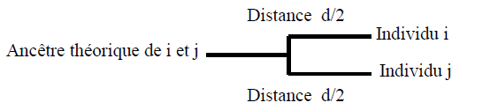
-Step 3: Create a new set including i and j.
-Step 4: Calculate the distance between the new group (ij) and each other taxon (k), by applying the following formula: (dki + dkj) / 2
-Step 5: From this new matrix, repeat the operation from step 1.
4.3.2.2. The NJ method This method developed by Saitou and Nei (1987) attempts to correct the UPGMA method in order to allow a different mutation rate on the branches (non-ultra metric tree). The distance matrix allows us to take into account the average divergence of each individual from other taxa. The tree is then constructed by connecting the closest individuals in this new matrix. The NJ method is carried out according to the following steps: -Step 1: Calculation of the net divergence r(i) of each of the N OTUs compared to the others -Step 2: calculation of the new distance matrix using the following formula: M(i,j) = d(i,j) - [(r(i) + r(j)) / (N-2 )]
Step 3: choice of the nearest neighbors, that is to say the two OTUs having the M (i,j) smaller. The first two OTUs form a new node u.
-Step 4: calculation of the distance of each of the two OTUs relative to node u. S (i,u) = d(i,j)/2 + [r(i) - r(j)]/2(N-2) hence S (j,u) = d(i,j) - S(i,u)
-Step 5: Calculation of the distances between u and all the OTUs.
-Step 6: Create a new matrix and repeat the operation from step1
4.4. Evaluation of a phylogenetic tree After successfully constructing the phylogenetic tree, the next step requires evaluating the tree topology. This process can be performed by using two evaluation methods, called the bootstrap method and the internal branches test.
4.4.1. The bootstrap method The basic concept of the bootstrap method is the evaluation of tree topology by constructing phylogenetic trees equal to the number of repeated pseudodata. Tree nodes showing values ​​>70% bootstrap are generally considered consistent.
4.4.2. The internal branches test This test is calculated using the bootstrap procedure, its construction is based on the length of internal branches, it is valid only in NJ trees. In this test the confidence of the length of the internal branches is non-zero. 4.5. Examples of phylogenetic trees The values of the evolutionary distances obtained previously in the distance matrix (the sequences of chloroplast proteins of 10 plant species, Table 3), are projected in space and make it possible to construct the phylogenetic tree with: • The NJ method and boostrap test (Figure 6),
• La méthode NJ et test des branches internes (Figure 7).
• La méthode UPGMA et test boostrap (Figure 8),
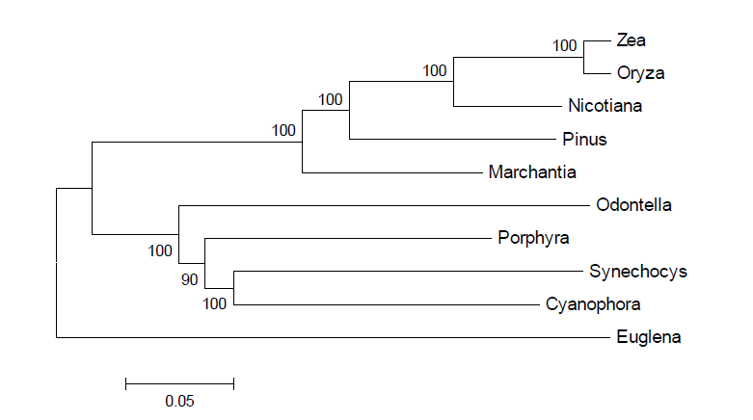
Figure 6. Phylogenetic tree of chloroplast protein sequences of 10 species plants by the NJ method with bootstrap test, carried out by the MEGA6 software.
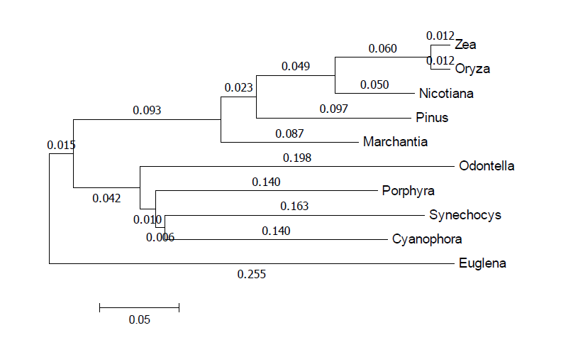
Figure 7. Phylogenetic tree of chloroplast protein sequences of 10 species plants by the NJ method with testing of internal branches, carried out by the software MEGA6.
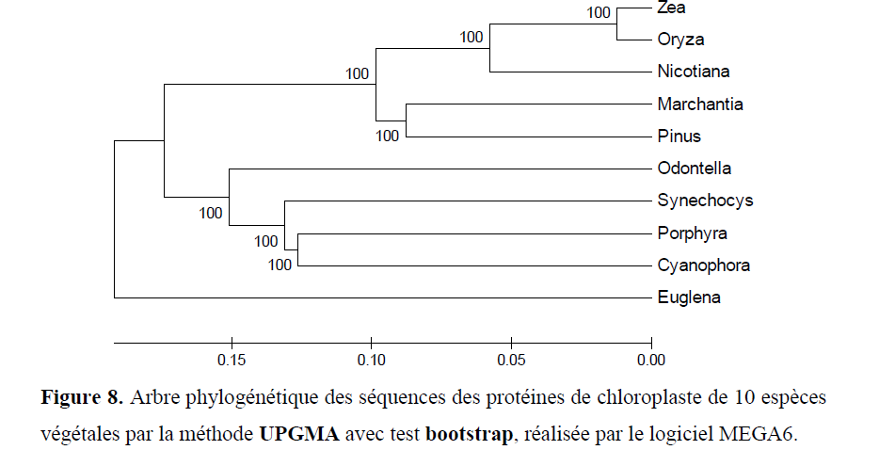
Figure 8. Phylogenetic tree of chloroplast protein sequences of 10 species plants by the UPGMA method with bootstrap test, carried out by the MEGA6 software

