2. Even alignment
If a new sequence is obtained from genomic sequencing, the first step is to look for similarities with known sequences in other organisms. If the function/structure of similar sequences/proteins is known, most likely (highly likely) the new sequence corresponds to a protein with the same function/structure. Indeed, it has been found that only about 1% of human genes have no counterpart in the mouse genome and that the average similarity between the mouse and human genes is 85%. Similarities exist because all cells have a common ancestor cell (a mother cell). So in different organisms there might be amino acid mutations in certain proteins because not all amino acids are important for function and can be replaced by amino acids that have similar chemical characteristics without changing the structure. Sometimes there are so many mutations that it is difficult to find similarities. The method of calculating gene functions by similarities is called genomics. comparative or homology research. Two sequences are homologous when they have as the root a common ancestor.
2.1. Sequence similarities and score After sequencing, biologists usually have no idea of the usefulness of the genes found. Hoping to discover a clue about their functions, they try to find similarities between newly sequenced genes and others already sequenced which they know the functions. The following game, transform an English word into another word by going through a series of intermediate words, in which each word differs from the next by only one letter. To transform head into tail, we only need four intermediaries: head → heal → teal → tell → tall → tail. For biological sequences, it is known how one sequence can mutate into another. First, there are mutation points where one nucleotide or amino acid is changed to another. Second, there are deletions where an element (nucleotide or amino acid) or an entire subsequence of an element is deleted from the sequence. Third, there are insertions where an element or a subsequence is inserted into the sequence. An alignment can be interpreted as the fruit of editing work: finding the minimum number of elementary editing operations which make it possible to transform a sequence into another. We consider the following three operations: (a) insertion: insertion of one or more letters; (b) deletion: deletion of one or more letters; (c) substitution: replacement of one letter by another. From an evolutionary perspective, these three operations can be interpreted as mutations and editing work as an attempt to reconstruct history evolutionary by considering these 3 elementary mutations. The following alignment for example.
The story gives 12 identical letters taken from the 14 letters of BIOINFORMATICS.
The mutations could be:
(1) deletion I BOINFORMATICS
(2) LI BOILINFORMATICS insertion
(3) G BOILINGFORMATICS insert
(4) change from T to N BOILINGFORMANICS
the two texts seem very similar. Note that insertion or deletion cannot be distinguished if both sequences are presented (is the I deleted from the first sequence or inserted in the second?). So both cases are denoted by “-”. The task of bioinformatics algorithms is to find from two series (the part on the left in the example above) the optimal alignment (the part on the right in the example above). The optimal alignment is the arrangement of the two sets in a way where the number of mutations is minimal. The alignment can be global (over the entire length of the sequence) or local (over the best conserved parts), depending on the presumed relationship between the sequences. We define an alignment score which makes it possible to define the best alignment of two sequences and to quantify their resemblance.
2.2. The identity matrix The identity matrix or dot matrix is a tool for representing alignments, where one sequence is written horizontally at the top and the other vertically to the left. Which gives a matrix where each letter of the first sequence is coupled with each letter of the second sequence. For each correspondence of letters a point (dot) is written in the matching position in the matrix. Which pairs appear in the optimal alignment? We will see below that each path through the matrix corresponds to an alignment

Figure 2a. Principe opérationnel de la matrice d’identité.
Rules: you can move horizontally “→”, vertically “↓”, and you can only move diagonally “ ” if you are in the dowry position. Spot: make as many diagonal movements as possible when moving from the corner to the highest left to lowest right corner.
Figure 2b. Principe opérationnel de la matrice d’identité.

The number of diagonal moves “ ” represents matches and number of scores, “→” corresponds to “-” in vertical sequence, “↓” to “-” in horizontal sequence and the combination “→↓” or “↓→” corresponds to divergence. So each path through the matrix corresponds to an alignment and each alignment can be expressed by a path in the matrix. In Figure 3 the dots on the diagonals correspond to the regions of correspondence (similarities). It represents Dot Matrices for the comparison of human protein triosephosphate isomerase (TIM) with that of yeast, E. coli and Archaeon. For yeast the diagonal is complete and for E. coli small gaps are visible, but Archaeon does not show an extended diagonal. Therefore, human TIM corresponds most closely with yeast TIM, followed by E. coli and has the lowest similarity to Archaeon TIM.
Figure 3. Dot matrix of human triosephosphate isomerase with the same protein in yeast, E. coli and Archaeon. Yeast gives the best match because the diagonal is almost complete. E. coli has some diagonal fractures. Archaeon shows the lowest similarity. However, the 3D structure and function is the same for all proteins.
3. Multiple Alignment
The goal of comparing protein sequences is to discover “biological” (i.e. structural or functional) similarities among proteins. Biologically similar proteins may not exhibit strong sequence similarity and one would like to recognize structural/functional resemblance even when the sequences are very different. Comparing many sequences simultaneously can often find similarities unseen in pairwise sequence comparison “pairwise alignment whispers...multiple alignment shouts”. Multiple alignment is the basis for the study of protein families and functional domains. Its goal is to reveal sequence or structural similarities in a family of neighboring sequences in evolution or function. It is important to carefully analyze the result of the multiple alignment before proceeding to the construction of the phylogenetic tree and to properly adjust the software parameters. We will carry out the multiple alignment of the set of sequences using the ClustalW tool. These sequences belong to the family of “Basic Leucine Zipper” transcription factors. These are genes that code for proteins that regulate mRNA transcription. The result of part multiple alignment of this series of sequences is as follows:
This alignment presents a lot of gaps which distort the interpretation. This is due to the fact that our sequences belong to individuals whose taxonomy is completely different. We lined up sequences of frog, wheat, etc. Example of sequence alignment by BLAST/NCBI Figure 4 represents the result of a partial sequence alignment of the 16S rRNA gene of Aeromonas veronii obtained on GenBank, via the BlastN program. >Aeromonas veronii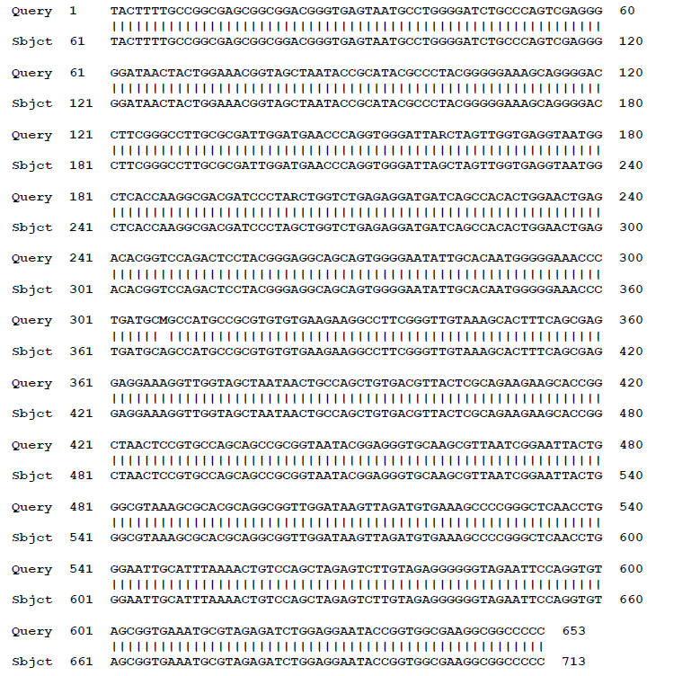
Figure 4. Bioinformatics analysis of 16srDNA sequences on GenBank, using the BlastN program

GenBank, via the BlastN program, carries out an alignment using its own sequences and proposes the one which presents the best identity with ours by calculating a score which corresponds to the number of identical nucleotides in the two sequences. This score can be translated as identity percentage (%id). The calculated E-value indicates the probability that the outcome of this alignment occurred by chance. So the closer this value is to zero, the better. However, all the alignments resulted in zero values ​​of the E-value; which expresses that the identities found between our sequences and those proposed by GenBank are not due to chance.

