Chapitre 2 : Biological Banks and Databases
Introduction
The internet offers biologists an overwhelming amount of information and tools for analyzing biological data, and lists of useful websites are readily available. Some servers offer real-time data analysis (response on a web page) or delayed data analysis (response by email). Others allow users to download their programs for local installation. Theoretically, searching for sequences similar to a given sequence requires comparing all sequences in the database with the query sequence. We need to distinguish between two things: what is a database (DB)? What is the difference between a database and a database? A database, usually abbreviated as DB, is a file or set of files that allows for the permanent or temporary storage of information and access to this structured information (http://www.webadev.com/lexique-b-base-dedonnees.php). It is a table in which information is integrated in a logical and structured way, such as a list of a group of students:
Difference between databases and databases
It's important to understand that a database is a type of database (because it's a structured table) but contains heterogeneous biological information (viruses, bacteria, fungi, plants, animals), whereas a database is more specialized (specifically for E. coli, Bacillus, etc.). It's impossible to list all biological databases here; however, it's useful to know and monitor the most important databases in your field (Table 1):

Tableau 1. Main general-purpose bioinformatics servers.

National Center for Biotechnology Information (NCBI,
http://www.ncbi.nlm.nih.gov/genbank).
European Bioinformatics Institute of the European Molecular Biology Laboratory
(EBI-EMBL, http://www.ebi.ac.uk/services).
DNA Data Bank of Japan (DDBJ, http://www.ddbj.nig.ac.jp).
UniProt KnowledgeBase (http://www.uniprot.org) contient les séquences protéiques
avec leurs annotations fonctionnelles.
Protein Data Bank (PDB, http://www.rcsb.org/pdb) contient les informations sur la
structure tridimensionnelle des protéines.
ExPASy Molecular Biology Server: http://www.expasy.ch
Informatique appliquée à l’étude des Biomolécules des Génomes:
http://www.infobiogen.fr
Institute for Genomic Research : http://www.tigr.org

scientific literature can be searched on PubMed (http://www.ncbi.nlm.nih.gov/pubmed) or Google Scholar (http://scholar.google.com). You can search for articles by author or keywords.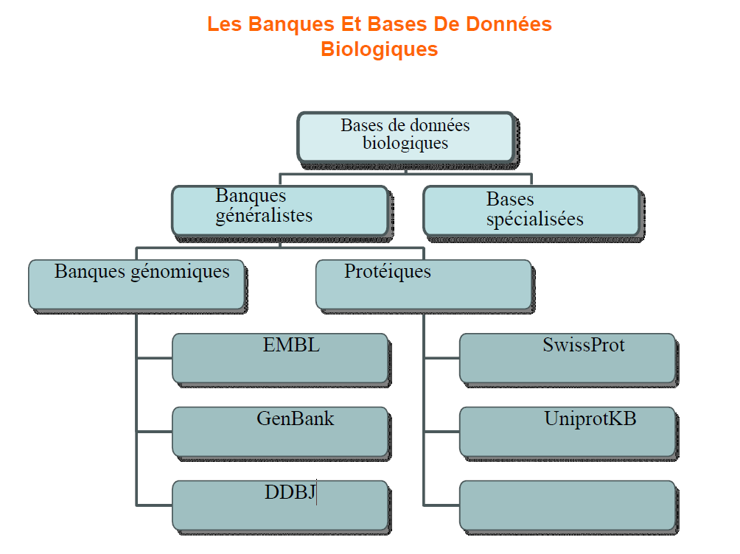
  - Nucleic Acid Databases
The data stored in these types of databases are derived from DNA and RNA sequencing. Three well-known nucleic acid databases share information and therefore contain nearly identical sets of sequences. These three databases have systematically exchanged their contents since 1987 and have adopted a common convention system: "DDBJ/EMBL/GenBank":
  - • The EMBL database: created in 1980 and funded by EMBO (European Molecular Biology Organization), developed within the European Molecular Biology Laboratory located in Heidelberg, Germany, it is now distributed by EBI: http://www.ebi.ac.uk/embl/. As of February 24, 2014, the database contained 369.5 million sequences. • GenBank (Genetic Sequence Databank): created in 1982 by IntelliGenetics and now distributed by the NCBI (National Center for Biotechnology Information): http://www.ncbi.nlm.nih.gov/. As of February 2014, the database contained 171,123,749 sequences. GenBank includes a sub-database of proteins, which translate nucleic acid sequences, called GenPept.
  - • DDBJ (DNA Databank of Japan): created in 1986 and distributed by the NIG (National Institute of Genetics, Japan), it had a total of 81,994,905 DNA sequences as of December 2019 (DDBJ 2019).

2.2. Protein databases The data stored in these databases comes from the translation of DNA sequences or by protein sequencing (rare because it is long and expensive): • The SwissProt database: is a protein database created in 1986 at the University of Geneva and maintained since 1987 as part of a collaboration between this university (via ExPASy, Expert Protein Analysis System) and the EBI. It also includes annotated sequences from the PIR-NBRF database as well as translated coding sequences from EMBL. As of February 2014, the database contained 542,503 sequences compressing 192,888,369 amino acids. 1.3. Structural databases These are specialized databases for the 2D and 3D structures of proteins. Several databases are well-known in this context; we cite the PDB database as an example:
2.2.1 • The PDB (Protein Data Bank), created in 1971, is the reference database of protein structures obtained experimentally by X-ray crystallography, NMR spectroscopy, and cryo-electron microscopy (the most recently used technique). The coordinates of the atoms forming the structure of a protein, the sequence details, and the crystallization conditions are the main pieces of information available for each structure in the database. Structural homologs are detected from this database. Figure 1 shows the evolution of the number of protein structures recorded per year in the PDB; January 2020 saw a total of 147,827 structures.

Figure 1. Statistiques des structures protéiques PDB réalisées par année.

Uniprot
the data comes from two sources: - The SwissProt database, populated manually from publications - The automatic translation of DNA sequences from the EMBL database. It is easier to sequence a gene than a protein! Search primarily by gene or protein name, and/or species name
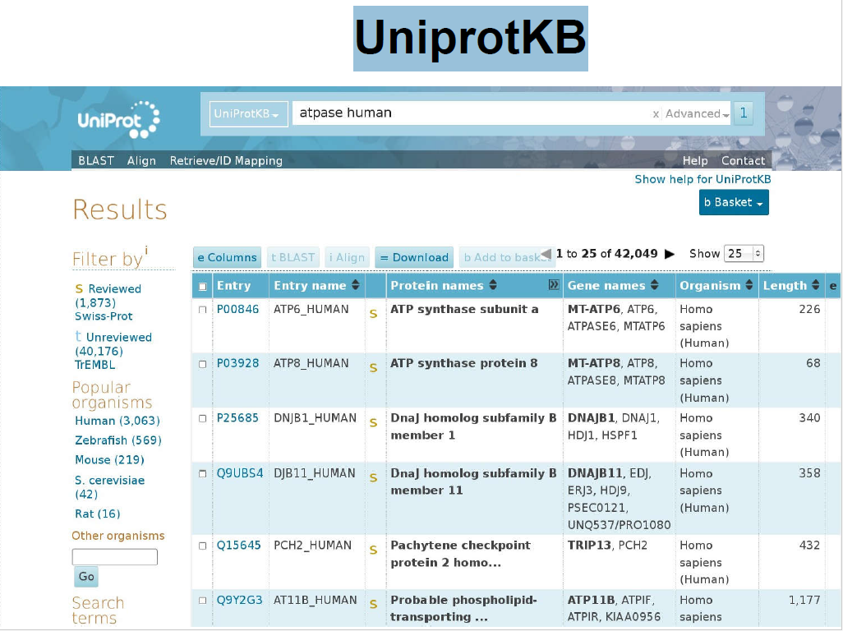

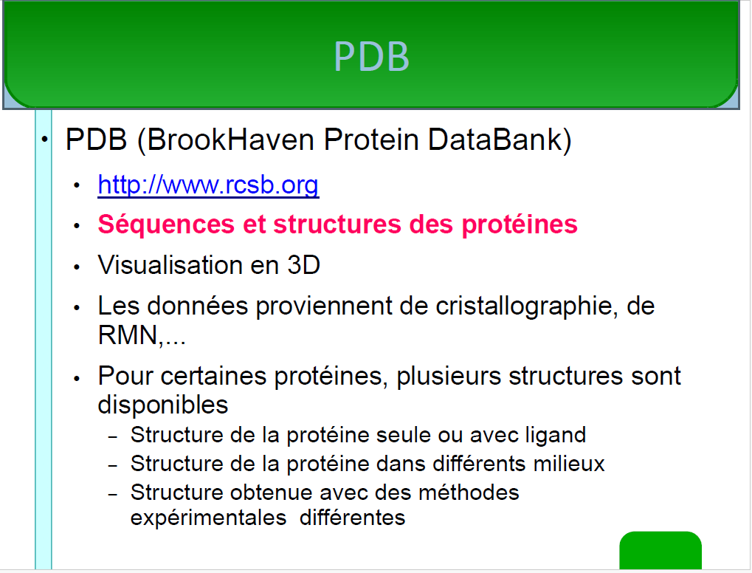

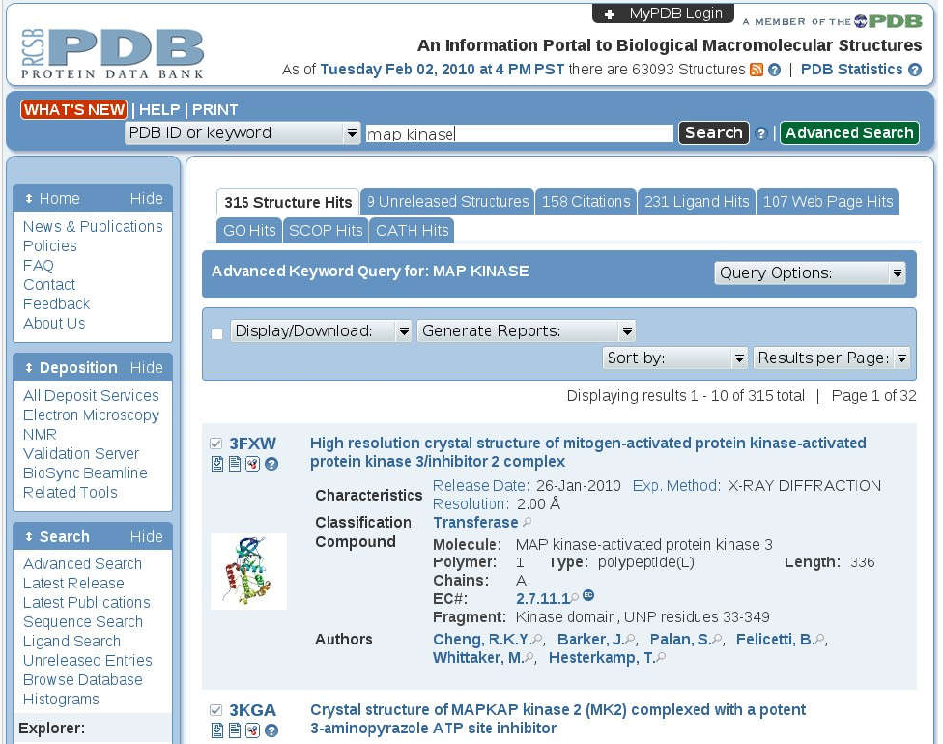
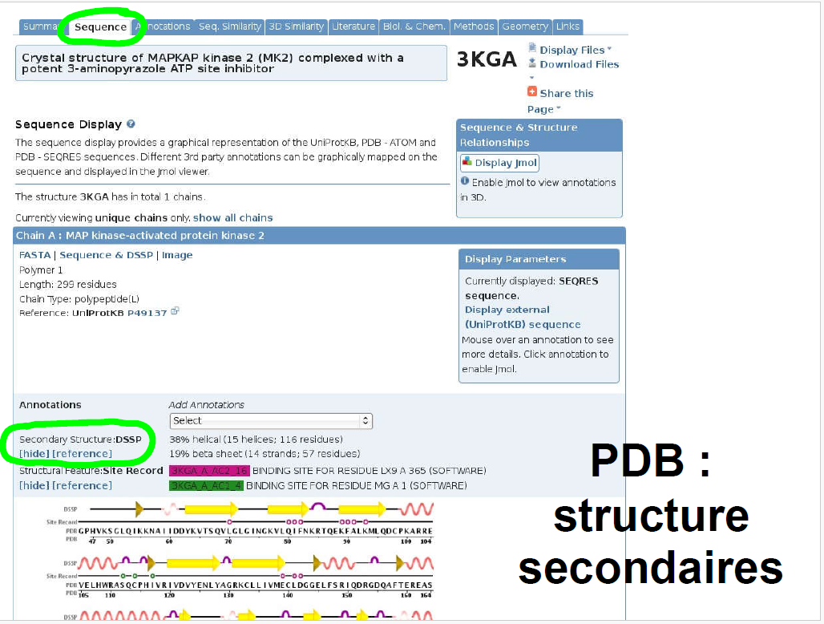

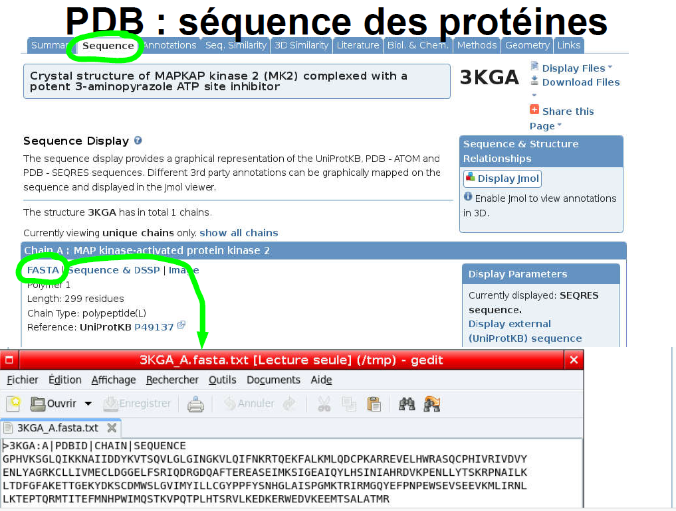

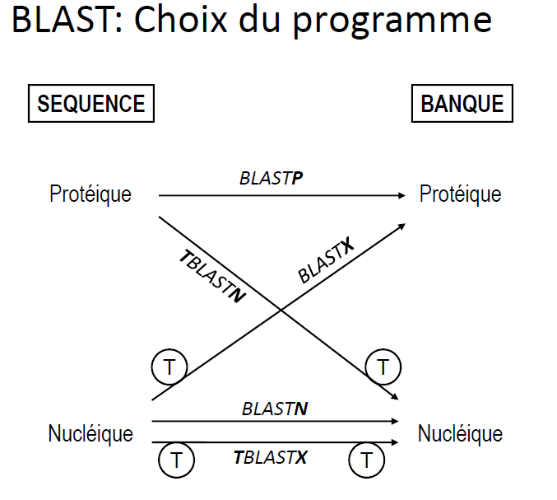

-blastn, of nucleotides, nucleotide sequence against a database of nucleotide sequences.
-blastp, of proteins, protein sequence against a database of protein sequences.
-blastx, nucleotide sequence translated into a protein sequence against a database of protein sequences.
-tblastn, protein sequence against a database of nucleotide sequences translated into protein sequences.
tblastx, nucleotide sequence translated into a protein sequence against a database of nucleotide sequences translated into protein sequences.

NCBI rRNA 16S Gene Sequence Alignment Search
Steps 1. Open the NCBI website using Google
2. Select the BLAST program
3. Select the BLASTn nucleotide tool
4. Enter the DNA sequence or the Gene Bank Access Number and activate the BLAST tool
5. Review the alignment results
6. Review the detailed alignment results
7. Gather information about the individual using the Gene Bank Access Number: Author, affiliation, publication, sequence, etc.
1. Opening the NCBI link on the internet using the Google search engine
2. BLAST program selection
. Choice of the BLASTn nucleotide tool
4. Insert the DNA sequence or Access Number into Gene Bank and activate the BLAST tool
5. Reading the list of Alignment results
6. Reviewing the detailed results of the Alignment
7. Gathering information about the individual using the access number on Gene Bank: Author, affiliation, publication, sequence, etc.

