Exercise 1
Consider the DNA sequence:
5' ATCTA 3'
3' TAGAT 5'
-Is this sequence a "palindrome"?
-Complete the following example of a palindromic restriction site. The arrow represents a site of strand cutting.
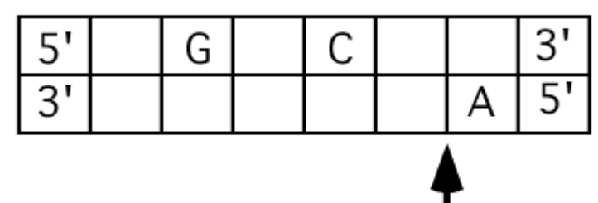

Exercise 2
The following diagram is a restriction map of a small linear DNA molecule containing one gene.
EcoRI
BamHI
EcoRI
BamHI

GENE
0.1 kb
0.3 kb
0.9 kb
1.0 kb
0.5 kb

Samples of this DNA are digested in 4 separate tubes with different combinations of restriction enzymes as follows:

Tube#: | 1 | 2 | 3 | 4
Enzyme/s: | Control | EcoRI | BamHI | EcoRI + BamHI
 | (no enzyme)
Unfortunately, the 4 DNA digests were not labeled properly, and were mixed up while loading them onto an agarose gel. The stained gel looked like this:
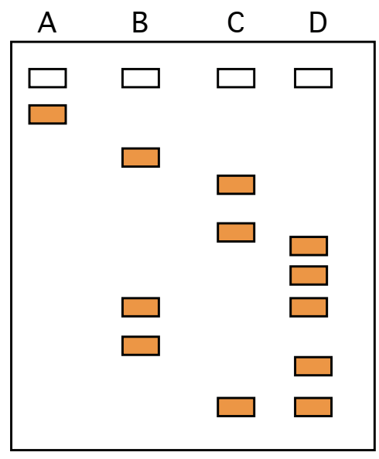

1) Can you determine which lane of the gel (A-­‐D) corresponds to each tube (1-­‐ 4)?
2) Give the sizes of these fragments. Circle all the bands on the gel that containing a DNA fragment with the complete sequence of the gene.

Exercise 3
The pedigree shown hereafter is that of a family affected by a recessive genetic disease (color blindness caused by expression of an X-linked recessive allele). During a pregnancy of II-1 woman, all subjects are tested by restriction fragment length ppolymorphism (RFLP) (digestion with restriction enzymes and analysis of the results by electrophoresis).

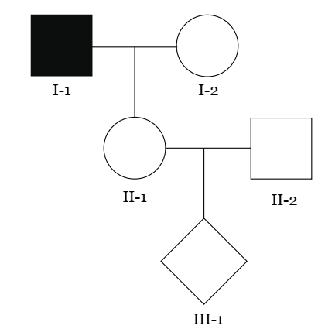
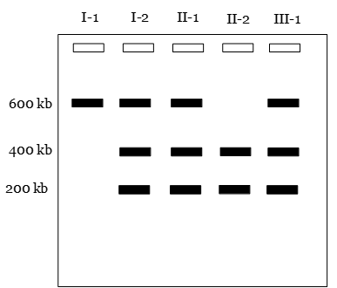

Establish the prenatal diagnosis of child II3. Justify this result based on electrophoresis.
Exercise 4
To map a plasmid, you perform a series of restriction enzyme digestions and obtain the following results by agarose gel electrophoresis.
Enzyme Track Size (pb)

1) What is the approximate size of the plasmid?
2) Add the SmaI, KpnI and BglII sites to the plasmid map, and indicate the distances between each of the restriction sites.

