Exercise 1
Consider the DNA sequence:
5' ATCTA 3'
3' TAGAT 5'
-Is this sequence a "palindrome"?
Yes, A palindromic sequence in molecular biology is a nucleic acid sequence where the
5’ to 3’ reading on one strand matches the 5’ to 3’ reading on the complementary strand.

-Complete the following example of a palindromic restriction site. The arrow represents a site of strand cutting.
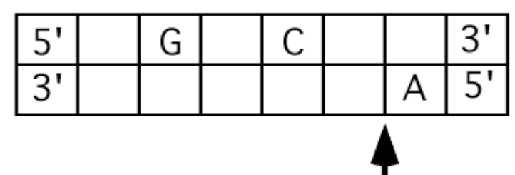
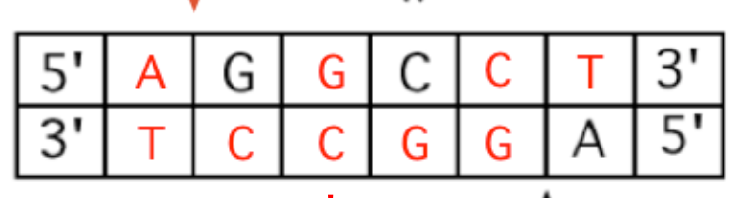

Exercise 2
The following diagram is a restriction map of a small linear DNA molecule containing one gene.
BamHI
BamHI
EcoRI
EcoRI
0.1 kb
0.3 kb
0.9 kb
1.0 kb
0.5 kb

GENE

Samples of this DNA are digested in 4 separate tubes with different combinations of restriction enzymes as follows:

Tube#: | 1 | 2 | 3 | 4
Enzyme/s: | Control | EcoRI | BamHI | EcoRI + BamHI
 | (no enzyme)
Unfortunately, the 4 DNA digests were not labeled properly, and were mixed up while loading them onto an agarose gel. The stained gel looked like this:
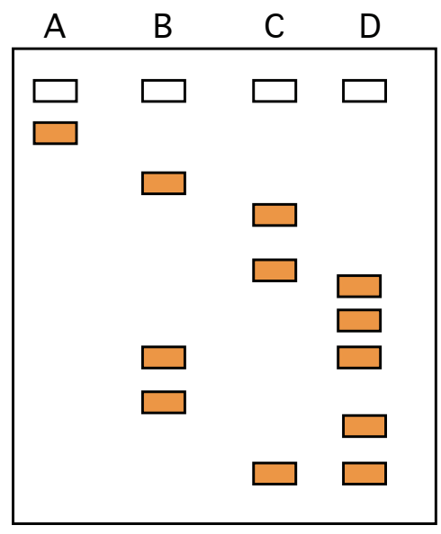

1) Can you determine which lane of the gel (A-­‐D) corresponds to each tube (1-­‐ 4)?
Tube 1 Lane A (control no digestion)
Tube 2 EcoRI Lane C
Tube 3 BamHI Lane B
Tube 4 EcoRI + BamHI Lane D

2) Give the sizes of these fragments. Circle all the bands on the gel that containing a DNA fragment with the complete sequence of the gene.
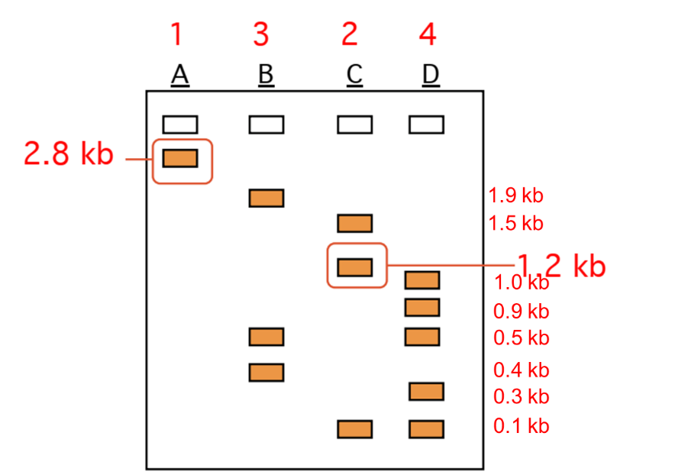

Exercise 3
The pedigree shown hereafter is that of a family affected by a recessive genetic disease (color blindness caused by expression of an X-linked recessive allele). During a pregnancy of II-1 woman, all subjects are tested by restriction fragment length ppolymorphism (RFLP) (digestion with restriction enzymes and analysis of the results by electrophoresis).

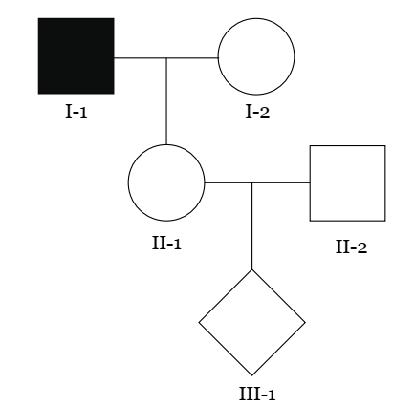
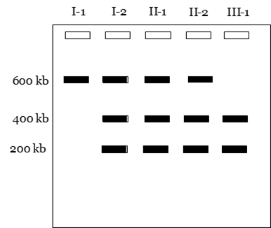

Establish the prenatal diagnosis of child II3. Justify this result based on electrophoresis.
The daughter III-1 will have normal vision.
According to the family tree, individual I-1 is diseased and therefore homozygous for the disease allele. the III-1 child expected by two heterozygous parents (since the diseased allele is recessive). these two apparently healthy parents who therefore each carried the allele in a hidden state have a 1/4 risk of having a sick child. According to the prenatal diagnosis carried out by genetic testing, child III-1 is healthy homozygous since he notably has the same restriction profile of two healthy alleles. It is very possible that he would not be affected by the disease.
Exercise 4
To map a plasmid, you perform a series of restriction enzyme digestions and obtain the following results by agarose gel electrophoresis.
Enzyme Track Size (pb)

1) What is the approximate size of the plasmid?
The approximate size of the plasmid is 5000 bp (5Kb)
2) Add the SmaI, KpnI and BglII sites to the plasmid map, and indicate the distances between each of the restriction sites.
It should first be mentioned that by cutting a linear DNA with a restriction enzyme which has X restriction site we obtain X+1 fragments, while when we digest a circular DNA with a restriction enzyme which has Here it is a circular plasmid so we place the restriction sites of each enzyme according to the results of the electrophoresis (of each experiment) and each time we place a restriction site for a given enzyme we compare the theoretical results of the digestion to the practical results obtained by electrophoresis (presented in the diagram or the table)
