Magnetic stirrer
- Definition
A magnetic stirrer, also known as a magnetic mixer, is a widely used laboratory device that revolutionized the process of stirring and mixing solutions. It operates on the principle of a rotating magnetic field generated by either a rotating magnet or stationary electromagnets, which causes a stir bar immersed in a liquid to spin rapidly, thereby facilitating the mixing process.
A magnetic stirrer is a device widely used in laboratories and consists of a rotating magnet or a stationary electromagnet that creates a rotating magnetic field. This device is used to make a stir bar, immerse in a liquid, quickly spin, or stirring or mixing a solution, for example. A magnetic stirring system generally includes a coupled heating system for heating the liquid (Figure 1).
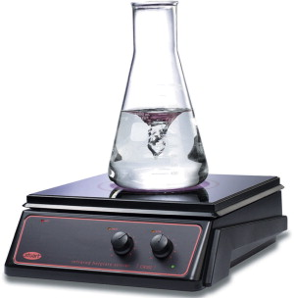
Fig 1: magnetic stirrer . https://www.sciencedirect.com/
Magnetic stirrers use a rotating magnetic field to move a stir bar around in liquid samples, and some are coupled with stirring hot plate. The movement of this stir bar mixes the samples thoroughly with rapid movement and agitation. The user controls the magnetic field's speed, so it can be customized to the specific sample that's being stirred. These stirrers should be used with glass or other non-metal beakers to prevent interference with the magnetic field.
A magnetic stirrer is commonly used in microbiology laboratories for the purpose to prepare a medium for cultivating bacteria. It is also used in chemical experiments and synthesis involving the combination of two or more components. Various other applications, such as oil analysis, soil suspension, buffer solution production, and pH testing. Altogether in general, it is used for sample preparation and analysis in laboratories.

- the elements of a magnetic stirrer
Top plate/Hot plate: Stainless steel or ceramic is typically used for the plates of magnetic stirrers. Ceramic: The white surface of ceramic top hotplates makes them suitable for titrations and other tasks requiring clear color vision. They also have high chemical resistance, making them ideal while working with corrosive chemicals that may splash onto the plate surface. Stainless steel: A stainless steel top plate offers a highly forceful coupling and stirring action since it does not produce eddy currents (like aluminum).
Stir bar: The term “stir bar” or “spin bar” refers to a tiny, Teflon-coated, white, rectangular magnet. The sole function of these bars is to stir solutions. They work in tandem with a stirring motor. The stir bar is put in a liquid-filled container, then placed over a stirring motor. The bar spins, and the liquid is stirred when the stir motor is turned on. The vessel shape and the viscosity of the stirring media determine the shape of the stir bar, which can be octagonal, circular, etc. The stir bar’s dimensions range from millimeters to a few centimeters.
Stationary electromagnet: It is positioned inside the stirrer instrument that helps to generate a magnetic field and rotate the magnetic needle (stir bar) immersed in liquid, thereby creating a high-speed stirring action enough to homogenize the mixture.
Speed controlling knob: The speed control knob is used to adjust the rotating speed (rpm) of the stir bar depending on the liquid’s density or project needs.
Temperature controlling knob: The magnetic stirrer features a knob for temperature control which controls the temperature based on the vessel size, the viscosity of the liquid, and its volume.
Stir bar retriever: These magnets are permanently embedded with PTFE (teflon) rod. It facilitates the safe and easy recovery of magnetic stirring and spin bars from irritant and corrosive liquid samples in glass flasks. However, it is less commonly employed in magnetic stirring.

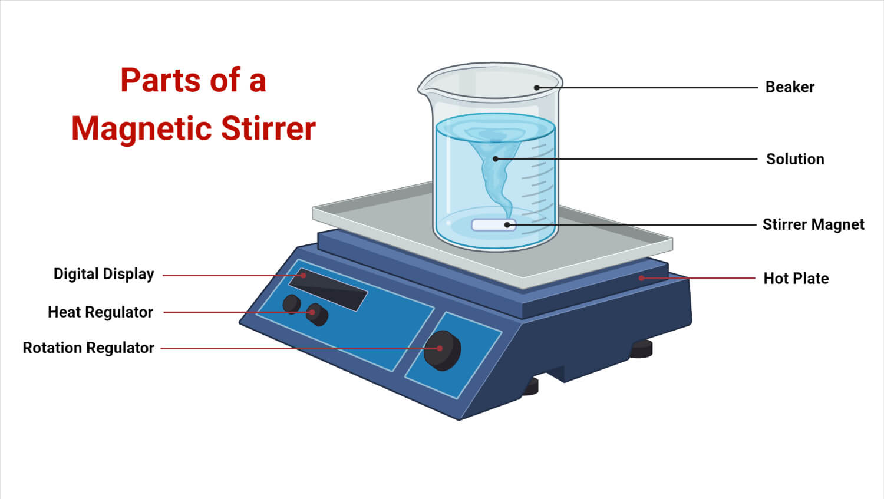
Fig 2: part of magnetic stirrer. https://microbenotes.com/
- Principle of Magnetic Stirrer
The magnetic stirrer operates on the principles of attraction for opposite charges and repulsion for like charges. The stirring speed is adjustable, and it is frequently used to stir solvents of various viscosities. A micromotor powers a magnet to create a rotating magnetic field that rotates the stirring bar inside the vessel, enabling a thoroughly mixed reaction to take place. It is equipped with a temperature control system that can heat and regulate the sample’s temperature in accordance with experiment requirements, ensuring that the mixed liquid satisfies the experiment’s requirements while keeping the required temperature.
- Characteristics of Magnetic Stirrer
Capacity: Obviously, running water is rarely used for stirring. Therefore, the nominal capacity is significantly higher than the real capacity. A minimum of 1 liter of surfactant solution and roughly 250 ml of an emulsion can be accommodated in the micro models’ 3-liter capacities.
Maximum speed: The speed is measured in revolutions per minute (rpm) (rotations per minute). The speed is roughly 1000 rpm. Up to 2500 revs per minute are possible with strong versions.
Maximum permitted temperature and humidity: An individual should look at the instrument’s maximum allowable operating temperature and humidity while working in a wet lab, in a tropical area, or planning to mix hot materials.
Dimensions of the mounting surface: The size of beakers you can use with each magnetic stirrer is determined by the surface area.
The magnet: There are magnets in every size and shape imaginable, including basic rods and other geometric shapes like ellipses, discs, etc. The beaker must be compatible with the size of the stirring rod, typically 0.5–1.0 cm smaller than the beaker’s diameter. Undoubtedly, various magnetic rods are required while working with different beaker sizes.
- Use of Magnetic Stirrer
- Prepare a container with the liquid solution already inside of it.
- The container should be placed on the hotplate.
- Connect to the mains to turn on the hotplate.
- By pressing the temperature setting button, adjust the hotplate’s temperature.
- Place the magnetic stir bar in a vessel filled with solution.
- Next, turn the stirrer magnetic speed adjustment button clockwise to change the speed of the magnetic stirrer. Turn the magnetic stirrer adjustment knob counter-clockwise if the stirring speed is too high.
- Stir the liquid mixture until uniformity is achieved.
- Remove the magnetic stirrer from the liquid solution container once done.
- Disconnect from the mains to turn off the hotplate.
- Use hot hands to lift the container.

- Types of Magnetic Stirrers
The choice of size, configuration, and applications of magnetic stirrers are used to classify them. Some of the types of magnetic stirrers are as follows:
- Magnetic Mini Stirrer
The laboratory magnetic stirrers for use in laboratories are compact and require less space. They have electronic controls that enable the user to precisely manage the speed. It can withstand destructive and corrosive substances in the lab. The speed regulator manages the rotation per minute (rpm) of the stirrer.
- Magnetic Stirrer with Timer
The motor is automatically turned off after a certain time, thanks to a magnetic stirrer with a timer. A built-in timer will turn the stirrer off when the pre-selected duration of time has elapsed. Additionally, the speed is automatically decreased, and the weight is automatically removed.
- Heavy-Duty Magnetic Stirrer
High mixing capacities are included with the heavy-duty magnetic stirrers. They are also very robust and exhibit good chemical resistance. They may be the ideal instrument for the lab to use for precise findings. The majority of chemical reactions require heated magnetic stirrers.
- Battery Powered Magnetic Stirrer
They can be utilized in places with no electricity or other restricted environments. They are mostly used in incubators, operate on batteries, and have rubber feet to provide stability. They are portable and lightweight to carry.
- Air-operated Turbine Magnetic Stirrer
The air-operated turbine magnetic stirrer is the ideal tool for blending liquids up to 1 liter of solution. A low-pressure air supply drives this magnetic stirrer. The crucial feature of this magnetic stirrer is that it eliminates the risk of sparking from electrical sources.

- Maintenance of Magnetic Stirrer
- To prevent mishaps, the instrument housing needs to be correctly grounded.
- To avoid excessive vibration during operation, the medium-speed operation can run continuously for eight hours, and the high-speed operation can run continuously for four hours.
- To prevent harm to the instrument, keep it dry and clean, forbid solution from entering it, and turn off the power when not in use.
- Turn off the power and keep items in a dry, ventilated area when not in use for an extended time.
- Stirring heating time should not be lengthy; occasional use can extend the life.
- If a stirrer is beating or not stirring while mixing, slow it down or turn off the power to verify if the location is correct and the beaker’s bottom is flat.

