Lesson 3: the Listening Skill
1.The Nature of Listening
Listening is defined as a process or an activity of paying attention to what one hears and trying to understand or to get the meaning conveyed or implied by the speaker.
Listening is often misunderstood as a passive act, but in linguistics and communication science, it is defined as an active, psychological process.
Just like the other macro-communication skills (speaking, reading, writing), listening can be acquired, learned, and practiced.
2.Types of Listening
2.1. Intensive: listening for perception of the components (phonemes, words,
intonation, discourse markers, etc.) of a larger stretch of language
2.2. Responsive: listening to a relatively short stretch of language (a greeting,
question, command, comprehension check, etc.) in order to make an
equally short response
2.3. Selective: processing stretches of discourse such as short monologues for
several minutes to “scan” for certain information.
4. Extensive: listening to develop top-down, global understanding of spoken
language. Extensive performance ranges from listening to lengthy lectures
to listening to a conversation and deriving a comprehensive message or
purpose. Listening for the gist—or the main idea—and making inferences
are all part of extensive listening.
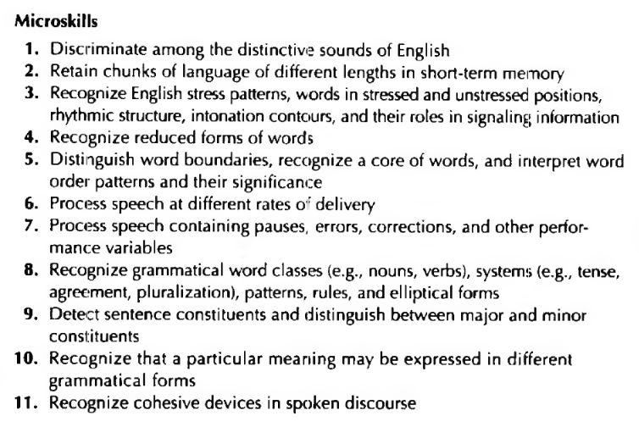
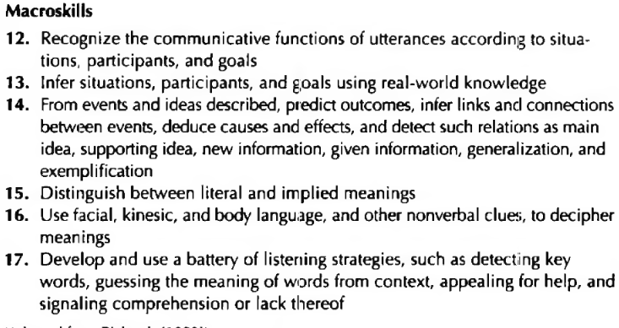
3. Enabling Listening Skills
While "Enabling Skills" generally refer to the building blocks of language (like grammar and vocabulary), Enabling Listening Skills specifically refers to the sub-abilities that allow a listener to decode sound and extract meaning in real-time.
Without these micro-skills, a learner may "hear" everything but "understand" nothing. Here is a breakdown of the specific skills that enable effective listening:

3.1. Perception Skills (The "Ear" Skills)
These are the most basic enabling skills. They involve the physical and cognitive ability to distinguish sounds.
- Phonemic Discrimination: Being able to tell the difference between similar sounds (e.g., th vs. f in "thin" and "fin").
- Recognizing Stress and Intonation: Understanding how a change in pitch can change meaning (e.g., identifying a question vs. a statement just by the rising tone at the end).
- Word Boundary Recognition: Identifying where one word ends and the next begins in a stream of connected speech (e.g., hearing "ice cream" instead of "I scream").

3.2. Language-Specific Enabling Skills (The "Logic" Skills)
These skills use the listener's knowledge of the language system to predict and decode.
- Lexical Recognition: Quickly retrieving word meanings from memory.
- Syntactic Parsing: Understanding the grammatical relationship between words (e.g., knowing who did what to whom based on word order).
- Predictive Listening: Using existing knowledge to "guess" what word comes next, which reduces the cognitive load on the brain.

3. 3.Cognitive Enabling Skills (The "Brain" Skills)
These skills involve how the brain manages the information it receives.
- Working Memory: The ability to hold the beginning of a sentence in your head until the speaker reaches the end.
- Inferencing: Filling in the gaps of what wasn't explicitly said (e.g., if a speaker says "I forgot my umbrella," the listener infers they might be wet or worried about rain).
- Filtering: Distinguishing the "signal" from the "noise"—ignoring background sounds or "filler words" (like um or uh) to focus on the message.
4. How to Build Enabling Listening Skills
In a classroom or self-study, you don't just "listen more." You practice the sub-skills:

Dictation: Improves word boundary recognition.
Minimal Pair Drills: Improves phonemic discrimination.
Gap-fills: Forces the listener to use predictive and lexical skills.
Shadowing: Speaking along with a recording to master stress and intonation.
Key Takeaway: If a student is "bad at listening," they usually don't need a longer audio clip; they need to strengthen a specific enabling skill, such as word recognition or working memory.
5. Listening process
It is a further explanation of the enabling listening skills.

1. Recognition (The "What" Stage)
This is the foundational level where you perceive and identify the building blocks of the message.
- Sensory Input: You hear the physical sound waves.
- Linguistic Identification: You recognize the phonemes, words, and grammatical structures.
- Targeting: You distinguish the speaker's voice from background noise.
- Key Question: "What words are being said, and do I know them?"

2. Interpretation (The "Why" Stage)
Once the words are recognized, the brain must assign a deeper meaning to them. This is the most complex cognitive part of the process.
- Decoding Nuance: You look at the speaker’s tone, pitch, and speed (prosody).
- Contextualizing: You use your "schema" (background knowledge) to understand the situation.
- Inferencing: You read between the lines to find the speaker’s intent or emotional state.
- Key Question: "What does the speaker actually mean by this?"

3. Participation (The "How" Stage)
Listening is incomplete without a reaction. Participation turns a one-way stream of sound into a two-way act of communication.
- Active Feedback: Providing non-verbal cues like nodding, eye contact, or leaning in.
- Verbal Response: Asking clarifying questions, paraphrasing, or offering a rebuttal.
- Internal Engagement: Even if silent, the listener is participating by evaluating the logic and forming an opinion.

6. Listening Materials (The "Input")
Materials are the audio or video sources used to provide language input. They are generally categorized by their origin:

Authentic Materials
Real-world content not originally created for language learners.
- Examples: Podcasts, news broadcasts, movie clips, TED Talks (Technology, Entertainment, and Design), or recorded phone calls.

Adapted/Pedagogical Materials
Content specifically designed for students at a certain CEFR level Common European Framework of Reference for Languages (A1, B2, etc.).
- Examples: Scripted dialogues in textbooks, "slowed-down" news, or graded readers with audio.

Visual vs. Audio-Only
- Video: Provides extra context through body language and setting (easier for beginners).
- Audio-only: Forces the brain to focus entirely on phonemes and intonation (better for advanced training).

7. Listening Tasks (The "Activity")
The task is the goal-oriented activity that ensures the student is processing the material. Tasks should move from General (Gist) to Specific (Detail).
Task Type | Goal | Example Activity
Gist (Global) | Understanding the main idea. | "Is the speaker happy or angry?" or "Where are they?"
Selective (Specific) | Finding tiny pieces of info. | Filling in a flight number, a price, or a name.
Intensive | Understanding every word. | Transcribing a 30-second clip or "Gap-fill" lyrics.
Inferential | Reading between the lines. | "Why did the speaker pause before answering?"

8. Matching Material to Task
The "Goldilocks Rule" of listening is to match the difficulty of the material with the difficulty of the task.
- Difficult Material + Easy Task: Use an authentic BBC news clip but only ask students to identify the topic (e.g., "Is this about sports or politics?"). This builds confidence with real English.
- Easy Material + Difficult Task: Use a simple scripted dialogue but ask students to transcribe it exactly or identify every adjective used. This builds precision.

9. The "Three-Stage" Task Design
To prevent "listening fatigue," organize tasks into this flow:

Pre-Listening (Preparation)
- Task: Looking at a photo or title and predicting 3 words they might hear.
- Purpose: To activate Enabling Skills and "warm up" the brain.

During-Listening (Engagement)
- Task: Numbering pictures in the order they happen or "Tick the items on the shopping list."
- Purpose: To give the student a reason to keep listening.

Post-Listening (Extension)
- Task: "The speaker has a problem. Write a 2-sentence email giving them advice."
- Purpose: To move the information from Receptive (Listening) to Productive (Writing/Speaking).
9. Listening in Relation to other Skills

1. Listening as the Foundation for Speaking (The Input-Output Loop)
The most direct implementation of listening is in Oral Fluency. You cannot produce sounds you have not first decoded.
- Phonetic Modeling: Listening provides the "blueprint" for pronunciation, word stress, and intonation.
- Functional Implementation: In a classroom, a "Listen and Repeat" or "Shadowing" task implements listening to improve speaking mechanics.
- Conversational Symmetry: Listening enables the "Participation" phase of a conversation. If the listening stage fails, the speaking response will be irrelevant.

2. Listening to Support Writing (The Dictation/Synthesis Path)
Writing is often the "permanent record" of what was heard. Implementing listening into writing tasks helps with accuracy and cognitive processing.
- Dictogloss: A common pedagogical implementation where students listen to a short text, take notes, and then work together to reconstruct the text in writing. This forces them to move from Recognition to Encoding.
- Note-taking: This is the most practical implementation of listening in academic and professional writing. It requires the listener to filter "noise" and synthesize "signal" into written form.
- Style and Tone: Exposure to different spoken registers (lectures vs. casual chat) helps a writer understand how to adjust their "voice" in text.

3. Listening to Support Reading (The Prosody Connection)
While reading is a visual skill, it has a strong "inner voice" component that is built through listening.
- Read-Alouds: When a teacher reads while students follow along, they are implementing "Audio-Visual Mapping." This helps students connect the sounds of words to their written symbols.
- Phonemic Awareness: For young learners, listening to rhymes and stories implements the awareness of letter-sound correspondences, which is the "Enabling Skill" for reading.
- Fluency: Listening to fluent readers helps students understand where to "pause" at punctuation marks when they read silently.

