2-5.1: Introduction
Beverages are liquid products consumed to provide hydration, sensory pleasure, and nutritional value. The beverage industry encompasses both alcoholic and non-alcoholic products. It represents a rapidly expanding sector, largely driven by evolving lifestyles and shifting consumer preferences.
Beverages are very important sector of the food industry based on all types of liquid foods including:
- alcoholic (beers, wines, and spir its);
- nonalcoholic drinks (water, soft or cola drinks, fruit juices and smoothies, tea, coffee, dairy beverages, and carbonated and noncar bonated drinks).
2-5.2:Classification of Beverages
Beverages are broadly classified into two main categories: alcoholic and non-alcoholic beverages.
- Alcoholic Beverages
- Contain ethanol (alcohol) as a result of fermentation; Produced primarily through microbial fermentation, typically involving yeast
- Common examples include beer, wine, vodka, and whiskey
- May require aging or maturation to develop desired sensory properties (e.g., wine, whiskey)
- Production processes are often sensitive to pH and microbial stability
- Non-Alcoholic Beverages
- Contain little to no alcohol
- Produced through processes such as mixing, pasteurization, and sometimes carbonation
- Include products such as soft drinks, fruit juices, energy drinks, milk-based beverages, and flavored water
- Generally ready for consumption shortly after production
- Frequently carbonated and may contain additives (e.g., sweeteners, flavorings, preservatives)
- Example denominations: Orange juice; Apple juice from concentrate
2-5.3. Juice-Based Beverages
In an academic and regulatory context, the distinction is defined by standards (normes), which vary slightly by region but follow similar principles:
- 100% Fruit Juice (Jus de fruits): Must contain only fruit juice, with no added sugars or dilution (except restoration from concentrate).
- Nectar (Nectars de fruits) : Contains fruit juice or puree plus water and possibly added sugar → Minimum fruit content typically 25–50%, depending on the fruit.
- Juice Drinks / Juice-Based Beverages (Boissons aux fruits): Formulated beverages with lower fruit content (often 5–50%), plus water, sugar, flavorings, etc → Not strictly standardized globally, but regulated nationally.
- Soft carbonated beverages are formulated non-alcoholic drinks in which carbon dioxide is dissolved under pressure, producing carbonation, and are typically composed of water, sugars or sweeteners, acids, flavoring agents, and permitted additives.
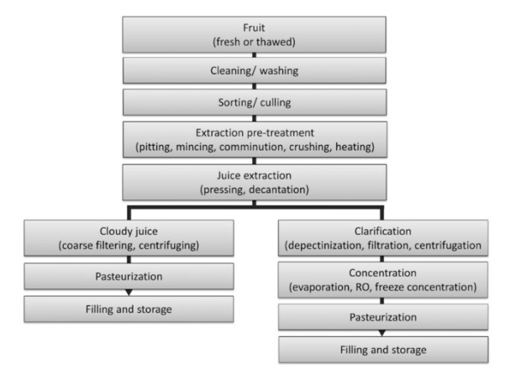
2-5. 3. General fruit juice processing

General fruit juice processing flow chart
