2-4. 1. Introduction
Sugar is the common name for sucrose, which is extracted and refined from sugar cane and sugar beet. There are many substances classified as sugars, and when these are referred to, they are always used with a qualifier such as in milk sugar (lactose), corn sugar (dextrose), and malt sugar (maltose). When the word sugar is used without a qualifier, it refers to the common sweetener (sucrose) or table sugar. Additional sources of sucrose include maple trees and some fruits.
2-4.2. Cane Sugar Manufacturing
Cane sugar manufacturing is a complex agro-industrial process that converts harvested sugarcane into raw sugar through a series of mechanical and physicochemical operations, carried out in several sequential steps as outlined below.
(1) Cane Sugar Processing (Raw Sugar Production)
a) Cane Preparation (Shredding): Mechanical size reduction of sugar cane using shredders to break the fibrous structure and expose juice-containing cells.
b) Juice Extraction (Milling & Imbibition):Mechanical pressing of shredded cane using multiple roller mills (3–7 units), often combined with imbibition (addition of hot water or dilute juice).
c) Bagasse Handling and Valorization: Separation and utilization of the fibrous residue (bagasse) after juice extraction.
d) Juice Clarification (Liming and Heating): Treatment of raw juice (pH ≈ 5.2) with calcium hydroxide (Ca(OH)₂), followed by heating and settling to remove impurities.
e) Filtration and Sedimentation: Removal of suspended solids after clarification through settling tanks and filtration.
f) Evaporation (Concentration): Removal of water from clarified juice under vacuum to produce concentrated syrup.
g) Crystallization (Massecuite Formation): Formation of a mixture of sugar crystals and mother liquor (massecuite) in evaporation/crystallization pans.
h) Centrifugation (Separation): Mechanical separation of sugar crystals from molasses using centrifuges.
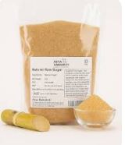
i) Raw Sugar Drying and Storage: Drying and packaging of raw sugar for transport or further refining.

- Cane Sugar Refining (White Sugar Production)
j) Affination (Washing of Raw Sugar): Mixing raw sugar with hot saturated syrup followed by centrifugation and washing.
k) Dissolution and Liming: Dissolution of sugar crystals in hot water, followed by lime treatment
(pH 7.3–7.6).
l) Filtration (Clarification): Removal of insoluble impurities using filtration media (diatomaceous earth or pulp).
m) Decolorization: removal of residual color compounds from the sugar solution using adsorbents such as activated carbon or ion-exchange resins, resulting in a clear liquor suitable for producing white sugar.
n) Recrystallization: Crystallization of purified sucrose from solution in vacuum pans.
o) Final Centrifugation and Washing: separate sugar crystals from the remaining syrup using high-speed spinning, followed by washing to remove impurities, resulting in clean, high-purity white sugar.
p) Drying, Screening, and Grading: remove moisture from sugar crystals and classify them by size to ensure stability, uniformity, and consistent quality.
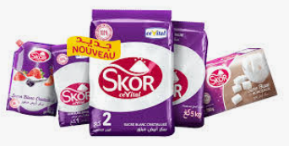
q) Packaging: Final packing of sugar in various forms (granulated, cubes, powdered).

