2-3.1. Edible oils
2-3.1. Introduction
Vegetable oils and fats are important constituents of foods and are essential components of our daily diet. Vegetable oils are obtained from oleaginous raw materials, including oilseeds such as soybean, rapeseed, and sunflower, as well as oil-rich fruits like palm and olive. The extraction of these oils is typically carried out by mechanical expelling or by solvent extraction, depending on the nature of the raw material and the desired efficiency of oil recovery.
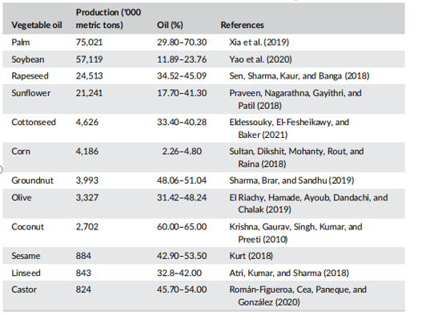
Table 2-3.1. World production and oil content of major vegetable oils

2-3.1.2. Composition of vegetable oils (edible oils)
Vegetable oils are mainly composed of triglycerides (about 98%), which are formed by the combination of glycerol and fatty acids. In addition, they contain minor compounds such as diglycerides, vitamins, phytosterols, tocopherols, and polyphenols, many of which have beneficial health effects and should be preserved during processing.
However, crude oils also include undesirable substances like free fatty acids, waxes, pigments, solid impurities, and oxidation products that negatively affect oil stability, taste, and odor. Although these compounds are not necessarily toxic, they reduce the sensory and functional quality of the oil.
Furthermore, vegetable oils may be contaminated with substances such as pesticides, heavy metals, hydrocarbons, and mycotoxins, originating from agricultural practices, environmental conditions, and processing steps. Therefore, refining is essential to obtain oils that meet food safety standards—clear, odorless, neutral in taste, and free from harmful contaminants.
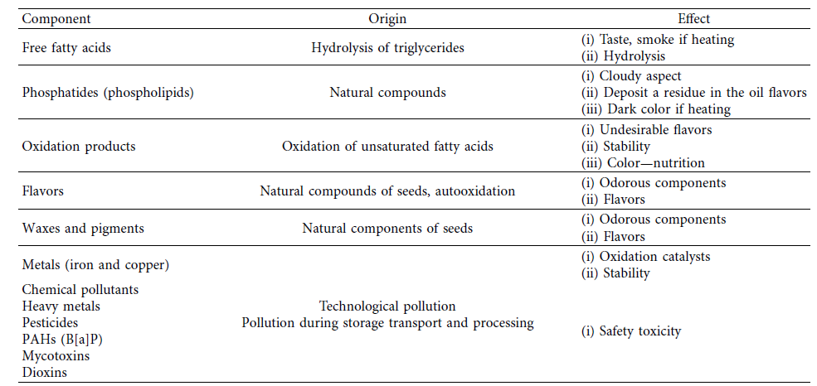
Table 2-3.2. Undesirable constituents in oil removed during refining.

2-3.1.3. Edible oil manufacturing
Industrial production of edible oils typically involves two main stages:
- Extraction;
- Refining.
Note: However, virgin oils are obtained solely by mechanical processes.
1) Extraction
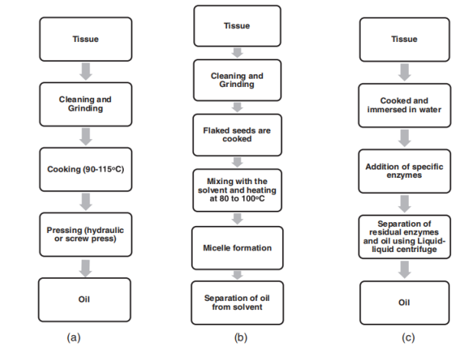
Edible oil extraction can be carried out through different methods, including mechanical pressing, solvent extraction, and enzyme-assisted extraction.

Figure 2-3.1. Flow chart of oil extraction through mechanical pressing, solvent-based extraction, and enzyme-assisted extraction methods.
2 )Refining
Refining is the set of treatments applied to crude vegetable oils to remove undesirable and potentially harmful components. It is essential for oils that cannot be consumed in their crude form, as it improves their appearance, making them clear and bright, neutralizes taste and odor, and enhances oxidative stability.
In addition, refining eliminates contaminants such as pesticide residues, trace metals, polycyclic aromatic hydrocarbons, dioxins, and degradation products, while producing oils that are suitable for both consumption and various industrial applications, with minimal processing losses.
- Chemical Refining of Oil
Chemical refining is the traditional method used since ancient times. It can be used for all fats and oils even when they have been slightly degraded. Each step of the refining process has specific functions for removing some undesirable compounds. Chemical refining
follows six processes:
(1) Degumming with the goal of the elimination of phospholipids and mucilaginous gums;
(2) Neutralization, which allows the elimination of free fatty acids (FFA), phospholipids, metals, and chlorophylls;
(3) Washing and drying in order to eliminate residuals of soaps and water;
(4) Bleaching aims at eliminating pigments, peroxides, and residuals of both fatty acids and salts;
(5) Dewaxing has as main objective removing the waxes in the case of oils rich in waxes;
(6) Deodorization, is the final stage of chemical refining, which allows the elimination of volatiles, carotenoids, and free fatty acids.
- Physical Refining
process consists of the same steps described in chemical refining, except for the alkali neutralization process. Chemical refining consists of removing free fatty acids by adding caustic soda and separating the soap by centrifugation (mechanical separation), while physical refining, in the
last step, removes free fatty acids and other compounds by steam distillation. ,is process is also known as steam refining.
In general, physical refining includes the following three main processing steps:
(1) Degumming to remove phosphatides
(2) Bleaching and filtration to eliminate color pigments
(3) Deodorization allows the elimination of free fatty acids and other volatile compounds.

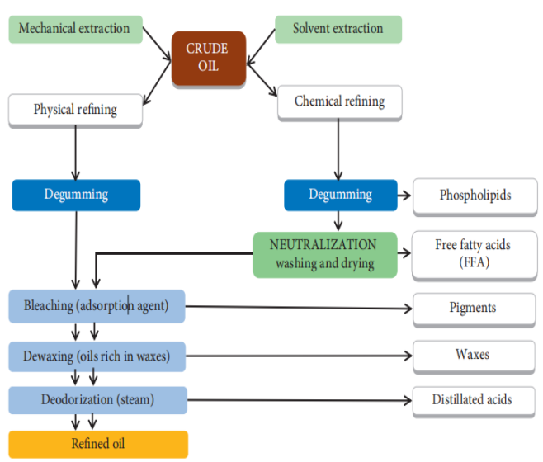

Figure 2-3.2. General overview of the chemical and physical refining processes of crude oil.
2-3.2. Margarine
2-3.2.1. Definition
Margarine is a water-in-oil (W/O) emulsion derived from vegetable and/or animal fats. It typically contains 80–90% fat and no more than 3% milk fat. The emulsion remains solid at 20 °C.
2-3.2.2. Composition of Margarine
Margarine is mainly composed of:
- Lipid fraction (80–90%) . This fraction is primarily made up of triacylglycerols (TAGs), along with minor components such as diacylglycerols (DAGs), monoacylglycerols (MAGs), and trace amounts of free fatty acids (FFAs). It also contains fat-soluble compounds like carotenoids and vitamin A (retinol).
- Aqueous phase: which contributes to its emulsion structure.
2-3.2.3. Margarine Manufacture Process
Margarine manufacture involves the blend of a lipidic and an aqueous phase in order to obtain a W/O emulsion with a fat percentage of at least 80%. Apart from 80% of fat, the rest isusually skim milk, whey, or a water solution containing salt and flavors.
- Preparation of the fatty raw material
The types of fats used in margarine manufacture are highly diverse, including vegetable oils with varying degrees of unsaturation, marine oils, and solid fats of both vegetable and animal origin, as well as their mixtures. In order to achieve the desired functional properties particularly appropriate solid fat content (SFC), plasticity, and crystallization behavior, these fats are commonly subjected to specific modification processes.The principal methods employed are:
- Hydrogenation, which involves the addition of hydrogen to unsaturated fatty acids, thereby increasing saturation and raising the melting point.
- Interesterification, a process that rearranges fatty acids within and between triglyceride molecules without altering their overall degree of saturation.
- Fractionation is a physical process used to separate fats into different parts (fractions) according to their melting points. The fat is slowly cooled so that the higher-melting (more solid) components crystallize first, while the lower-melting (liquid) components remain fluid. These fractions are then separated (e.g., by filtration).
This modification step is essential for designing margarine with optimal spreadability, stability, and sensory properties.
b)Description of the process: Margarine production includes the following steps:
• Blending of the suitable fats with other oil-soluble components such as emulsifiers (lecithin, mono- and diglycerides, or a combination of them), oil-soluble vitamins, and colorants (b-carotene and annatto).
• Preparation of the aqueous fraction by mixing different water-soluble components. These include milk or water with salt and flavors such as diacetyl or starter distillate.
• Mixing of both the lipidic and the aqueous phases to form the W/O emulsion at temperatures around 50–60 ℃.
• Pasteurization of the emulsion at temperatures around 70–86 ℃.
• Chilling to 15–25 ℃ in a scraped-surface heat exchanger while undergoing vigorous agitation and kneading (plasticizing). This makes an extremely fine dispersion of the water phase in the fat phase possible.
• Solidification of the margarine before extrusion to the packaging line.

