CHAPTER V. TOOLS AND TECHNIQUES IN MOLECULAR BIOLOGY
A series of essential tools are used by molecular biologists to analyze DNA, clone it, amplify it, transport it using vectors, and introduce it into host cells. Among these tools are:

- Restriction enzymes
Restriction enzymes are proteins synthesized by bacteria as a defense mechanism against viral infections (bacteriophages). These enzymes cut viral DNA at specific sites. This defense mechanism is known as restriction.
These enzymes are capable of cutting DNA at specific sites called restriction sites, thereby fragmenting foreign viral DNA. They cleave phosphodiester bonds between nucleotides. These enzymes belong to the class of endonucleases, which cleave phosphodiester bonds within a nucleic acid chain, in contrast to exonucleases that act only on nucleotides located at the ends (3’ or 5’) of DNA fragments.
Currently, around one hundred restriction enzymes are known, each having its own restriction site. These sites, mostly composed of a few nucleotides, are frequently found in genomes, so their action generates multiple DNA fragments. These enzymes have the particularity of cutting both strands of DNA.
Based on their mode of action, these enzymes are classified as endodeoxyribonucleases, since they are specific to DNA.
When a bacteriophage infects a bacterium, it injects its DNA. Without an appropriate defense system, numerous bacteriophages are produced, eventually leading to cell lysis. To resist this infection, bacteria produce restriction enzymes that fragment foreign viral DNA. At the same time, bacteria produce methyltransferases that modify (methylate) their own DNA so that it is not recognized by restriction enzymes.
I.1. Restriction sites
Restriction enzymes are divided into three classes based on the type of sites they recognize:
- Type I: Recognize specific sequences without symmetry and cut DNA far from the recognition site (about 1000 nucleotides away).
- Type III: Similar to Type I, but cut DNA approximately 20 nucleotides from the recognition site.
- Type II: The most common type. They recognize specific sequences and cut at defined positions within or near the recognition site. These sites are usually palindromic sequences of 4 to 8 nucleotides.
I.2. Modes of DNA cleavage by restriction enzymes
Restriction enzymes can cut DNA in two ways:
- Blunt-end cleavage: The cut occurs in the middle of the recognition site, producing blunt ends.
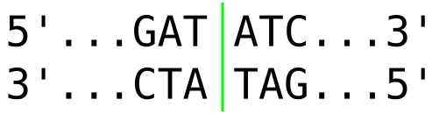
- Sticky-end cleavage: The cut occurs asymmetrically on both sides of the symmetry center, producing cohesive ends.
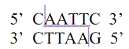
I.3. Nomenclature of restriction enzymes
These enzymes originate from microorganisms, mainly bacteria, which synthesize them as a defense mechanism against viral DNA.
The nomenclature of restriction enzymes follows specific rules:
- The first letter (capitalized) represents the genus of the bacterium.
- The next two letters (lowercase) represent the species.
- A Roman numeral indicates the order of discovery.
For example: Sau3A, BamHI, EcoRI, MspI, KpnI.
Today, hundreds of restriction enzymes are commercially available. They are essential molecular biology tools (“molecular scissors”) used for DNA fragmentation, genetic mapping, creation of recombinant DNA, and many other applications.

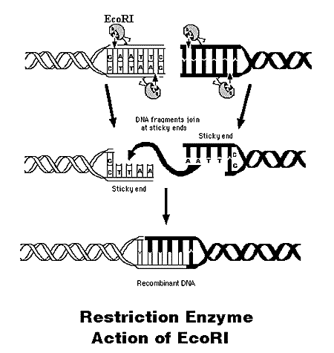

- Gel electrophoresis (DNA fragment separation)
Electrophoresis is one of the main techniques used in biology for separation and characterization of molecules. Separation is based on charge, and for molecules with identical charge, on size.
DNA is negatively charged due to phosphate groups and migrates toward the positive pole under an electric field. When placed in an agarose or polyacrylamide gel, larger molecules migrate more slowly than smaller ones. Therefore, DNA fragments are separated according to size: small fragments migrate further, while larger ones remain closer to the loading well.
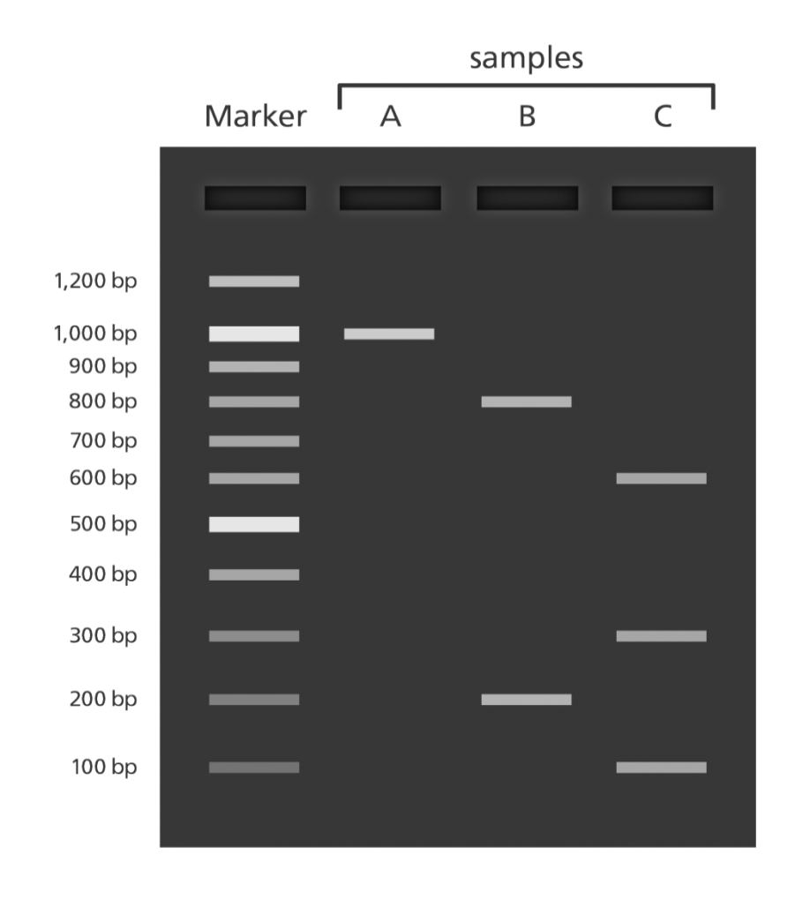
Two main polymers are used:
- Polyacrylamide gel: separates small DNA fragments (up to a few hundred base pairs) and is used vertically.
- Agarose gel: separates larger DNA fragments (several thousand base pairs) and is used horizontally.
Molecular weight markers are run alongside samples. DNA fragments are visualized under UV light after staining with ethidium bromide, a fluorescent nucleic acid dye.

- Molecular cloning
Cloning consists of producing identical and numerous copies of a DNA fragment. It requires several tools:
- DNA to be cloned
- A vector containing the DNA insert (recombinant DNA)
- A host cell
- A method for cell multiplication
- Selection of transformed cells
- Isolation and purification of recombinant DNA
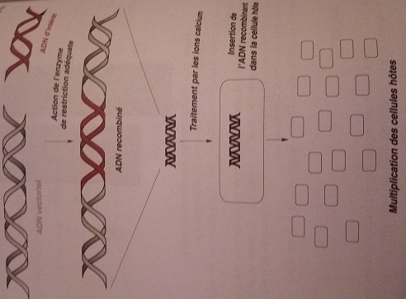
III.1. Recombinant DNA
Recombinant DNA is a hybrid molecule formed from DNA of two different species, where a DNA fragment (insert) is integrated into a vector. This process is carried out in vitro, while replication occurs in vivo.
Restriction enzymes are used to cut both insert and vector, and DNA ligase joins them to form recombinant DNA.
III.2. Vectors
Vectors are small DNA molecules used to carry foreign DNA into host cells, where they replicate. Their small size facilitates rapid replication.
Common vectors include:
- Bacteriophages
- Plasmids (circular bacterial DNA)
- YAC (Yeast Artificial Chromosomes)
- BAC (Bacterial Artificial Chromosomes)
III.3. Host Cells
Host cells must not degrade recombinant DNA. Mutant bacterial strains lacking restriction enzymes are often used.
- Transformation: bacterial cells are made competent and incubated with recombinant vectors, allowing uptake.
- Selection: antibiotic resistance markers (e.g., ampicillin resistance) are used to select transformed bacteria. Only cells containing recombinant vectors survive.

- PCR method
The Polymerase Chain Reaction (PCR), developed by Kary Mullis (Nobel Prize in 1993), allows exponential amplification of DNA in vitro.
It consists of repeated cycles:
- Denaturation (95°C): DNA strands separate
- Hybridation (50–60°C): primers bind
- Extension (70°C): DNA polymerase synthesizes new strands
Each cycle doubles the DNA quantity.
The use of Taq polymerase (from Thermus aquaticus) made the process efficient due to its heat resistance.
PCR allows rapid amplification of small DNA fragments, although yields are lower than classical cloning. RT-PCR is used for RNA analysis.
