2-2.1. Introduction
Meat is the edible portion of mammals—the flesh of animals used for food. “Meat” may include rabbit, venison, and other game, as well as the nonmammals poultry and fish. The flesh from various animals may be used as food throughout the world.
Red meat is the meat from mammals including beef and veal, lamb, mutton, and pork. White meat refers to meat from poultry.
2-2.2. Physical Composition of Meat
The physical composition of meat is composed of three tissues:
- muscle tissue;
- connective tissue (mostly collagen and elastin);
- adipose or fatty tissue.
Muscle Tissue. Muscle tissue is referred to as the lean tissue of meat. It includes cardiac, skeletal, and smooth muscle. Cardiac muscle islocated in the heart. Skeletal muscle, the primary component of the carcass, provides support forthe weight of the body, and its movement, or locomotion.
Within the muscle cell membrane, there are myofibrils containing alternating thin and thick protein filaments, namely the actin and myosin, which contract and relax in the living animal.
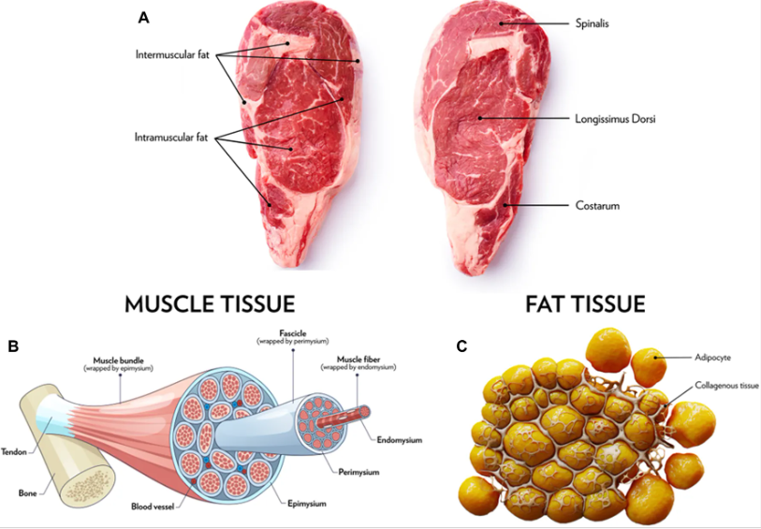

Figure 2-2.1. Muscle Tissue structure

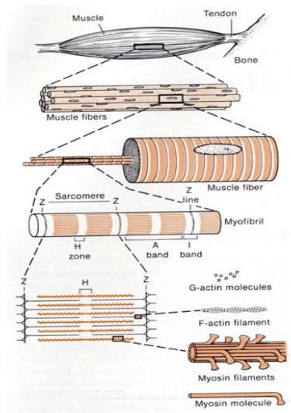

Figure 2-2.2. Hierarchical structure of skeletal muscle.
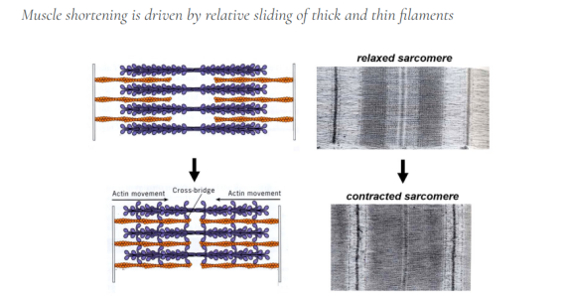

Figure 2-2.3. Sarcomeres, fundamental contractile units. Interactions between thick and thin filaments drive filament sliding. Thick and thin filaments are drawn in blue and orange, respectively, in the drawings at left. The images at right show real sarcomeres viewed by electron microscopy.
2-2.3. General Meat Processing
General meat processing involves a sequence of essential steps that ensure both product quality and safety. It begins with slaughter, followed by cutting and dressing, where the carcass is prepared and divided into primary parts. This is followed by carcass ageing, a crucial stage that improves meat tenderness and flavor through biochemical changes. Subsequently, meat inspection is conducted to ensure compliance with hygienic and safety standards. Finally, the process may include cooking of meat and meat products, depending on the intended form of consumption or further processing.
2-2.3.1. Slaughter
The basic process for slaughtering livestock is similar the world over though differences occur in terms of equipment, and levels of hygiene and oversight. At the slaughterhouse or abattoir, animals are allowed to rest for a period just before slaughter. This is done in order that muscle starch (glycogen) is not all used up. When the animal is slaughtered with an adequate amount of glycogen in its body, the glycogen is converted under anaerobic conditions to lactic acid that produces a pH decline. The presence of this acid has a preservative effect on the meat as well as its color and texture. If the animal is not rested before slaughter and it uses up its glycogen, there will not be enough lactic acid formed to have the preservative effect, and thus the meat will spoil sooner.
Generally, animals must be rendered insensible to pain before slaughter by stunning. With cattle, this is done by hitting them on the head with a bolt from a specially devised stunning gun. The stunned animal is shackled at the hind legs, raised from the floor in an upside-down position, and then bled by severing its jugular vein.
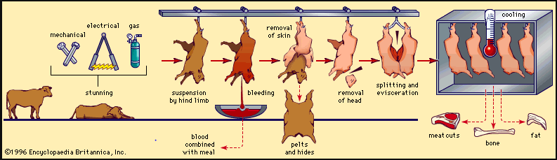
Figure 2-2.4. Beef slaughtering process
2-2.3.2. Cutting and Dressing: Main dressing steps
- Skinning: Removal of the hide from the carcass.
- Removal of head and feet
- Evisceration: Removal of internal organs (digestive tract; liver; lungs; heart; kidneys)
- Carcass splitting: The carcass is cut into two halves along the vertebral column.
- Washing and inspection: Veterinary inspection ensures the meat is safe for consumption.
- Chilling: The carcass is cooled at about 0–4°C to prevent microbial growth.
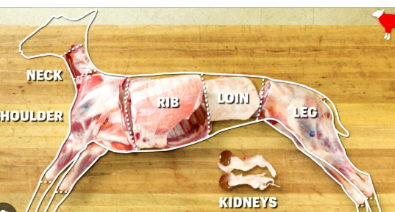
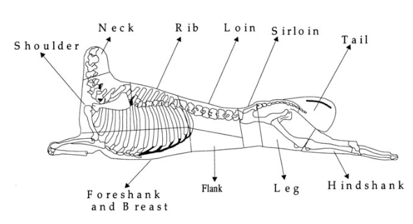

2-2.3.3.Carcase Ageing
After slaughter, the carcass portions are aged in cold rooms at low temperatures just above freezing, usually 35 °F (1.7 °C). This process may take up to one month, depending on temperature, humidity, and other conditions, but ordinarily, meat is held for about 12 days prior to consumption.The aging is accelerated if the beef is stored at higher temperatures, but the higher temperaturetures permit the growth of bacteria and surface spoilage.
The meat aging (post-mortem maturation) process is classically divided into three physiological and biochemical stages occurring after slaughter:
- Pre-rigor mortis;
- Rigor mortis
- Post-rigor maturation (aging)
These stages correspond to metabolic and structural changes in muscle transforming it into edible meat.
- Pre-Rigor Mortis Stage: is the early post-mortem phase immediately after slaughter, before the onset of muscle stiffening. During this stage, muscle cells still contain:
- ATP (adenosine triphosphate);
- glycogen reserves;
- active metabolic enzymes.
Because ATP is still available, actin and myosin filaments remain able to detach, so the muscle remains soft and elastic.
- Biochemical Events After slaughter: Oxygen supply stops; Muscle metabolism shifts to anaerobic glycolysis; Glycogen is converted to lactic acid; pH begins to decline from about 7.0 to ~6.2–6.5. Reaction: Glycogen → Glucose → Pyruvate → Lactic acid
This stage usually lasts a few minutes to several hours depending on species.
- Technological Importance : Pre-rigor meat has: high water-holding capacity; better protein functionality.
- Rigor Mortis Stage: is the post-mortem stiffening of muscle caused by depletion of ATP, leading to permanent binding of actin and myosin filaments.
Without ATP, the actin–myosin cross-bridges cannot detach, producing rigid muscle structure.
- Biochemical Mechanism: ATP depletion; accumulation of lactic acid; decrease in pH to 5.4–5.6; formation of actomyosin complexes; Reaction: Actin + Myosin → Actomyosin (rigid complex).
- Physical Characteristics: During rigor mortis muscle becomes stiff and inextensible; carcass hardens; water-holding capacity decreases.
Species | Rigor onset
Poultry | 1–2 h
Pork | 3–6 h
Beef | 6–12 h
The onset time varies with species:

- Post-Rigor Maturation (Meat Aging): is the controlled enzymatic process that occurs after rigor mortis, leading to improvement in meat tenderness, flavor, and juiciness.
- Biochemical Processes
During maturation:
- Proteolysis: Endogenous enzymes degrade muscle proteins: Calpains; Cathepsins. These enzymes break down:myofibrillar proteins; cytoskeletal proteins (Result → tender meat).
- Flavor Development: Protein and lipid breakdown produces: peptides; free amino acids; aromatic compounds.
- Structural Changes: weakening of muscle fibers; increased tenderness; improved texture.
Parameter | Value
Temperature | 0–4 °C
Humidity | 80–90 %
Aging time | 7–35 days
Industrial Aging Conditions: Typical aging conditions:

2-2.3.4. Meat Inspection
The Food Safety and Inspections Services (FSIS), examine meat for adulteration or misbranding in the broadest sense including inspections to check the health of livestock at the meat plant prior to slaughter.
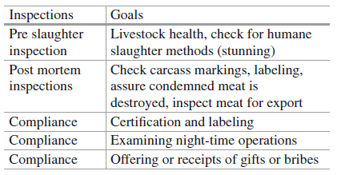
Table 2-2.1: Pre-slaughter and postmortem inspections for meat

2-2.3.5. Cooking Meat
Fresh meat such as steak may be subjected to a range of cooking methods, e.g. roasting, broiling, pan broiling, or cooking via impingement oven. Cooking produces desirable changes in sensory characteristics (flavor, texture, color etc.). Cooking also improves food safety. To inactivate any disease causing bacterial meat should be heated to prescribed minimum internal temperatures measured using a cooking thermometer. Since these temperatures represent the minimum settings for safety, there is considerable flexibility for culinary practice. Meat canbe cooked according to such designations as “rare, medium and well-done”.

