Exercise 1
Your research group has been assigned the task of cloning and expressing a newly discovered a protein to study it in-depth. The gene encoding this protein is named (gene A) and is found naturally in the genome of a breed of wild dog (Canis insanus ).
You plan to:
1. Clone the gene
2. Express the protein that codes to study its properties.
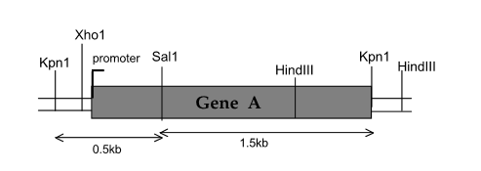
- How to clone this gene using a suitable cloning vector (see next page) and the techniques you have learned so far?
- During the vector digestion, explain how to prevent its recircularization?
- What is the appropriate host to use for the transformation of the recombinant vector?
- This breed of this dog is obviously a eukaryotic organism, so its genes have introns. These are removed during eukaryotic mRNA processing (post-transcriptional modifications), but prokaryotes don't know how to handle introns. Furthermore, you don't know exactly where the exons and introns are located within this gene. How will you create an intron-free version of gene A so that the mRNA will be translated correctly by E. coli?
- How can you use blue-white colony screening to help you determine which E. coli cells contain copies of the recombinant vector?
- If this gene is incorporated into the vector, it can be inserted in either the " forward" or "reverse" orientation. Is there one preferable orientation to the other?
- If so, can you explain how to screen plasmids that have the A gene in the correct orientation?
