CHAPTER VI: TRANSLATION
Throughout all living organisms, protein production is an essential process that allows each cell to live and reproduce. Translation corresponds to the process in which mRNA is translated into a protein: the conversion from a nucleotide sequence to an amino acid sequence according to the genetic code. Translation occurs in the cytoplasm of the cell.
- The Genetic code
The genetic code is a code that allows the conversion of a nucleotide sequence (DNA then RNA) into an amino acid sequence (proteins). The genetic code has several characteristics:
- The codes are triplets of nucleotides and they encode an amino acid (Figure 1).
- The genetic code is universal.
- The genetic code is redundant. Several codons encode the same amino acid: there are 64 codons and 20 amino acids.
- The nucleotides of one codon participate only in the coding of a single amino acid; therefore, the next amino acid will be encoded by the next codon present on the mRNA. This is known as the reading frame.
- The initiation codon is AUG (GUG for mitochondria), and the termination codons are UAA, UAG, and UGA. The UGA codon is not present in mitochondria.
- Among the 64 codons, three are stop codons, while the remaining 61 encode amino acids.

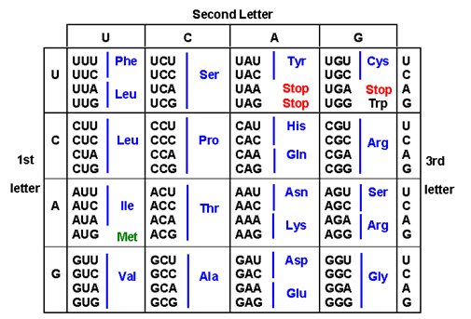
Fig 1. The genetic code.
- The components of translation
The components of translation are messenger RNA, transfer RNAs, ribosomes, amino acids, aminoacyl-tRNA synthetases, Mg²⁺, GTP, and ATP.
II.1. Ribosomes
Ribosomes consist of ribosomal RNAs (rRNAs) and proteins and are organized into two subunits in both prokaryotes and eukaryotes. Their size is defined in Svedberg units.
The bacterial ribosome contains specific sites:
- A site (Aminoacyl site): the binding site for aminoacyl-tRNAs carrying amino acids.
- P site (Peptidyl site): binding site for f-Met or for the tRNA carrying the growing peptide chain.
- E site (Exit site): the site where deacylated tRNA exits the ribosome.

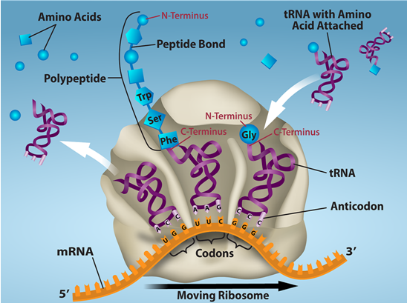
Fig 2. The ribosome specific sites.
II.2. tRNAs
During translation, there is antiparallel pairing between mRNA and tRNA: codon–anticodon.
At the 3’ end, there are three characteristic nucleotides: CCA–3’OH. It is through this end that the amino acid is attached to the tRNA. Amino acids do not arrive free on the ribosome; they are associated with their respective tRNAs.
There are 40 to 60 different tRNAs per cell; therefore, multiple tRNAs may correspond to the same amino acid. The formation of aminoacyl-tRNA (aa-tRNA) requires an aminoacyl-tRNA synthetase specific to the amino acid (Figure 3).
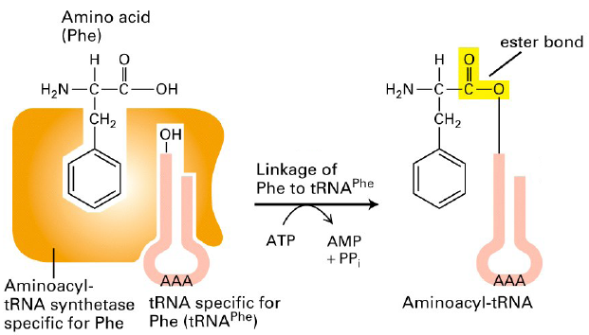
Fig 3. Example of phenylalanine tRNA.
The bond formed between the tRNA and the amino acid is a covalent carboxy-ester bond. There are 20 aminoacyl-tRNA synthetases in the cell—one for each amino acid involved in translation.
- The different stages of translation in prokaryotes 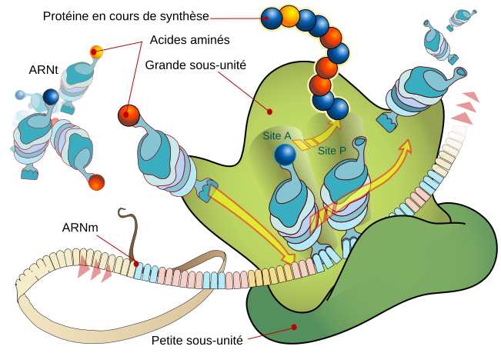
Fig.4 The different stages of translation
III.1. Initiation
All mRNAs have at their 5’ phosphate end, upstream of the initiator codon between positions –8 and –13, a sequence of nucleotides 5’-GGAGG-3’. This sequence is essential for ribosome binding to the mRNA. It is complementary to a short 3’-CCUCC-5’ region found at the 3’ end of the 16S rRNA within the 30S ribosomal subunit.
Near the 5’P end is the initiation codon AUG, which encodes methionine. Thus, every peptide chain begins with methionine during synthesis.
During initiation, the small ribosomal subunit forms a complex with:
- the mRNA at the AUG codon, and
- the tRNA carrying the initial methionine.
Then the large subunit binds. The ribosome is now assembled and functional.

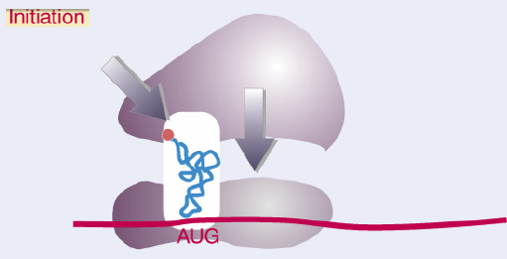
Fig.5 Initiation of translation.
The tRNA that carries the initial methionine has a conformation that allows it to be placed in the P site, rather than the A site.
The methionine attached to the initiator tRNA is N-formylated by methionyl-tRNA transformylase. This enzyme transfers a formyl group onto the amine group of methionine to form fMet-tRNAᵐᵉᵗ. To do this, it must distinguish between the initiator Met-tRNA and the elongator Met-tRNA.
Only the first methionine is formylated; if the others were formylated, the free NH₂ group would be blocked and elongation of the peptide chain would be impossible.

III.2. Elongation
Elongation corresponds to protein synthesis by the addition of amino acids to the C-terminal end of the growing peptide chain. This reaction is catalyzed by the peptidyl-transferase activity of the large ribosomal subunit. A peptide bond forms between the peptidyl-tRNA in the P site and the aminoacyl-tRNA in the A site, releasing a molecule of water. The tRNA is then expelled into the cytoplasm, where it will be recycled, while the peptide bond is formed.

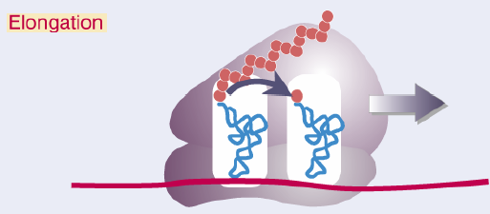
Fig 6. The elongation step.
mRNA is read by the ribosome in the 5’ → 3’ direction; therefore, the ribosome moves three nucleotides (one codon) in this direction.
.
III.3. Termination
Termination occurs at stop codons UAA, UAG, and UGA, which do not encode any amino acid. The ester bond linking the tRNA to the last amino acid of the peptide chain is hydrolyzed by peptidyl-transferase. The ribosome then dissociates into two subunits, which can begin translating another mRNA.
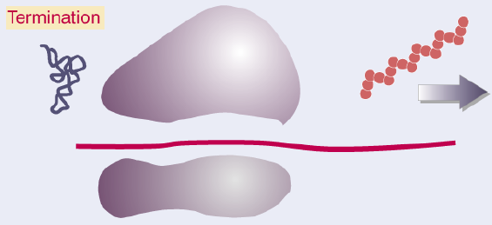
Fig 7. The termination step.
- Specificities of translation in eukaryotes
The ribosome is larger and composed of different rRNAs, although the overall structure and activity are comparable.
The initiation codon is also AUG, and it is generally the first AUG on the mRNA.
In eukaryotes, the first amino acid is methionine, not f-Met as in prokaryotes. Methionine is often removed shortly after the peptide chain is synthesized.

