Curriculum Models
1 Tyler Model (Ralph W. Tyler 1940’s)
objective

Evaluation Learning experiences
It is deductive for its proceeds from the general (examining the needs) to specific (specifying instructional objectives)
1.1 Objectives
Tyler recommended that curriculum planners identify general objectives by gathering data from three sources: student sources, society source, and subject matter source.
a.Student source: curricular planners start their searching for educational objectives by gathering and analysing data relevant to students needs and interests (educational, social, occupational, physical and psychological needs)
b. Society sources: planners develop a classification scheme that divides life into various aspects such as health, family, recreation, vocation, religion, consumption and civic role.
c. Subject matter sources: to specify the objectives, the planners need to identify the discipline of the subject matter.
From the three sources, the planners derive general or broad objectives.
1.2 Learning experiences
They are defined by Tyler as “the interaction between the learners and the external conditions in the environment to which he can react”. They are the methods and learning activities that:
- will develop skill in thinking
- will be helpful in acquiring information
- will be helpful in developing social attitudes
- will be helpful in developing interests.
1.3 Organization of learning experiences
The teacher at this stage needs to determine a logical order of experiences for the students.
1.4 Evaluation
It is done in order to check learners’ achievement of the objectives.

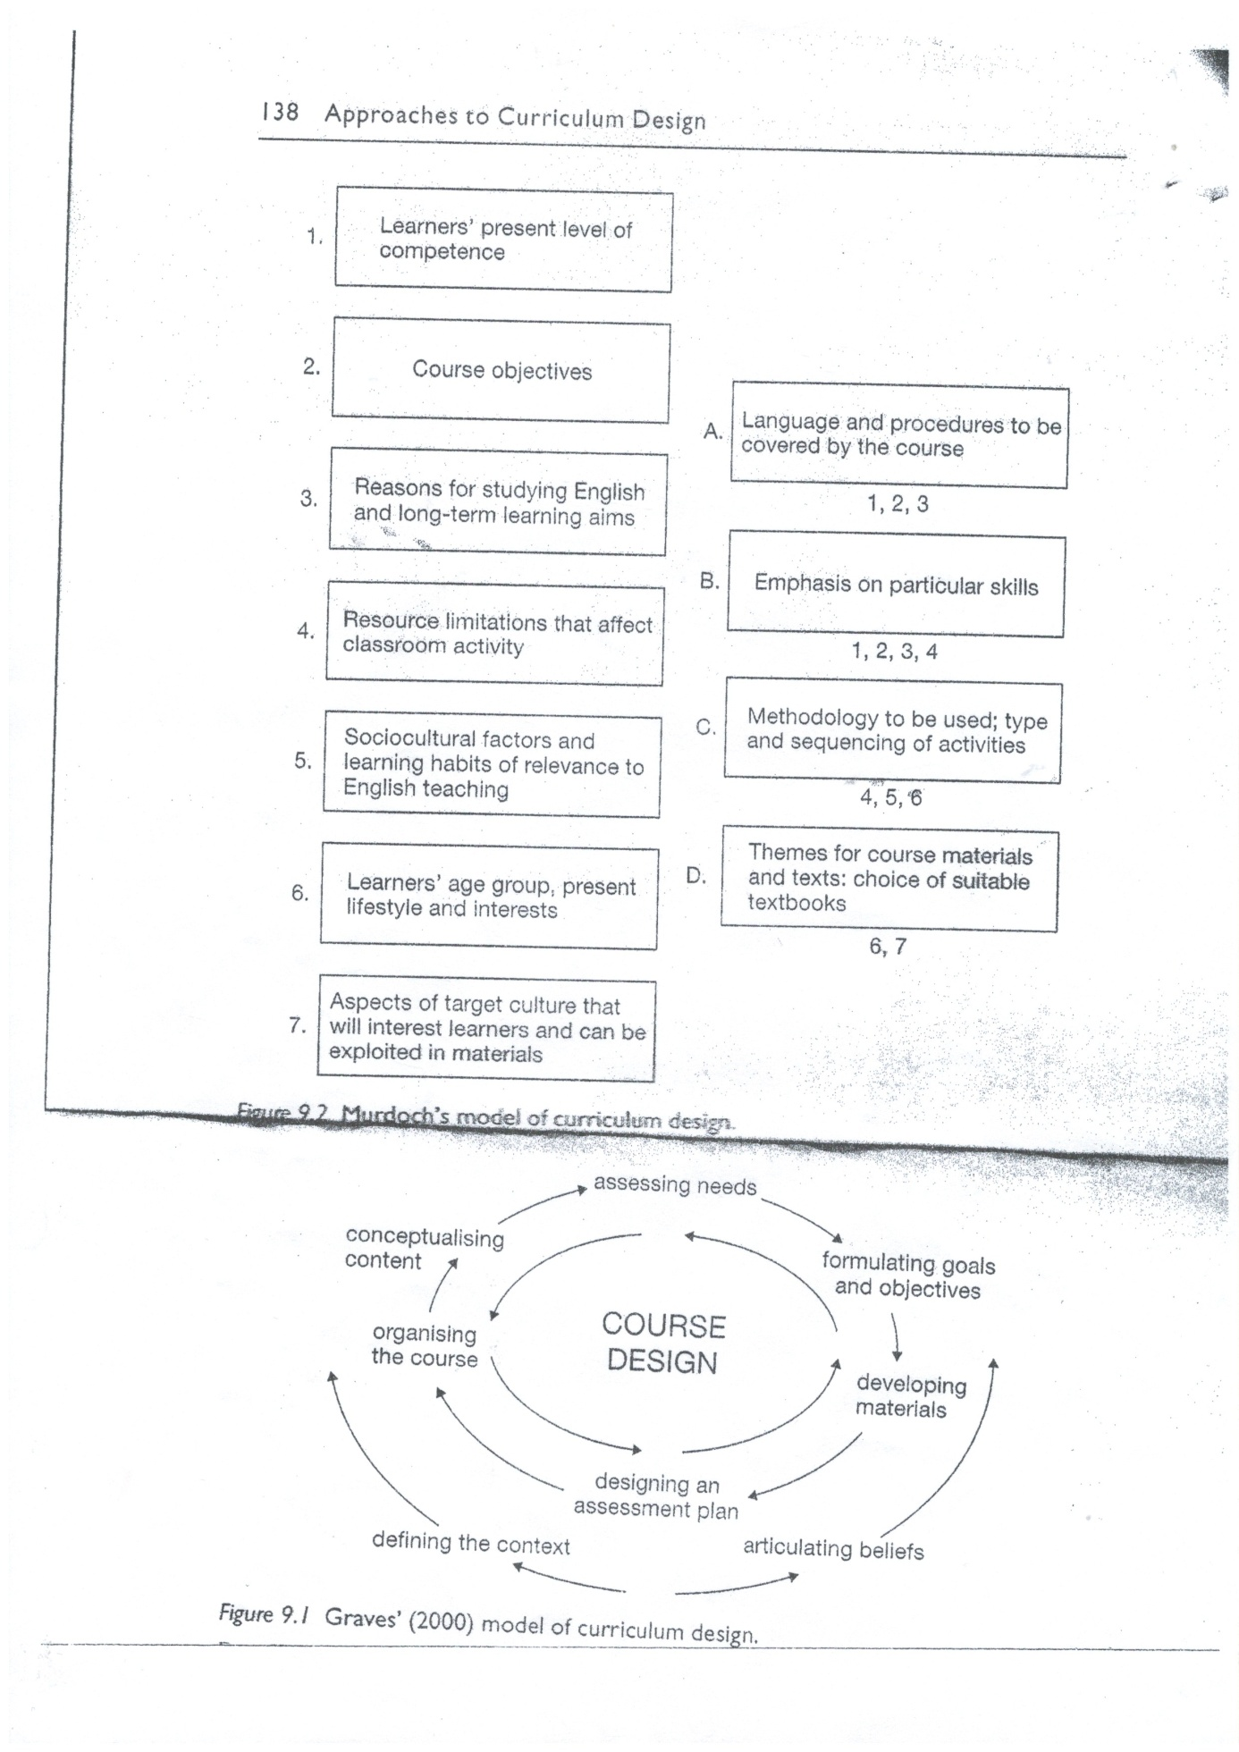

- Doing Curriculum Design
The best approach to curriculum design is viewed as a process like writing where the curriculum design could begin at any of several places – needs analysis, materials writing, selection of principles, goals, etc.
There are two main factors to consider when applying a model of curriculum design: (1) what is the starting point for the curriculum design process, that is, what is already available? (2) how will we move through the process of curriculum design as shown in the curriculum design model?
- Starting Points

Curriculum design begins either with no existing resources or some existing resources. The design of a completely new course may start from nothing except the knowledge of the curriculum designer. Most courses however have something more concrete to start from.
- Curriculum designers and teachers can start from nothing and gather and write the material. The curriculum designer or teacher is thus responsible for all parts of the curriculum design process.
- Curriculum designers and teachers can draw on a bank of existing materials from which they select the most appropriate material for the course. Such a bank could include (1) copies of activities prepared by themselves or other teachers for other courses or for previous deliveries of the course, (2) published supplementary materials such as graded readers, grammar activity books, and conversation texts, speed reading courses and so on, (3) clippings from newspapers or magazines, recordings from the radio or TV, or photocopied material from texts or course books. The curriculum designer or teacher chooses the bits and puts them together to make a course. The curriculum designer or teacher thus takes most responsibility for content and sequencing, and goals.
- Some curriculum statements and some course books deliberately provide only some of the material needed for a complete course. Curriculum statements usually provide the content and sequencing, goals, and assessment parts of the course, and leave it to the teacher to decide on the materials.
- The Process of Curriculum Design
We will look at the ways of going through the process of curriculum design – the waterfall model, the focused opportunistic approach, and the layers of necessity approach.
A “waterfall” model
Most reports of a sequence of carefully planned and produced curriculum design describe a progression from a study of the environment and needs (often they are not distinguished), to a consideration of important principles and the setting of goals, followed by the drawing up of a list of content items, and then the writing of the lessons. Macalister and Sou (2006) draw on a waterfall model in their description of a course’s design. The output of one stage becomes the input of the next.
Murdoch (1989) describes a similar sequence, beginning with an analysis of learners’ present proficiency and necessities, and a study of the learners’ reasons for studying English and long-term learning aims (needs analysis). This results in a description of the content of the course. The limitations of the environment are then studied, particularly the resource limitations that affect classroom activity, sociocultural factors, learning style, the learners’ age
group and interest, and aspects of the target culture that will interest learners (environment analysis). This then allows the curriculum designer to decide on what skills to emphasise (content), what methodology to use (format and presentation) and what themes to exploit in the course materials (ideas content).
Both of these situations provide time and resources for systematic curriculum design, so that designers can do needs analysis, consider the environment and principles, and prepare a syllabus and lessons in advance of the actual teaching.
A focused opportunistic approach
In a focused opportunistic approach, the format and presentation part (materials) of the curriculum design process is typically done first. That is, material is gathered or prepared to teach the course. Then, with each re-teaching of the course, one part of the curriculum design process is done thoroughly. Thus it might be that a proper needs analysis is not carried out until the third or fourth re-teaching of the course. Tessmer and Wedman (1990) warn against this approach, mainly from the point of view of efficiency in that working thoroughly on one aspect of curriculum design may result in wasted effort because the findings may not be able to be used in the other less-elaborated parts of the curriculum design process. The attractiveness of this model is that it allows a concentrated focus with possible high-quality improvements to a course. For example if, during one presentation of a course, assessment was focused on, or there was a careful needs analysis done, then these improvements could be done well.
The major reason for taking this approach is time pressure. The learners have to be taught and there is not time to do a lot of data gathering or planning. Because teaching most immediately involves format and presentation, this is usually done first. That is, the course is taught using whatever material is available or can be made. During the teaching, the teacher may do some kinds of needs analysis to work out if the lessons need some adjustment. Assessment will also need to be developed as the course is taught. After the first teaching of the course, the teacher might consider content and sequencing on the basis of experience and make some changes so that the second delivery of the course is a bit more organised. This do-what-you can- when-you-can approach is typical of most curriculum design carried out by teachers. It is clearly not ideal but is realistic. It can be effective if teachers have the opportunity to teach the same course several times, and if they know something about curriculum design so that they can make sensible decisions on where to focus the improvement of the course.
A “layers of necessity” model
curriculum design is seen initially as a choice between various layers. Each layer is complete in itself and includes the major parts of the curriculum design process – environment analysis, determining needs and goals, deciding on the instructional strategy (format and presentation), developing the materials, and evaluating and revising. But each layer differs in the detail and thoroughness with which each of these parts of curriculum design are carried out. The curriculum designer has to decide what layer of curriculum design will be chosen. This decision will depend on balancing the amount of time and resources available to do the curriculum design and the level of thoroughness needed.
If the time and resources available are very limited for example, the curriculum designer might choose the least detailed layer. This layer would involve all the following steps:
- Decide on the most severe environmental constraint on the course and how it will affect the curriculum design.
- Decide on the most urgent necessity that learners have to meet at the end of the course.
- Make a short list of items to cover.
- Decide on a simple lesson format that will make use of available material.
- Gather the material for the course.
- Decide on a simple form of assessment.
If more time and resources were available then a layer could be chosen which involved a more detailed set of steps
- Deciding on an Approach
We have looked at a range of starting points and different paths through the curriculum design process. Choosing which path to take will depend on the starting point, the time available for course preparation, the availability of needs analysis information, the availability of a usable course book, and the skill of the curriculum designer.

