2.1. Introduction
In the food industry, milk is one of the most precious, valuable foods and a major source of essential nutrients including protein, fat, vitamins, and minerals which are important for human growth. Milk is a precious food which has a very short life about 4–6 hours after milking. The shelf life of milk and milk products can be extended through various methods including cooling, freezing, heating (pasteurization, UHT, sterilization), bactofugation, and microfiltration, and the main objective is to eliminate or inhibit the growth of microorganisms. for milk, thermal processes are applied to eliminate, reduce, and inactivate microorganisms or enzymes and as a result enhance the shelf life of products.
2.2. Definitions (Codex Alimentarius)
- Milk: is the normal mammary secretion of milking animals obtained from one or more milkings without either addition to it or extraction from it, intended for consumption as liquid milk or for further processing.
- A reconstituted milk product: is a product resulting from the addition of water to the dried or concentrated form of the product in the amount necessary to re-establish the appropriate water to solids ratio.
- A recombined milk product: is a product resulting from the combining of milkfat and milk-solids-non-fat in their preserved forms with or without the addition of water to achieve the appropriate milk product composition.
- Milk product: is a product obtained by any processing of milk, which may contain food additives, and other ingredients functionally necessary for the processing.
2.3. Milk composition
- Milk is a complex biological fluid composed of approximately 87% water and 13% total solids, including fat (about 3–4%), proteins (3–3.5%), lactose (around 5%), and minerals (0.7–0.8%).
- The fat exists as globules dispersed in the aqueous phase, forming an oil-in-water emulsion, while proteins are mainly divided into caseins (αs1-, αs2-, β-, and κ-casein), which form micellar structures, and whey proteins (such as β-lactoglobulin and α-lactalbumin), which remain soluble.
- Lactose is the principal carbohydrate and contributes to the osmotic balance of milk, and minerals—particularly calcium and phosphorus—are partly associated with the casein micelles.
- In addition to these major constituents, milk contains minor components such as vitamins, enzymes.
2.4. Pasteurization and UHT Milk Process
- Reception of Raw Milk: Milk is milked at farms by hand or machine milking and may be stored at a chilling center or directly transported to a milk processing unit with the help of sanitized tanks or containers. When milk is received at the processing unit, its temperature should be below 10 °C but ideal 4 °C. a sample of milk is collected from the tank/container for laboratory analysis to check the microbial load and quality of raw milk before accepting it for further processing. If the quality of milk (see Notes 1–5) is good, it will be accepted or otherwise rejected. After a decision is made for accepting the milk, then milk is received for processing.
Quality Analysis of Raw Milk: Titratable Acidity; Determination of Fat% by Gerber Method; Determination of Solid Not Fat (SNF) (total solid).
- Filtration Process: Filtration of milk in the dairy industry is an initial, critical, and fundamental step to remove foreign particles from raw milk. Milk is heated before performing the filtration because preheating increases the efficiency of the filtration process. Preheating is mostly performed at 40 °C and at that temperature the fat is in liquid form and is easily removed. Filtration plays a vital role in ensuring the purity, safety, and quality of final products by removing visible impurities such as debris, dirt, hairs, and other contaminants.
- Cooling and Storage of Milk: After undergoing filtration processing, the temperature of raw milk is more than 4 °C, using extanger; Cooling tanks are a pillar of the dairy industry to maintain the quality of raw milk before processing or converting into final products.
- Cream Separation and Standardization: Cream separator is a mechanical device which is used to separate the cream from whole milk through a centrifugation process. Cream separator is designed for continuous operation of fat separation. Raw milk is passed through a cream separator with the help of a regulator at very high speed to separate lighter part of milk (fat ρ = 0.90) and heavier part (skim milk ρ = 1.037). Cream is light in weight and tends to move toward the center, whereas skim milk is heavier in weight and moves away from the center under the action of centripetal and centrifugal forces, respectively.
- Standardization is the process of adjusting the fat content of milk to a desired level by removing or adding the cream. In the dairy industry, it is very important for legal requirements and consistency of fat in dairy products.
- Degassing (deaeration) step: Removal of air improves process stability.
- Homogenization is the mechanical process of breakdown of fat globules into smaller ones and ensures the uniform distribution throughout the milk at very high temperature.
- Final Heating (Holding Tubes): For pasteurization and UHT milk, the time–temperature combination is 72 °C for 15 s and 142 for 2–4 s, respectively.
- Aseptic Packaging: After cooling (25 °C) UHT milk is transferred into an aseptic balance tank of a packaging machine, followed by packaging of milk aseptically. Aseptic packaging is defined as packaging of product in a pre-sterilized container under a sterile environment and ensuring that there is no post-processing contamination of milk. Milk packages are stored at room temperature and later are distributed to the market or superstore or directly to consumers.
- Unopened UHT milk (room temperature):Typical shelf life: 3 to 9 months; Most commercial products are labeled for 6 months; Storage temperature: preferably below 25 °C.
- Opened UHT milk (refrigerated): 3 to 5 days at ≤4 °C; Keep tightly closed
- Cleaning and Sanitization: Sanitizing means to clean, dry, and disinfect equipment, immediately after processing of products. Disinfection means destruction of microorganisms and cleaning means removal of soil (deposit fat, protein, salt) from the surface. During processing, residual products stick on the surface of the process line and are caused by growth of microorganisms.

2.5. Powdered milk
Powdered milk is the dehydrated product obtained through dehydration of fluid milk (whole, skimmed, or partially skimmed), which contains about 87% water in its initial composition. At the end of the process, only the dry extract and approximately 2.5–4.0% water remain. Thus, dehydration allows the conversion of milk, which is highly perishable, into a product that can be stored for extended periods (approximately 1 year), even at room temperature, without substantial loss of quality . The process, in addition to inhibiting microbial growth and enzymatic activity by reducing water activity (average values of 0.288 ± 0.035), also facilitates the product’s transportation, storage, and handling.
2.5.1. Processing of powdered milk
The processing of powdered milk depends on the type of product to be produced, which can be whole milk powder, partially skimmed, skimmed, instant, or non-instant.
The stages include raw material reception, pasteurization, ingredient mixing, concentration, dehydration, powder separation, and packaging.
- The collection of milk and its transportation to the company is carried out by isothermal trucks under ideal conditions of hygiene and quality. Upon reception, the raw material undergoes various sensory, microbiological, and physicochemical analyses.
- The milk is filtered to remove impurities or foreign material, cooled to temperatures below 4 °C, and stored in isothermal tanks (to hinder thermal exchange with the environment).
- The milk undergoes clarification through a centrifugal clarifier (2000–3000 rpm), an optional step used for the physical removal of impurities such as somatic cells, dead bacteria, blood clots, leukocytes, pus, protein-rich bacterial pellets, and other impurities that cannot be removed by filtration. (Centrifugal Clarifier; Remove heavy solid impurities, not fat.Particles with higher density than milk serum move outward toward the bowl wall).
- Then the fat and/or protein content standardization occurs, with these parameters aligning with the intended milk classification and current legal standards. Fat standardization usually involves total skimming and subsequent incorporation until the desired content is achieved. The protein content can be adjusted by adding milk retentate, milk permeate, or lactose.
Note: Milk clarification and fat standardization can occur simultaneously in a centrifugal separator, using the lower density of fat concerning skimmed milk to cause separation.
- Next, the milk undergoes thermal treatment, with rapid pasteurization being the most commonly used method (72–75 °C for 15–20 s) to ensure microbiological safety and inactivation of undesirable enzymes.
- Homogenization is performed to reduce the size of milk fat globules (0.4–2 μm), improving the stability of the fat emulsion and preventing flocculation (particle aggregation). This process occurs in homogenizers with pressures of up to 30 MPa.
- Following homogenization, optional ingredients (emulsifier, anticaking agents, minerals, vitamins) are added and mixed to ensure nutritional value and product quality. This phase may occur after the milk has been concentrated.
- The milk then undergoes concentration/evaporation to remove water from raw milk partially, reducing energy costs in the subsequent atomization stage of concentrated milk. This is achieved through a vacuum evaporator with temperatures between 40 and 70 °C (see Note 14) or membrane filtration.
- The concentrated milk undergoes dehydration/drying to eliminate the remaining moisture content through energy transfer, allowing water evaporation and obtaining powdered milk (3–4% water) (see Note 16). Spray drying is the most industrially used method (with temperatures medium 180 °C).
Note: To obtain these products on a large scale, among various moisture reduction processes, notable methods include roller or drum drying or just-hatmaker (contact with hot surfaces at 120–140 °C, leading to intense protein denaturation), spray drying, and freeze-drying (a dehydration process employing vacuum, promoting water sublimation while keeping the food at low temperatures of -30 to -80 °C, resulting in an instant final product, but not widely used due to its high energy, operational, and maintenance costs).
- To enhance the reconstitution ability of the powder (instant milk), the product undergoes agglomeration and instantization processes (wettability and dispersibility), either through a direct process or using a fluidized bed dryer, increasing its wetting and dissolution rate.
- Subsequently, the product is packaged in metalized, laminated, or canned packages, ensuring physical protection, mechanical resistance to handling, and impermeability to moisture, oxygen, gases, and light. In some product and packaging types, inert gas is added to prevent fat oxidation , and the product is stored preferably at 30 °C.
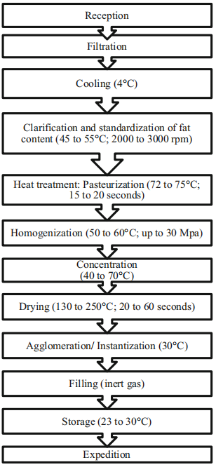

Figure 2.1. General flowchart of powdered milk processing
2.6. Dairy Products
2.6.1. Yogurt
Definition of Yogurt According to Standards
Yogurt is a fermented dairy product obtained by the controlled fermentation of milk using specific lactic acid bacteria, namely Streptococcus thermophilus and Lactobacillus delbrueckii subsp. bulgaricus, which must be present in the final product in viable and abundant form.
According to the Codex Alimentarius (FAO/WHO, 2003; updated 2018), yogurt is defined as:
“A milk product obtained by fermentation of milk with Streptococcus thermophilus and Lactobacillus delbrueckii subsp. bulgaricus, in which these microorganisms shall be viable, active, and abundant in the final product.”

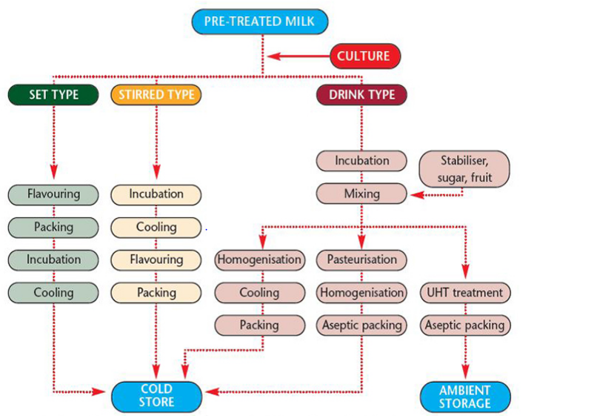

Fiure 2.2. Diagram of yougurt type production
2.6.2. Cheeses
A. Definition of Cheese
Cheese is a dairy product obtained by the coagulation of milk, cream, or a mixture of both, followed by the separation of whey and the transformation of the resulting curd into a solid or semi-solid product, which may be ripened or unripened.
According to the Codex Alimentarius (FAO/WHO, Codex Stan 283-1978, revised), cheese is defined as:
“The ripened or unripened soft, semi-hard, hard, or extra-hard product, which may be coated, and in which the whey protein/casein ratio does not exceed that of milk, obtained by coagulating wholly or partly the following raw materials: milk, skimmed milk, cream, whey cream or buttermilk.”
- Classification of Cheeses: Fresh and Ripened Cheeses
Cheeses can be broadly classified into two main categories based on the presence or absence of a ripening (maturation) phase:

- Fresh Cheeses (Unripened Cheeses): are obtained after coagulation and whey drainage, without undergoing a ripening process. They are consumed shortly after production.
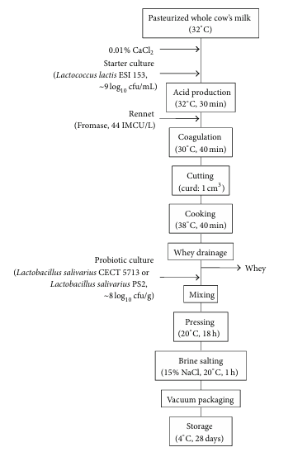
- Ripened Cheeses (Matured Cheeses): undergo a controlled maturation process during which complex biochemical and microbiological changes occur, leading to the development of specific texture, flavor, and aroma.

Figure 2.3. Flowchart of a cheese making process.
2.6.3. Butter
- Is a multiphase water-in-oil-type plastic emulsion consisting of crystalline fat, aqueous dispersed phase, and fat globules (FGs) and must contain >80% milk fat and <16% water;
- Butter can be obtained from pasteurized cream or fermented pasteurized cream with lactic acid bacteria
- submitted to a high-speed churning that will induce a phase inversion from an oil-water emulsion to a water-in-oil emulsion.

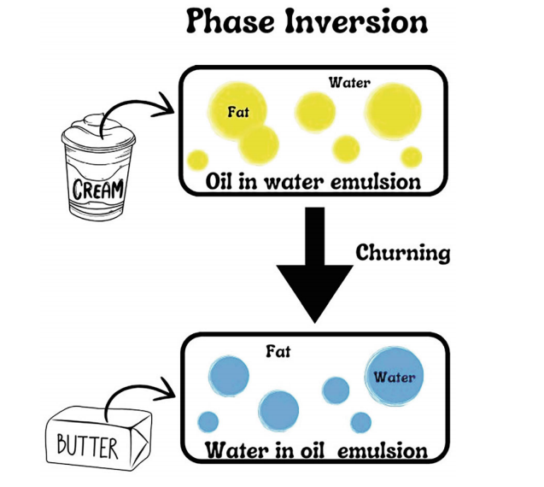

- Butter a high fat content. Due to that, it is susceptible to some undesirable reactions, such as rancidity caused by peroxidation of their lipid fraction and hydrolytic rancidity.
The majority composition of the milk’s fat is of:
- saturated fatty acids around 70%;
- monounsaturated fatty acids around 25%;
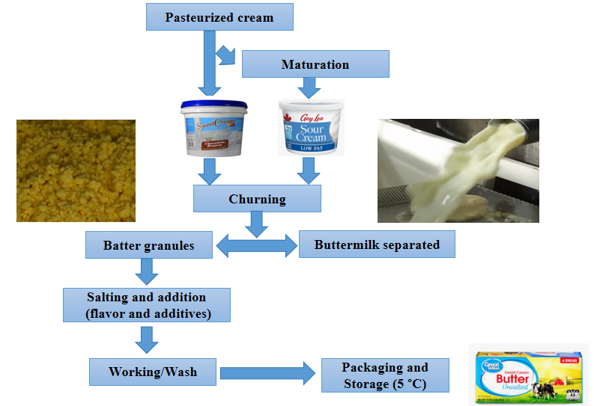
- and finally polyunsaturated fatty acids with an amount of approximately 5%.

Figure 2.4. Diagramt of a butter making process.

