Exercise 1
A simply supported beam at A and B is subjected to a force F applied at its midpoint.
- Calculate the internal force system (cohesion forces) at the cross-section G1​ located near A, and deduce the type of loading in this region.
- Assuming a uniform distribution of shear stress in section G1​, calculate its value.
The weight of the beam is neglected.
Given: F=50 kN
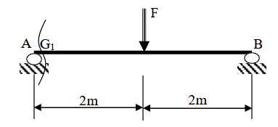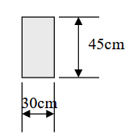

Exercise 2
A punching machine is used to manufacture washers by shearing mild steel sheets.
Calculate the force F required for the cutting (punching) operation.
Given:
- Diameter of the washers: d=20 mm
- Thickness of the sheet: e=2 mm
- Shear strength of the steel: τm=70 MPa
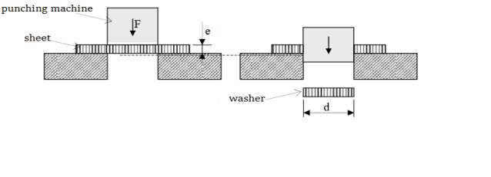

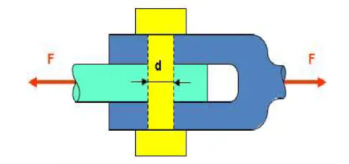
Exercise 3
A pin connected by two joints must withstand a shear force of 15000 kN. It is made of steel (S275, Rg=185 MPa with a shear modulus G=8000 MPa. The safety factor is s=3.
- Calculate the minimum diameter
- Deduce the maximum shear stress
- Calculate the shear strain (angular deformation) γ

