CHAPTER V: TRANSCRIPTION
- GENERAL OVERVIEW
Transcription encompasses all the mechanisms by which RNA is synthesized. Only certain portions of DNA are transcribed; these DNA sequences are called genes.
In bacteria, the produced mRNA is directly accessible to the protein synthesis machinery, and protein synthesis begins even before the mRNA is fully transcribed.
In eukaryotes, the transcription process is confined to the nucleus. Moreover, most RNAs are modified before entering the cytoplasm.
I.1. Basic rules
The synthesis of mRNA from DNA always occurs:
- In the 5′ to 3′ direction
- In an antiparallel manner relative to the DNA strand being copied
- In a complementary manner
I.2. Requirements for transcription
The synthesis of mRNA requires:
- The presence of RNA-specific nucleotides, i.e., containing ribose, bases A, U, G, and C, in the form of triphosphate nucleotides
- The presence of the enzyme RNA polymerase; magnesium ions are essential for its activity. Polymerization occurs in the 5′→3′ direction. RNA polymerases do not have proofreading (3′→5′ exonuclease) activity
- The presence of a DNA template. During transcription, one DNA strand is transcribed while the other is not, and it is not always the same strand

- PROKARYOTIC TRANSCRIPTION
mRNA synthesis consists of three successive phases: initiation, elongation of the polynucleotide chain, and termination.
Transcription is carried out by RNA polymerase, which consists of five subunits: 2 α chains, 1 β chain, 1 β′ chain, and 1 σ (sigma) chain.
II.1. Initiation (Binding of RNA polymerase to promoter sites)
Chez In all bacteria, the initiation of transcription depends on the recognition of specific DNA sequences called promoter sites.
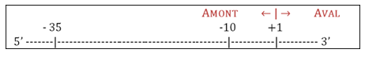
-35TTGCA-30 TATAAT
Fig.28 Promoter site sequences.
Analysis of DNA regions upstream of the transcription start site has defined the promoter sequences:
- -35 region: TTGACA
- -10 region (Pribnow box): TATAAT
The σ subunit associates transiently with the other subunits and binds to the promoter site. The -10 and -35 sequences are recognized by the sigma subunit, leading to local opening of the DNA double helix.
Additional contacts form between RNA polymerase and DNA, allowing transcription to begin. The sigma subunit then dissociates once a short RNA chain has been synthesized and can be reused.
Thus, the σ subunit enables specific recognition of promoter sites and reduces enzyme affinity for non-promoter regions. It acts cyclically during transcription initiation.
II.2. Elongation
The opening of the DNA helix allows the addition of nucleotides complementary to the 3′→5′ template strand. The first nucleotide incorporated is usually ATP or GTP. The phosphodiester bond formation is catalyzed by the β subunit, which is the catalytic subunit of RNA polymerase.
II.3. Termination
Termination is ensured by specific sequences called terminators, which form GC-rich hairpin loops that are difficult to unwind. These structures destabilize the interaction between RNA polymerase and the DNA template.
II.4. RNA modifications after transcription
These differ depending on the RNA type:
- mRNA: no modification
- tRNA: undergoes maturation, including cleavage from precursors, addition of CCA at the 3′ end, and base modifications
- rRNA: transcribed as long precursors that are later cleaved into functional rRNAs.

- EUKARYOTIC TRANSCRIPTION
Three major differences distinguish eukaryotic from prokaryotic transcription:
- In eukaryotes, DNA is located in the nucleus, where transcription occurs, while translation occurs in the cytoplasm. In bacteria, transcription and translation are coupled.
- Transcription of rRNA, tRNA, or mRNA initially produces a precursor molecule that undergoes several modifications before becoming functional.
- Eukaryotes have three distinct RNA polymerases:
- RNA polymerase I: synthesizes rRNA (5.8S, 18S, 28S)
- RNA polymerase II: synthesizes mRNA and small nuclear RNAs
- RNA polymerase III: synthesizes tRNA, 5S rRNA, and small RNAs

- TRANSCRIPTION BY RNA POLYMERASE II
IV.1. Formation of a primary transcript (pre-mRNA)
The primary transcript contains both exons (coding sequences) and introns (non-coding intervening sequences).
Important upstream regulatory regions include:
- TATA box: located around -25 bp, sequence 5′-TATAAA-3′
- GC box: located between -110 and -40, sequence 5′-GGGCGG-3′
- CCAAT box: located between -120 and -80
IV.2. Modifications of the primary transcript
- 5′ capping
The first nucleotide of the primary transcript begins with a triphosphte group; the corresponding base is a purine base (A or G).
The 5′ end is modified by the addition of 7-methylguanosine derived from GTP via guanylyltransferase.
Additionally, methylation occurs at the 2′-OH groups of the first two nucleotides.
This modification occurs after about 30 nucleotides have been synthesized.

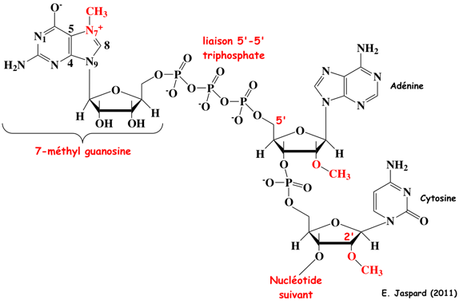
Fig.29 Addition of the cap to the 5’ end of the RNA chain
The cap plays several roles, including facilitating interaction with ribosomes (the small subunit). RNAs lacking this cap (rRNA an tRNA) are not translated.

- 3′ polyadenylation
The 3′ end is modified by the addition of 100–200 adenine residues (poly-A tail) by poly(A) polymerase. This tail contributes to mRNA stability and export from the nucleus to the cytoplasm.
- Maturation of the primary transcript (splicing)
Splicing is a key step in mRNA maturation. After capping and polyadenylation, introns (non-coding sequences) are removed and exons (coding sequences) are joined together.
This process relies on:
- A donor splice site (GU) at the 5′ end of introns
- An acceptor splice site (CAG) at the 3′ end

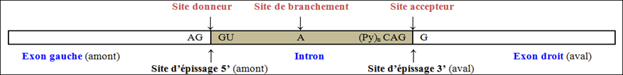
Fig.30 Excision of introns
Steps include:
- Recognition of the donor site and cleavage of the phosphodiester bond between the first exon and the intron.
- Recognition of the acceptor site and cleavage of the phosphodoester bond at the 3’ end of the intron.
- Formation of a phosphodiester bond between the 3’-OH group of the first exon and the 5’-phosphate end of the second exon
- The intron is released and degraded.

