clc; clear; close all;
% ==========================================
% TP: Ethanol production by fermentation
% ========================================
% -----------------------------
% Parameters
% -----------------------------
mu_max = 0.5; % maximum specific growth rate (h^-1)
Ks = 1.0; % Monod constant (g/L)
Yxs = 0.2; % biomass yield coefficient Yx/s (gX/gS)
Ypx = 0.45; % ethanol yield coefficient Yp/x (gP/gX)
% -----------------------------
% Initial conditions
% -----------------------------
X0 = 1; % biomass (g/L)
S0 = 100; % substrate (g/L)
P0 = 0; % ethanol (g/L)
y0 = [X0 S0 P0];

% -----------------------------
% Time span
% -----------------------------
tspan = [0 40];
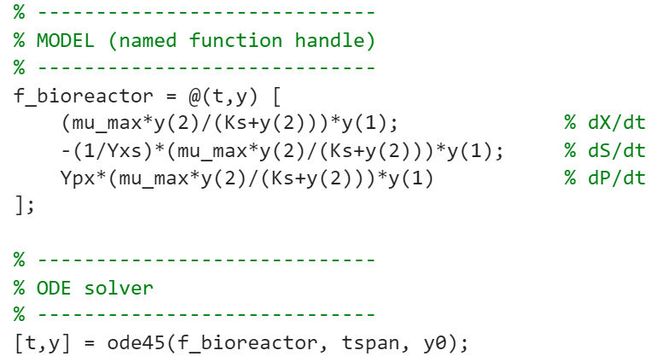

% -----------------------------
% Extract variables
% -----------------------------
X = y(:,1);
S = y(:,2);
P = y(:,3);

% -----------------------------
% Plot results
% -----------------------------
figure;
plot(t,X,'LineWidth',2); hold on;
plot(t,S,'LineWidth',2);
plot(t,P,'LineWidth',2);
grid on;
xlabel('Time (h)');
ylabel('Concentration (g/L)');
legend('Biomass X','Substrate S','Ethanol P');
title('Batch fermentation');

