Chapter 5: Monoclonal and Recombinant Antibodies
1. Definition of Immunoglobulins
Immunoglobulins (Ig) are glycoproteins that carry antibody activity (Ab). They are capable of binding specifically, through the paratope, to a single antigenic determinant known as an epitope. They are the soluble effectors of antigen-specific humoral immunity.
2. Structure of Immunoglobulins
Heavy and Light Chains
Antibodies (Abs) are glycoproteins belonging to the immunoglobulin superfamily and are composed of four polypeptide chains: two heavy chains (CH) (H for heavy) and two light chains (CL) (L for light). These chains are linked together by a variable number of disulfide bonds, which provide flexibility to the molecule.
Hinge Region
This is the region where the arms of the Y-shaped antibody structure are located. It is called the “hinge” region because it allows the molecule to have a certain degree of flexibility.
Constant Domains
Constant domains are characterized by an amino acid sequence that is very similar from one antibody to another and is characteristic of the species and the isotype. Each light chain contains one constant domain, noted CL. The heavy chains contain, depending on the isotype, three or four constant domains: CH1, CH2, CH3, and CH4 (Figure 1). The constant domains are not involved in antigen (Ag) recognition but play a role in the activation of the complement system.
Variable Domains
An antibody has four variable domains located at the ends of the two “arms” of the immunoglobulin. The association between a variable domain carried by a heavy chain (VH) and the adjacent variable domain carried by a light chain (VL) forms the antigen recognition site (or paratope). Thus, an immunoglobulin molecule has two antigen-binding sites, one at the end of each arm. These two sites are identical, allowing one antibody to bind two antigen molecules.
Fab Fragment
These fragments are called Fab because they contain the antigen-binding sites of the antibody. Each Fab fragment is monovalent. The antibody-binding site is formed by the association of the VH and VL domains. Different combinations of VH and VL domains lead to antibodies that can bind to different antigenic determinants.
Fc Fragment
The effector functions of immunoglobulins are mainly carried by this part of the molecule. Different functions are associated with different domains of the Fc fragment. Normally, an antibody can exert its function only after it has first bound to the antigen.
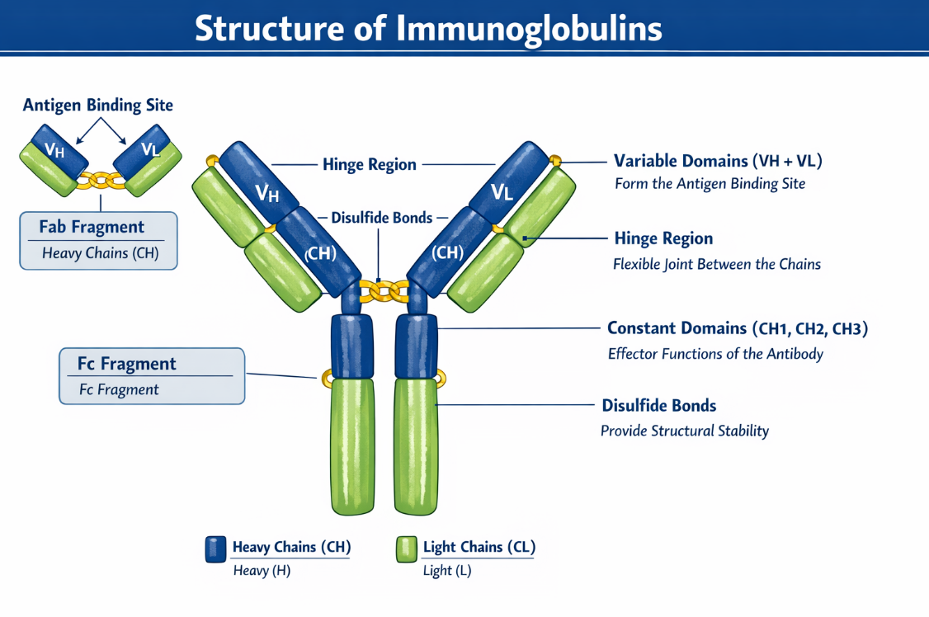
3. Classes and Subclasses of Immunoglobulins
The isotype of an antibody is determined by the constant regions of the heavy chains. Humans, like all mammals, possess five antibody isotypes: IgM, IgD, IgG, IgE, and IgA. The constant domain of the heavy chain is referred to respectively as Cμ, Cδ, Cγ, Cε, and Cα.
There are four subclasses of IgG designated IgG1, IgG2, IgG3, and IgG4, and two subclasses of IgA (IgA1 and IgA2). These subclasses are defined by the constant domains of the heavy chains Cγ1, Cγ2, Cγ3, Cγ4, Cα1, and Cα2, respectively. The other isotypes (IgM, IgD, and IgE) do not have subclasses.
Each heavy chain is associated with either a kappa (κ) or lambda (λ) light chain. IgG, IgD, and IgE are typically monomeric forms, whereas IgA and IgM may exist either as monomeric or multimeric forms (Figure 3).
There are circulating forms of immunoglobulins (IgG, IgA, IgM, and IgE), as well as membrane-bound forms, particularly IgM and IgD.
4. Definition of Monoclonal Antibodies
Monoclonal antibodies (mAbs) are recognized as an identical population of antibodies derived from a single clone of B cells. They recognize only one type of epitope on a given antigen and always exhibit the same characteristics, particularly the same specificity.
In contrast, recombinant antibodies are antibodies produced from recombinant genes, usually inserted into host cells such as mammalian or bacterial cells.
5. Definition of Polyclonal Antibodies
Polyclonal antibodies are a heterogeneous mixture of antibodies produced by different cells. The sensitivity and specificity of these antibodies therefore vary widely. They are heterogeneous and possess broad specificity. They may also show many undesirable cross-reactions.
6. Differences between Monoclonal Antibodies and Polyclonal Antibodies
Polyclonal antibodies (pAbs) are capable of recognizing several different epitopes of the same antigen. They offer lower specificity compared to monoclonal antibodies because they consist of a complex mixture of immunoglobulins targeting all epitopes of the antigen, whereas monoclonal antibodies target a single epitope.
Polyclonal antibodies have a wide range of selectivities and affinities, which may lead to cross-reactivity or interference in an immunological assay. Therefore, they are generally less stable than monoclonal antibodies.
7. Different Generations of Monoclonal Antibodies and Their Production

7.1 Production of Monoclonal Antibodies by the Hybridoma Technique (Murine Antibodies)
Monoclonal antibodies (mAbs) were discovered by Köhler and Milstein in 1975 following the development of the cell hybridization technique. This technology was mainly developed using mouse cells, largely due to the availability of murine myeloma cell lines.
The general principle of hybridoma production is based on the fusion of B lymphocytes, which secrete antibodies but do not multiply in vitro, with myeloma lymphoid cells, which have the capacity to multiply rapidly and indefinitely in vitro in an appropriate culture medium (Fig. 2).
The hybridoma technique is carried out in five steps:
- Immunization of the animal and obtaining B lymphocytes
- Fusion of plasma cells with lymphoid myeloma cells
- Selection of hybrid cells
- Screening and cloning of hybridomas of interest
- Large-scale production of monoclonal antibodies

a) Immunization and Choice ofthe Animal
Immunization is mainly performed in mice because their genome has approximately 95% homology with the human genome. Mice allow the production of both compatible myeloma cells and B lymphocytes required for the fusion step. In addition, mice have a short lifespan and reproduce easily.
The most commonly used strain is BALB/c, an inbred albino strain that facilitates a strong immune response to antigenic stimulation.
The principle of production relies on injecting an antigen of interest into a rodent, which then develops an immune response against this antigen. As a result, B lymphocytes producing specific immunoglobulins directed against the injected antigen are generated. These B lymphocytes are recovered from the spleen after splenectomy of the animal.

b) Fusion of the Two Cell Types
All subsequent steps must be carried out under sterile conditions to prevent bacterial and fungal contamination.
The aim of this step is to fuse a mouse cell producing a monoclonal antibody with an “immortal” cell line capable of dividing indefinitely.
Lymphoid cells from the spleen or lymph nodes of the animal are isolated. They are then fused, in the presence of polyethylene glycol (PEG), with myeloma cells previously cultured and selected in vitro for their deficiency in hypoxanthine-guanine phosphoribosyltransferase (HGPRT−) or, more rarely, thymidine kinase (TK).

c) Selection of Hybrid Cells (Formation of Hybridomas)
The resulting cells, called hybridomas, express the characteristics of both parental cell lines. However, not all cells fuse, leading to a complex mixture containing:
- unfused myeloma cells
- unfused plasma cells
- fused cells
Among the fused cells, three combinations may occur:
- fusion of two plasma cells
- fusion of two myeloma cells
- the desired plasma cell–myeloma fusion
The mixture of all these cells is placed in a selective culture medium called HAT medium (Hypoxanthine, Aminopterin, and Thymidine).
The principle of this selection is based on:
- the HGPRT mutation, and
- the ability of aminopterin to block endogenous synthesis of purine and pyrimidine bases.
Myeloma cells lacking the enzyme HGPRT cannot use exogenous hypoxanthine to synthesize purines and therefore die. In contrast, hybridomas receive the functional enzyme from the sensitized B lymphocytes, allowing them to use hypoxanthine and thymidine through the salvage pathway to synthesize DNA and RNA necessary for cell proliferation.
Unfused B lymphocytes, which have a relatively short lifespan, also die rapidly.

d) Screening andCloning of Antibody-Producing Cells
Among the fused cells, only a few secrete antibodies. These hybridomas must be isolated and multiplied by cloning.
After testing each clone to determine the antibodies produced, positive cultures are selected and subjected to additional cloning. The final result is a hybridoma producing a single type of monoclonal antibody.

e) Large-Scal Production of Monoclonal Antibodies
The production of monoclonal antibodies is then performed either:
- in vitro, using a bioreactor, or
- in vivo, in mice.
The antibodies can then be purified by chromatography from ascitic fluid.
To meet the increasing demand for monoclonal antibodies, in vitro techniques allowing the growth of hybridoma cells at very high densities have been developed.
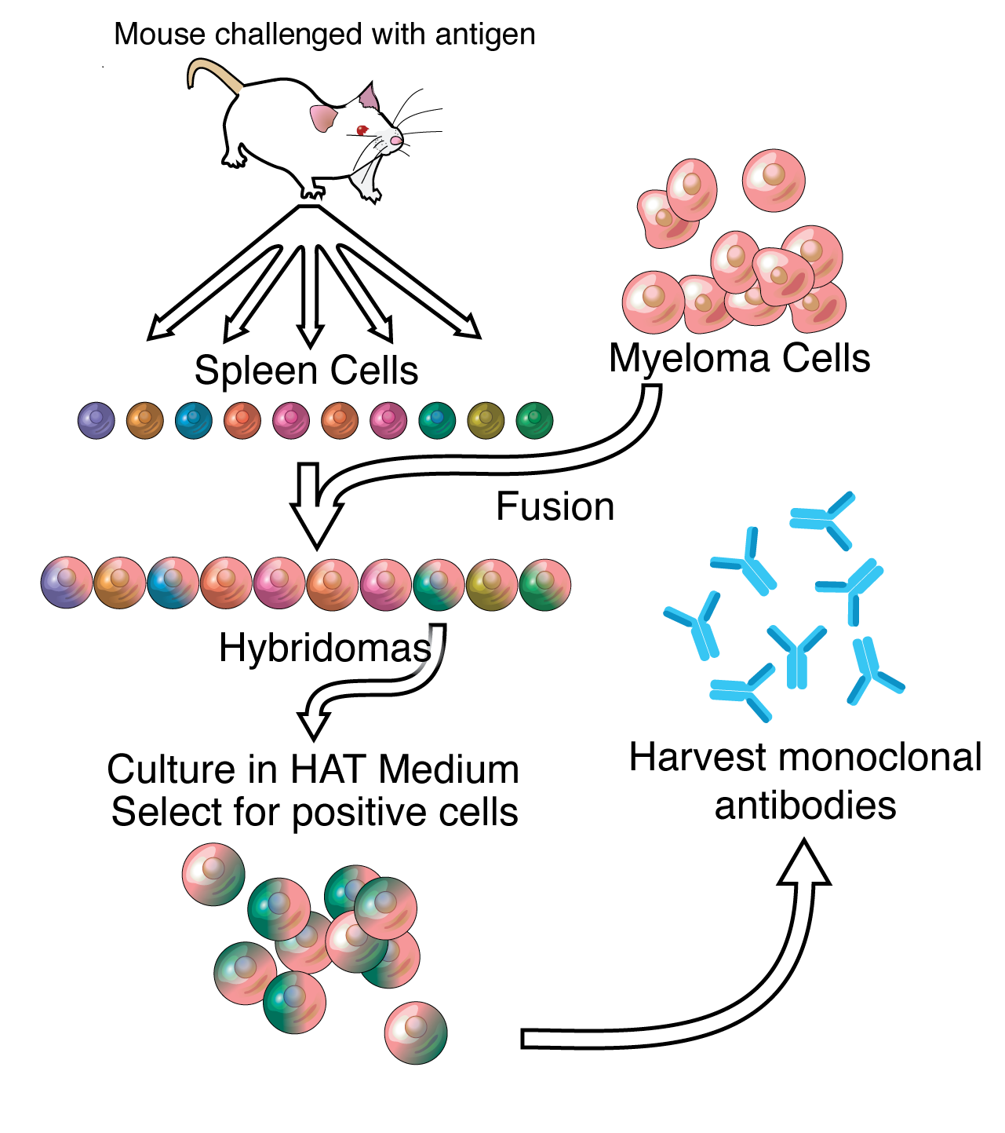
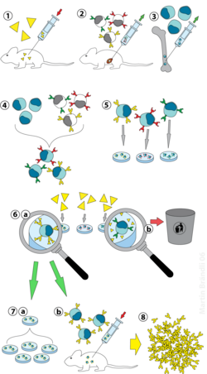
8- Recombinant Monoclonal Antibodies
The first monoclonal antibodies produced by murine hybridomas (first generation) proved to be remarkable tools for research, yet disappointing for therapeutic immuno-intervention due to a short half-life and high immunogenicity.
The use of monoclonal antibodies (mAbs) in human therapy requires a reduction in their immunogenicity. Consequently, humanization techniques were developed to obtain antibodies capable of recognizing a specific antigen in humans without triggering immunogenic reactions caused by the presence of murine structures.
Thanks to advancements in technology and genetic engineering, recombinant mAbs were born. Their evolution progressed as follows:
- 1984: Chimeric mAbs, consisting of human constant domains associated with murine variable domains.
- 1989: Humanized mAbs, where only the antigen-recognizing part (the CDR) is murine.
- 1994: Fully human mAbs.

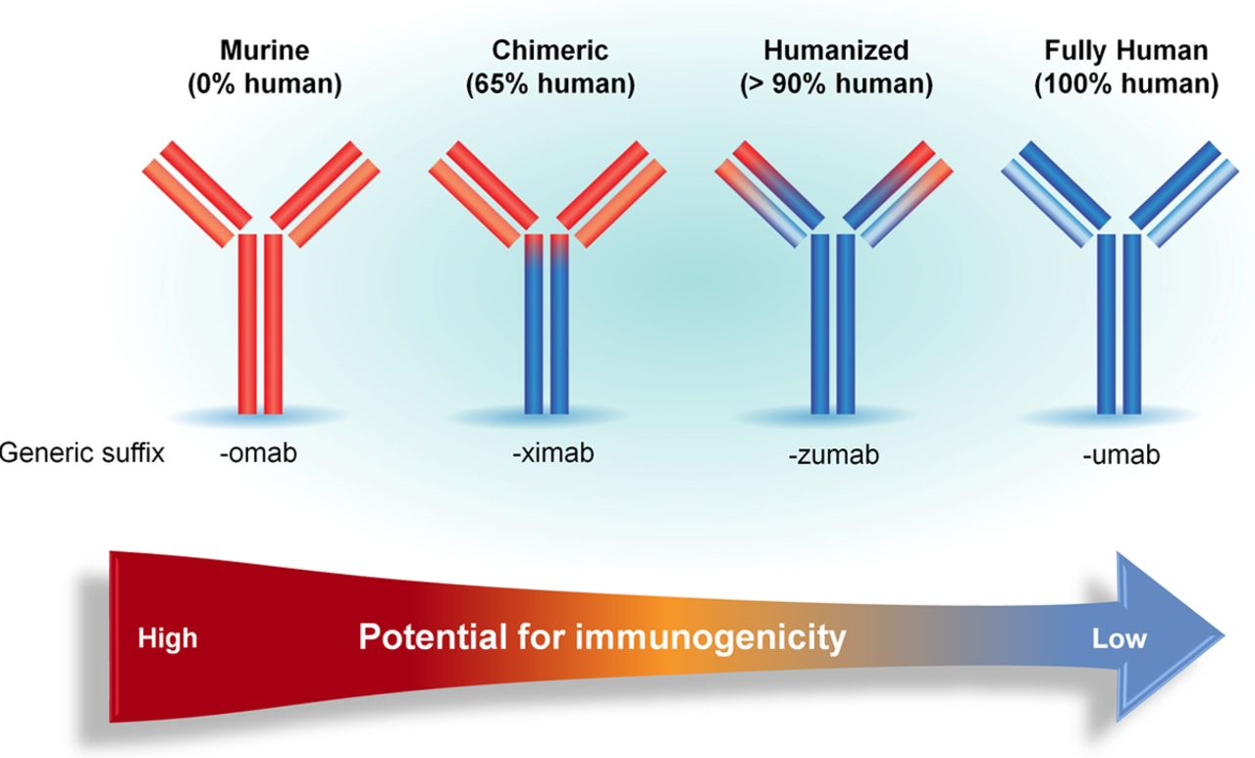

1. Chimeric Recombinant Antibodies
The first attempts to humanize murine antibodies led to the construction of chimeric antibodies, in which the constant regions of the murine immunoglobulin heavy and light chains are replaced by human constant regions.
Chimeric antibodies are formed by combining the variable domains of a murine monoclonal antibody with the constant domains of a human antibody. These antibodies are approximately 70% human, which makes them considerably less immunogenic in humans and allows them to interact with effector cells and induce the complement cascade via their human Fc region.
The construction of chimeric antibodies involves isolating the DNA encoding the VH and VL domains of a murine mAb and linking it to the DNA encoding the human H and L constant domains. This produces a hybrid antibody with a human constant part. In most cases, the specificity and affinity of chimeric antibodies remain identical to those of the parental murine antibodies. However, slight modifications in fine specificity have occasionally been observed, suggesting an influence of the constant regions on the topology of the variable domains.

2. Humanized Recombinant Antibodies
Humanized antibodies are technologically more difficult to obtain than chimeric antibodies. The general principle of humanization, as proposed by Greg Winter in the late 1980s, consists of grafting the hypervariable regions (Complementarity Determining Regions, CDR) of an antibody of interest (often murine) onto the framework regions (FR) of a human antibody.
In humanized antibodies, all amino acid sequences derived from the mouse are replaced by human sequences, with the exception of the CDRs, which are responsible for forming the antigen-binding site.

3. Fully Human Recombinant Antibodies
Recent technological leaps have made it possible to obtain fully human recombinant antibodies (Avril, 2013). Today, a large portion of antibodies entering clinical phases are completely human, and nine human therapeutic antibodies are currently on the market (with 7 new approvals since 2009).
In theory, these antibodies are "transparent" to the patient's immune system and avoid the hypersensitivity reactions observed with antibodies that still contain murine fragments. Several methodologies have been developed to generate such totally human antibodies.

9. Pharmacokinetic Properties of Monoclonal Antibodies
mAbs are high molecular weight proteins (150 kDa) characterized by their hydrophilicity. Their pharmacokinetics (the relationship between dose and concentration) differ significantly from classical drugs, which are generally small, chemically synthesized molecules. Their journey in the body is described through phases of absorption, distribution, and elimination.

9.1 Absorption
Absorption depends on the route of administration (subcutaneous, intravenous, or intramuscular). While the majority of mAbs are administered via IV, allowing for rapid and complete exposure, other routes involve passage through the lymphatic or blood systems. Absorption via non-IV routes remains slow and difficult to quantify precisely.

9.2 Distribution
This corresponds mainly to the tissue targeting of the molecule. Studies show that distribution depends directly on physiology and tissue vascularization. In cancer treatment, therapeutic targeting is challenging because mAbs diffuse poorly and heterogeneously within tumors. The gold standard for studying this is Tissue Cross-Reactivity (TCR) studies, which analyze mAb binding across various human and animal tissues.

9.3 Elimination
Data on mAb elimination is limited, but they generally have a long terminal half-life (8–28 days). Since they are analogues of endogenous IgG, they are catabolized via three main mechanisms:

9.3.1 Pinocytosis
As they pass into interstitial fluid, mAbs (like all proteins) are taken up by vascular endothelial cells through pinocytosis ("cell drinking"). They migrate into endosomes, are degraded in lysosomes, and then released. This is a non-specific and non-saturable catabolic pathway for all circulating proteins.

9.3.2 Target-Mediated Elimination
mAbs are eliminated after binding to their target:
- Internalization: If the receptor is cellular, the immune complex is internalized and degraded.
- Immune Complex Formation: If the target is circulating, the complex is eliminated by the immune system. This is a specific and saturable pathway, as it depends on the type and number of antigens.

9.3.3 FcRn Receptor-Dependent Elimination
The FcRn (neonatal Fc receptor) is a saturable receptor located in endothelial, intestinal, and renal cells. It facilitates the trans-cellular passage and recycling of IgG. The FcRn binds the mAb via its Fc portion, diverting it from the lysosomal degradation pathway and redirecting it back to the cell surface. This mechanism explains the long half-life of mAbs, as they are protected and released back into the bloodstream.

10. Applications and Mechanisms of Action of Monoclonal Antibodies
For a long time, mAbs were primarily applied in fundamental immunology for studying cell lines, non-lymphocytic cell markers, pathological cells, and proteomics. Currently, they are used therapeutically across several fields: hemato-oncology, immunodeficiency, autoimmune diseases, oncology, infectious diseases, graft rejection, and enzyme therapy.
Depending on the target and the disease, therapeutic antibodies can act through different pathways. There are three main modes of action: blocking, signaling, and targeting.

1. Blocking (Direct Pathway)
In this direct mode of action, mAbs can mimic or block the natural ligand of a receptor, such as growth factors, cytokines, or other soluble mediators.
- Example: Trastuzumab, which binds to the HER-2 receptor, preventing the binding of the growth factor EGF, thereby inhibiting cell proliferation.

2. Signaling (Indirect Pathway)
This is an indirect pathway that recruits other effectors and utilizes the antigenic plurivalency of the mAb. The antibody facilitates the clustering of recognized antigenic markers on the target cell membrane. This clustering triggers intracellular phosphorylation cascades, ultimately inducing apoptosis (programmed cell death) of the target cell.

3. Targeting (Direct Pathway)
This pathway is primarily activated in cases of microbial invasion or malignant cells. The mAb recognizes the pathogen or target cell and induces its elimination through three main mechanisms:
- CDC (Complement-Dependent Cytotoxicity): The antibody triggers the complement cascade, leading to the formation of a membrane attack complex that lyses the cell.
- ADCC (Antibody-Dependent Cellular Cytotoxicity): Effector cells (like Natural Killer cells) recognize the bound antibody via their Fc receptors and release cytotoxic granules to kill the target cell.
- Phagocytosis: The antibody "flags" the target (opsonization), allowing macrophages to engulf and destroy it.

