TP3 of Molecular biology
Agarose gel electrophoresis
(Separation and analysis of nucleic acids)

Objective of the practical work
Separation and identification of DNA fragments and determination of their size.
Principle
Agarose gel electrophoresis is a technique commonly used in biochemistry laboratories:
- To separate and identify nucleic acid fragments (DNA or RNA), determine their size, and estimate their quantity.
- To purify a DNA fragment of known size.
DNA is a negatively charged molecule (due to its phosphate groups). Therefore, under the effect of an electric field, it migrates toward the positive pole. Since migration occurs through an agarose or polyacrylamide gel, larger molecules are slowed down more than smaller ones by the electrophoretic medium. Consequently, DNA fragments are separated according to their molecular size.
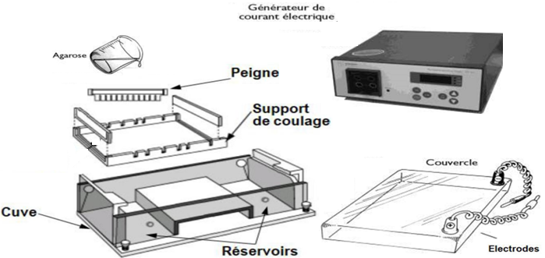
Materials and reagents

- Balance
- Watch glass
- Spatula
- Erlenmeyer flask
- Microwave or water bath
- Micropipette
- Test tubes
- Gel tray and comb
- Electrophoresis tank
- Agarose
- Ethidium bromide (EtBr) or Cyber Green or Midori Green
- Buffer (Tris-Borate-EDTA TBE or Tris-Acetate-EDTA TAE)
- Bromophenol blue or xylene cyanol
- Glycerol

Procedure

- Preparation of the agarose gel
- Weigh 1 g of agarose powder and dissolve it in 100 mL of migration buffer (the agarose concentration depends on the size of the DNA molecules to be separated). The migration buffer is either Tris-Borate-EDTA (TBE) or Tris-Acetate-EDTA (TAE).
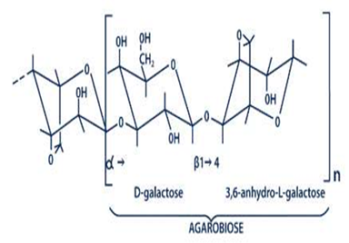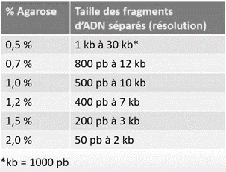
- Heat the solution to boiling to completely dissolve the agarose.
- Allow the solution to cool to approximately 60 °C.
- Add a few microliters of Ethidium Bromide (EtBr), which is a DNA intercalating agent capable of binding to DNA and emitting fluorescence under ultraviolet (UV) light.
- Pour the agarose solution into a gel casting tray, where it solidifies upon cooling.
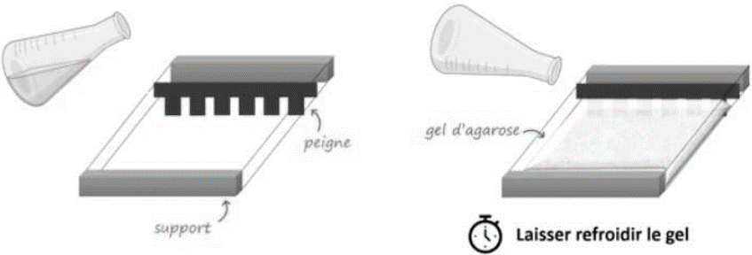
- Place the gel in the electrophoresis tank and cover it with migration buffer.
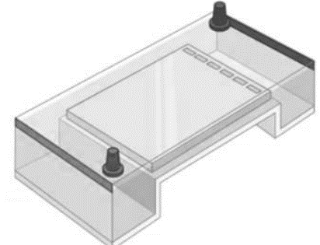
- Preparation of samples to be analyzed
Samples may be fragmented using restriction enzymes and then mixed with a loading buffer containing:
- A tracking dye (bromophenol blue or xylene cyanol) that allows monitoring of the migration of samples in the gel.
- Glycerol, which increases the viscosity of the sample.
- Electrophoretic Migration
- Using a micropipette, carefully load the sample into the wells of the gel while keeping the pipette vertical.
- Calibrate the gel using a DNA size marker.
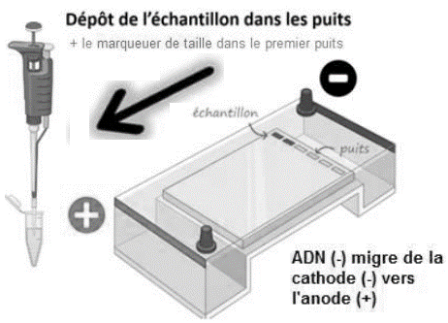
- After completing the preparation of the electrophoresis plate, close the tank and apply the electric field.
- Allow migration until the loading dye reaches near the edge of the gel (5 to 10 V per cm of gel).
- Visualization and Analysis
DNA molecules are not visible to the naked eye. The bands corresponding to DNA fragments are visualized either under UV light or through fluorescence emission.

