CHAPTER IV. RIBONUCLEIC ACIDS (RNA)
- Characteristics
RNA molecules are characterized by:
- The sugar: ribose
- The bases: A, C, G, and U (uracil replaces thymine)
- A single nucleotidic strand, shorter than DNA strands
- Base-pairing Rules
Base pairing occurs:
- Between two RNA molecules (mRNA and tRNA)
- Within the same RNA molecule, forming a hairpin loop
A pairs with U (two hydrogen bonds)
C pairs with G (three hydrogen bonds)

- Types of RNA
Cells contain four main types:
- Ribosomal RNA (rRNA): 82%
- Transfer RNA (tRNA): 16%
- Messenger RNA (mRNA): 2%
- Small nuclear RNA (snRNA) and small cytoplasmic RNA (scRNA): <1%

- Ribosomal RNAs
Ribosomes are intracellular organelles in the cytoplasm and mitochondria responsible for protein synthesis.
- Prokaryotic rRNA (E. coli)
Prokaryotic ribosomes are 70S (S for Svedberg: a unit measuring sedimentation rate, which depends on mass, shape, and rigidity. This explains why the assembly of the 50S and 30S subunits results in a 70S ribosome) and have two subunits:
- A large subunit (50S)
- A small subunit (30S)
Each subunit contains proteins known as ribosomal proteins (r-proteins) and rRNAs (Fig. 1):
- The 50S subunit: contains two rRNAs, 5S (120 nucleotides) and 23S (2900 nucleotides), along with 31 proteins.
- The 30S subunit: contains a single rRNA, 16S (1500 nucleotides), along with 21 proteins.
- Eukaryotic rRNAs
In eukaryotes, ribosomes are larger (80S) and also have a two-subunit structure:
- The 60S subunit: contains three different rRNAs—28S (4800 nucleotides), 5.8S (160 nucleotides), 5S (120 nucleotides)—and 50 proteins.
- The 40S subunit: contains a single rRNA, 18S (1900 nucleotides), along with 33 proteins.

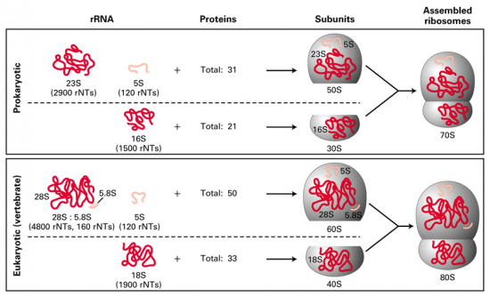
Fig.1. Eucaryotic and procaryotic ribosomes
- Role of rRNA
They play an essential role in the structure and maintenance of ribosomal integrity in association with ribosomal proteins. They also facilitate the binding of other RNAs to the ribosome (mRNA and tRNA during translation).
- Transfer RNAs
tRNAs transport amino acids to the ribosome for protein synthesis.
- Structure of tRNA
They share the general structure of RNAs but also exhibit some specific features:
- Unusual bases:
They contain unusual nucleotides due to the bases they include, such as hypoxanthine and thymine.
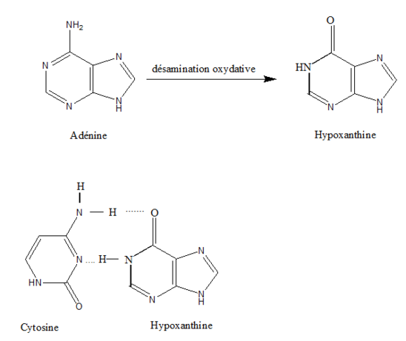
Fig. 2. Example of an unusual base
These bases are not incorporated as such during tRNA synthesis; they are formed later through modification of the four bases A, U, G, and C.
- Spatial structure of tRNAs (cloverleaf shape):
tRNA chains consist of approximately one hundred nucleotides. There are pairing regions following the complementarity rule and unpaired regions called loops, where unusual bases are found (Fig. 3).

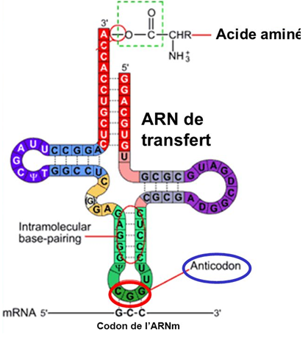
Fig.3. Spatial structure of tRNA
- Important Sites in tRNAs
Several important sites are found in tRNAs:
- The 3'-OH end: at this end, there are three characteristic nucleotides, CCA-3'OH. This is where the amino acid transported by the tRNA is attached.
R-COOH + R-OH → Sugar-O-CO-aa + H₂O
- The anticodon: a group of three nucleotides located on one of the tRNA loops. It plays an important role because it pairs with the corresponding codon on the mRNA. This pairing occurs through hydrogen bonds, following the complementarity rule and in an antiparallel manner. There are about twenty amino acids and 61 different codons, which means that an amino acid is carried by several tRNAs (differing by their anticodon).
- The 5' end of tRNAs contains a phosphate group.

- Role of tRNAs
tRNAs play a role in protein biosynthesis by attaching the amino acids to be transported onto the specific tRNA through a covalent ester bond. This bond forms between the carboxyl group (COOH) of the amino acid and the alcohol function (3'OH) of the tRNA through the elimination of a water molecule.

- Messenger RNAs (mRNAs)
They constitute the essential carrier of genetic information between DNA and the ribosome, where protein synthesis occurs. Their lifespan is very short; they are synthesized and degraded rapidly. mRNAs consist of a single nucleotide chain containing a succession of nucleotide triplets. Each triplet forms a codon specific to an amino acid.
Messenger RNAs correspond to the complementary and antiparallel sequences of the template strand (or anticoding strand) of DNA.

- Small RNAs
Small nuclear RNAs (snRNAs) are found in the nucleus of cells and are involved in certain steps of transcription. These snRNAs exist as ribonucleoprotein particles known as snRNPs, and they play a role in removing introns from transcripts. snRNAs assemble on the intron through a precise mechanism and catalyze the different steps of the splicing reaction. They constitute the RNAs of the splicing machinery, or spliceosome.
In the cytoplasm, small RNAs can also be found, existing as ribonucleoprotein particles (scRNPs).

