Lesson 1.Aims, Goals, Objectives, and Outcomes
  - Aim (the philosophy why teaching this subject)
An aim is large in scope because it specifies the teacher’s intention; it is a statement about what the teacher is going to cover over a period of time. Aims deal with broad purposes or goals. Aims try to answer two major questions:
- What is the purpose of this program or module?
- What is the program or module trying to achieve?
Aims are brief, succinct and provide learners with an overview of the course. The aim is general statement that suggest a direction. In the educational and training process, there should be a final living outcome to be focused.
For example
- In a science curriculum, the aim is to develop students’ evidence-based understanding of the natural world (years to be covered).
- Developing the ability to evaluate information sources, detect bias, and synthesize multiple perspectives.
- Ensuring students can use their learning in daily life.
- Training students to identify obstacles and apply creative or logical solutions.
- Developing the ability to work effectively in diverse teams and handle conflict constructively.
  - Goal (content: what will be covered in this term)
A goal is a statement of academic intention and it is smaller than an aim, a subset of it. The statement of goals dominates the amorphous terms of the aim which are not directly measured. A goal is more definite than an aim, and more general than an objective. A goal is specific; it is designed to address a specific aspect of society life such as religion and worship, economics and business, politics and governance, justice and fair. Those sectors have specific goals. Questions such as: how do we enhance worship that builds up Godly interpersonal relationship? The target goals answer the question what is religion? How do we worship? What is the focus of religion? The goal is subsumed in the general aim of the society. Goal is the soul of society growth and development, and it is realized through school programs and activities.
Objectives train the body for practical skills, goals equip the soul with proven knowledge, and aims free the spirit for promising operation.
Examples of Goals
- To improve conversational fluency regarding daily routines.
- To develop the ability to extract specific info from audio.
- To teach formal email etiquette and structure.
- To foster "skimming" and "scanning" techniques.
  - Writing Aims and Objectives
Hyland and Kennedy (2022, p.2) stated that aims and goals can be written using terms such as:
To give students an understanding of …..
• To give students an appreciation of…..
• To make students familiar with……
• To ensure that students know…….
• To enable students to experience …..
• To encourage students to …….
• To provide students with the opportunity to…….
  - Objective ( Activities done in the classroom)
It is a specific statement of a teaching intention. For example, one of the objectives of a lesson could be to give students an appreciation of how they can contribute to sustainability through the recycling of materials. Objectives are steps which will be taken to move towards a goal. Objectives are the steps which are taken to move towards a goal. Objectives translate the goals of an institution into concrete actions through a set of programs and activities. There are measurable results in terms of physical changes in attitudes, actions, and orientation. Even behavior is targeted through a set a set of body knowledge to achieve the desired changes. Objectives are set to maintain institutions goals; hence, they should be measured to adjust the necessary changes in the program. The assessment should be done via a set of instruments such as tests and interviews. Objectives indicate what learners can do and the change in behavior at the end of teaching (skills, values, and attitudes). A lot of factors should be taken into consideration when designing objectives such as: age, the experience and level of exposure, the cultural background, the religion, the social content, learning environment, and resources available for learning. Those factors suggest the right method to achieve the objectives.
Examples of Objectives
- Students will perform a 3-minute roleplay of a doctor's appointment.
- Students will fill in a blank flight schedule while listening to airport announcements.
- Students will write a 150-word letter of complaint about a faulty product.
- Students will find three specific prices and dates in a French newspaper advertisement.
1.2. Writing SMART Objectives
SMART is an acronym that summarizes the characteristics of good objectives. The term was first introduced in 1981 by George I. Doran to provide clarity, direction, and accountability.
S Specific which means clear, unambiguous and focused
M Measurable means objective and includes quantifiable criteria to track progress and determine success
A Achievable means realistic and attainable, considering available resources and constraints
R Relevant means aligns with broader organizational goals and strategies.
T Time-bond means timeline to create urgency and focus efforts.
SMART objectives should indicate the audience (who will achieve the result) and action (what the experience will be.
For better understanding of objectives, Bloom’ Taxonomy of creative objectives must be mentioned.
1.3. Bloom’s Taxonomy of Educational Objectives
Learning Objectives was classified into (1) cognitive which deals with intellectual outcomes such as acquisition of knowledge, conceptual understanding, thinking, and problem solving. (2) Affective deals with emotional outcomes like development of interests, attitudes, and values. (3) Psychomotor skills including carrying out a laboratory and clinical procedures. In other words, cognitive has also called mental, and deals with knowledge in the head/brain. Affective deals with love and affection at the level of heart/mind. Psychomotor deals with acquisition and manipulation of skills doing hands/arms. The 3Hs: head, heart, and hand work together to create a man.
Most courses focus on Bloom’s cognitive domain that demonstrates six level with action verbs that might proceed objectives; the bottom three levels (remembering, understanding, and applying) are lower levels whereas the top three levels ( analyzing, evaluating, and creating) are higher level, and represent thinking skills.
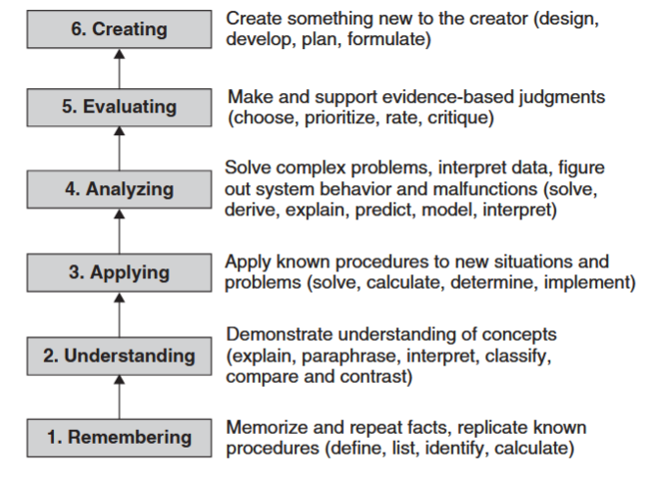
Blooms’ Taxonomy of Educational Objectives (Felder and Brent, 2016, p.31)
  - Outcomes (competence what students mastered)
Hyland and Kennedy (2022) clarified that learning outcomes are statements of what a student should know, understand and be able to do after completion of a process of learning. The latter can be a lesson, a part of it, or a program for several years. They are statements that describe observable behaviour (what a student should be able to do).
Examples of Outcomes
- The learner can accurately describe physical symptoms to a medical professional.
- The learner can navigate international travel hubs by understanding oral instructions.
- The learner is able to advocate for their consumer rights in a written formal format.
- The learner can quickly identify essential information in foreign-language media.
Rules for Writing Learning Outcomes
Since outcomes are statements that the describe the observable behavior, the crucial rule is using actions verbs for writing them. Action verbs describe which activity the subject of the sentence is doing. For example, EXPLAIN why rules are needed in any institution, EVALUATE the effect of climate change, ARGUE why students do not attend lectures. State verbs (understand and appreciate), on the other hand, should never be used when writing outcomes. Verbs such as explain, discuss, illustrate, solve, or outline, summarize can be used to express action. The active verb is a great glue to provide the appropriate form of assessment. Thus, when outcomes are written, there should be a question of how can learning outcomes be assessed, the answer needs measurement in order to be visible. Learning intentions are descriptions of what learners should know, understand and be able to do by the end of a learning period or unit. Intention is similar to the definition outcomes but there is inconsistency of practice in literature because sometimes intentions are written like objectives.

