CHAPTER III: MUTATIONS AND DNA REPAIR
- Mutations
Mutations correspond to copying errors involving purine and pyrimidine bases, usually occurring during DNA replication. As a result, the newly synthesized strand is no longer identical to the parental one.
I.1. Mutations during replication
Three types of mutations may occur:
- Substitutions
- Transition: replacement of a purine with another purine, or a pyrimidine with another pyrimidine.
- Transversion: purine ↔ pyrimidine exchange.
- Deletion: loss of one or more nucleotides.
- Addition: insertion of one or more nucleotides.
I.2. Mutagenic Agents
Spontaneous mutations are rare (1 error per 10¹⁰ bases), thanks to DNA polymerase proofreading (3'→5' exonuclease activity). However, mutagenic agents increase the error rate.
I.2.1. Physical Mutagens
DNA can be damaged by physical agents such as X-rays, gamma rays, and UV radiation.
UV rays cause thymine dimers and thymine–cytosine dimers (Fig. 20), preventing proper base pairing and blocking DNA polymerase during replication.
Alpha and gamma radiation can cause double-strand breaks, the most dangerous type of DNA lesion.
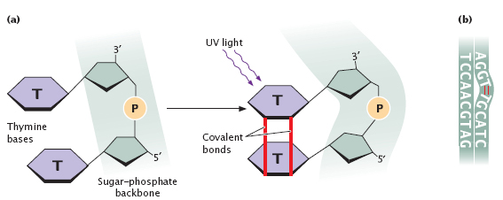
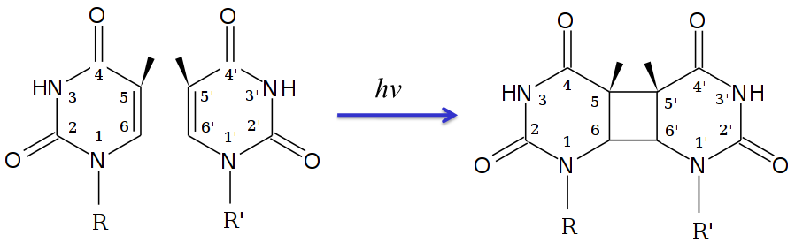
Fig. 20. DNA mutation by UV rays.
Alpha and gamma radiation cause the most dangerous types of DNA damage, namely double-strand breaks of the molecule, which can lead to cell death if no repair mechanism intervenes. This property is exploited to kill cancer cells.
I.2.2. Chemical agents
They can produce chemical modifications on certain bases and thus transform them:
- Alkylating agents
They cause the addition of alkyl groups to bases (often CH₃ groups) (Fig. 21).
Example: Nitrogen mustards are alkylating agents used in the treatment of a number of cancers.
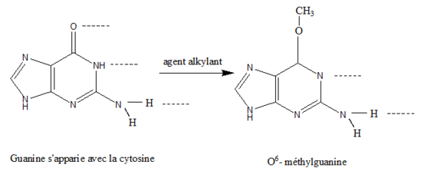
Fig. 21. Mutation caused by an alkylating agent.
- Nitrous acid
A chemical compound with the formula HNO₂. The mutagenic action of nitrous acid is linked to its deaminating power. For example, by oxidative deamination, it converts adenine into hypoxanthine and cytosine into uracil (Fig. 22).
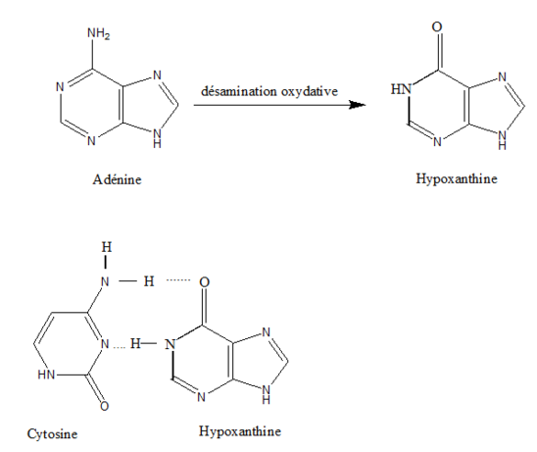

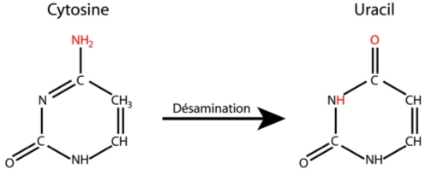
Fig. 22. Mutagenic action of nitrous acid.
- Reactive oxygen species
They lead to hydroxylation (addition of OH) on bases. Example: hydrogen peroxide and hydroxyl radicals.
These different chemical agents can cause the loss of a base from a nucleotide. The glycosidic bond linking the bases to deoxyribose in DNA is relatively fragile. Inside a mammalian cell, several thousand purine bases and several hundred pyrimidine bases are lost from the genome of a single cell. The loss of a purine or pyrimidine base creates a site called an apurinic or apyrimidinic site (or AP site).
- DNA repair mechanisms
There are several types of repair systems that act on different types of mutations.
II.1. Repair of DNA breaks
II.2. Correction of mismatches produced during replication
Some mismatches produced during replication are not corrected by the proofreading activity of DNA polymerase. The MMR (Mismatch Repair) system therefore scans the newly synthesized strand of DNA and detects mismatches.
The presence of a localized mismatch is detected by a specific protein called MSH. The MSH protein recognizes pairing errors as well as small insertions or deletions of a few nucleotides. The MLH protein stabilizes the complex formed between MSH and the double-stranded DNA region containing the mismatch. An endonuclease hydrolyzes the DNA strand upstream and downstream of the mismatch. DNA polymerase III then fills in the gap, and finally a ligase completes the process.
II.3. Nucleotide excision–resynthesis: repair of thymine dimers
Thymine dimers produced by ultraviolet radiation are removed by a specific repair system. First, the thymine dimer is recognized, the double helix is opened by a helicase, and an endonuclease cuts the DNA strand on both sides of the thymine dimer over a length of about 30 nucleotides. The gap is then filled by DNA polymerase δ (delta) using the intact strand as a template, and finally the ends are sealed by a DNA ligase.
This type of mechanism also allows the repair of other lesions besides thymine dimers.
II.4. Excision repair of abnormal bases
Bases can undergo chemical modifications due to the action of mutagenic agents. There are enzymes capable of excising only the base affected by this modification, since their substrates are modified bases.
Glycosylases remove the modified base, creating an abasic (baseless) site recognized by an AP (apurinic/apyrimidinic) endonuclease, which removes the sugar and its phosphate group. The resulting gap is filled by DNA polymerase β (beta), then a ligase seals the DNA.
II.5. Direct repair of bases
Just as mutagenic agents can chemically modify a base, there are enzymes capable of removing these modifications and restoring the base to its normal form. These modifications occur in situ, i.e., directly on the DNA itself, without excision of either the base or the nucleotide.
II.6. Post-replicative repair of thymine dimers
These repairs take place after replication. As a result, DNA polymerase skips over the thymine dimer during replication, which creates a gap in the daughter strand, while the parental template strand still contains the thymine dimer. Genetic information is therefore lost on both strands, which can have serious consequences for the cell, since no intact original information remains. This problem must be resolved before the cell divides and the information is permanently lost.
A protein, RecA (Recombination A), uses the second intact DNA double helix to reconstruct the damaged one and fill the gap in the daughter strand opposite the thymine dimer. This creates a gap on the parental strand of the other double helix, which, however, has a normal daughter strand from which a polymerase can fill the gap. On the other double helix, excision–resynthesis systems can remove the thymine dimer and fill the gap because the daughter strand has become normal again.

