Exercise 1
Your research group has been assigned the task of cloning and expressing a newly discovered a protein to study it in-depth. The gene encoding this protein is named (gene A) and is found naturally in the genome of a breed of wild dog (Canis insanus ).
You plan to:
1. Clone the gene
2. Express the protein that codes to study its properties.
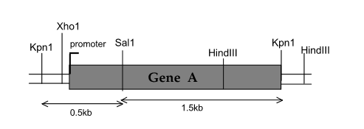
- How to clone this gene using a suitable cloning vector (see next page) and the techniques you have learned so far?
To clone this gene into the vector (the plasmid below), the following cloning protocol must be followed:
1- Digest gene A with the restriction enzyme KpnI (because it is the only possible one; using HindIII destroys the gene because it includes a restriction site in the middle of the gene. Using KpnI and XhoI leads to cloning the gene in the wrong direction because on the vector the two enzymes are not in the same order (in reverse order), which does not result in the expression of the desired protein (as explained in the course)).
2- Digest the cloning plasmid with the same enzyme (KpnI) so that the ends of the vector are compatible with the ends of the gene after digestion.
3- Mix gene A with plasmid e preferably at a ratio of 1:1.
4- ligation of gene A (the insert) to the cloning plasmid by T4 DNA ligase.
5- Transformation of the recombinant plasmid in the appropriate host (see the following questions for what as a host).
6- Cultivate the cells under restrictive conditions (optimal temperature…)
7- Spread the cells onto plates containing culture medium + kanamycin as an antibiotic (because the plasmid contains a kanamycin resistance gene) + X-gal + IPTG (see the following questions to see the role of X-gal and IPTG)
8- blue/white selection of colonies containing the recombinant plasmid.

- During the vector digestion, explain how to prevent its recircularization?
To prevent recircularization of the vector (plasmid), it can be treated after digestion with alkaline phosphatase which removes the phosphate in 5' on both sides, thus making recircularization impossible.

- What is the appropriate host to use for the transformation of the recombinant vector?
The plasmid contains the T7 promoter, which is recognized by the T7 RNA polymerase of bacteria. Therefore, a prokaryotic transcription unit is required, meaning a bacterium as a host expressing T7 RNA polymerase . If the bacterium does not express T7 RNA polymerase, then cotransformation with another plasmid encoding T7 RNA polymerase is necessary.
- This breed of this dog is obviously a eukaryotic organism, so its genes have introns. These are removed during eukaryotic mRNA processing (post-transcriptional modifications), but prokaryotes don't know how to handle introns. Furthermore, you don't know exactly where the exons and introns are located within this gene. How will you create an intron-free version of gene A so that the mRNA will be translated correctly by E. coli?
In this case, the use of mature messenger RNA is essential. The mature messenger RNA encoded by gene A is extracted from the cells and reverse transcribed into cDNA (complementary DNA) using reverse transcriptase and oligonucleotides (dT) as a primer, and then into double-stranded DNA. The double-stranded DNA is then digested and cloned into the vector.

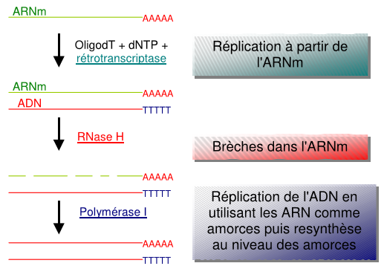

- How can you use blue-white colony screening to help you determine which E. coli cells contain copies of the recombinant vector?
After transformation, the bacteria are cultured on Petri dishes containing culture medium supplemented with kanamycin as an antibiotic (because the plasmid contains a kanamycin resistance gene + X-gal + IPTG). During the selection or screening of colonies containing copies of the recombinant vector, the untransformed cells are first destroyed by the antibiotic because they do not contain the vector (whether recombinant or non-recombinant) and therefore do not express the resistance gene. kanamycin and do not resist it.
Cells transformed by the non-recombinant vector express the lacZ gene , which codes for beta-galactosidase. Beta-galactosidase degrades the disaccharide X-gal (X-galactose) into a monosaccharide (galactose + glucose), resulting in a blue colony color.
The cells transformed by the recombinant vector do not express the lac Z gene (lac Z gene destroyed by the insert), therefore do not express beta-galactosidase which does not degrade X-gal and the colony remains white (blue/white selection of colonies).
IPTG (isopropyl beta-Dl-thiogalactopyranoside) acts as an inducer of the lac operon . It has the ability to bind to the operon repressor, thus allowing the synthesis of beta-galactosidase or the gene of interest. One of the advantages of IPTG is that it is not metabolized by cells, and therefore the expression of the gene of interest remains constant.

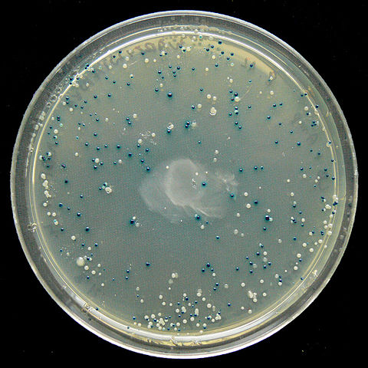

- If this gene is incorporated into the vector, it can be inserted in either the " forward" or "reverse" orientation. Is there one preferable orientation to the other?
Since we are going to express this gene, it must be cloned in the "forward" orientation (that is, in the right direction) to obtain the correct protein, because if it is cloned in the "reverse" orientation (that is, in the wrong direction) we obtain a bad protein.

- If so, can you explain how to screen plasmids that have the A gene in the correct orientation?
