CHAPTER II: TRANSMISSION AND CONSERVATION OF GENETIC INFORMATION
During cell division, when a mother cell gives rise to two daughter cells, it is essential that the DNA present in the daughter cells be an identical copy of the DNA found in the mother cell. This DNA copy must be produced before cell division; this process is called DNA replication.

- DNA replication in prokaryotes
Replication is described as semi-conservative (Fig. 14). This means that of the two DNA strands, one strand always comes from one of the parental DNA strands and the other strand is newly synthesized. At each replication cycle, the two parental DNA strands separate; each of them serves as a template for the synthesis of a complementary strand.
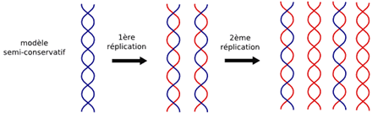
Fig.14 The semi-conservative model.
I.1. Elements required for DNA replication
DNA replication requires:
- A DNA template consisting of a parental strand.
- The presence of nucleotides specific to DNA, containing 2'-deoxyribose, the bases A, T, G, and C, in the form of nucleoside triphosphates: dATP, dTTP, dGTP, and dCTP.
- The presence of several enzymes.
- The presence of certain ions (bivalent cations such as Mg²⁺, which is essential for DNA replication).

I.2. Mechanisms of replication
I.2.1. Concept of the replicon
The DNA unit where replication occurs is called the replicon. It contains an origin where replication begins and a termination site where replication ends. Bacterial DNA itself constitutes a replicon. From a single initiation point, replication can proceed bidirectionally. In prokaryotes, from the origin of replication (also called replication eye), replication progresses in both directions.
I.2.2. Initiation of replication
In E. coli, there is a single origin of replication called OriC on the double-stranded DNA. The OriC locus consists of a sequence of 245 base pairs (Fig. 15). This sequence contains:
- Three nearly identical nucleotide sequences of 13 nucleotides each (of the type GATCTNTTNTTTT).
- Four binding sites with a 9-base-pair motif for a protein called DnaA, the replication initiation protein. Multiple copies of DnaA bind to DNA at the replication origin; these interactions require ATP.

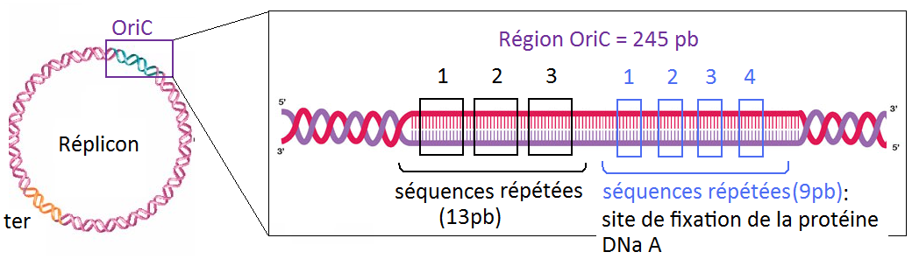
Fig. 15. Structure of the E.coli origin of replication (OriC).
This step is essential for the localized transformation of double-stranded DNA into single-stranded DNA. These complexes then recruit DNA helicase, which catalyzes the separation of the two DNA strands in the presence of ATP, forming the future replication fork (Fig. 16).
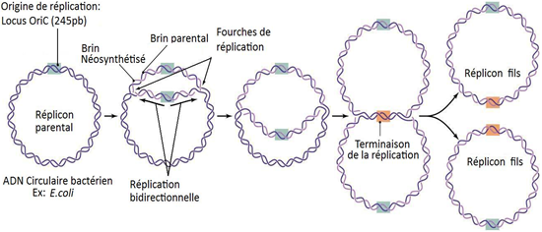
Fig. 16. Circular DNA replication of prokaryotes Ex : E.coli.
The separated DNA strands are stabilized in their single-stranded form by proteins called SSBs (Single-Strand Binding proteins). These proteins prevent the strands from reannealing.
Next, an enzyme called primase (or DnaG protein) synthesizes an RNA primer. After the RNA primer (9–12 nucleotides) is synthesized, DNA polymerase III binds at the replication fork and uses the RNA primer to begin DNA synthesis. DNA polymerase III has two active sites capable of synthesizing new DNA strands at the replication fork.
The protein complex that moves along DNA to catalyze replication is called the replisome (Fig. 17).

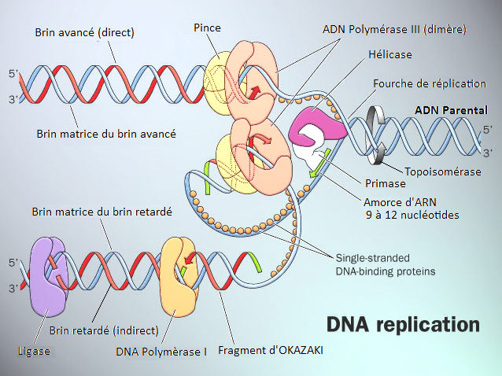
Fig.17. The DNA replication fork.
I.2.3. Discontinuous replication
Replication does not occur identically on the two DNA strands. On one strand, replication proceeds continuously—this is the leading strand. On the other, replication is discontinuous—this is the lagging strand.
On the leading strand, replication proceeds in the 5'→3' direction, using the template strand oriented 3'→5'.
On the lagging strand, short DNA fragments called Okazaki fragments are synthesized. Each fragment is synthesized in the 5'→3' direction, using the antiparallel template strand oriented 3'→5'.
The template strand for the lagging strand must form a loop around one of the two active sites of DNA polymerase III. After synthesis of each fragment, the loop is released and reformulated at the replication fork. Thus, DNA on the lagging strand is synthesized discontinuously.
I.2.4. Requirement for RNA primers
Copying the parental DNA strand requires an RNA primer synthesized by RNA polymerase or primase. This enzyme synthesizes a primer of 9–12 nucleotides. DNA polymerase III then extends this primer. DNA polymerases cannot start a DNA strand on their own; they can only add nucleotides to a free hydroxyl group, usually the 3'-OH end. Therefore, a primer is necessary.
I.2.5. Hydrolysis and replacement of RNA primers — role of DNA polymerase I
RNA primers are degraded/hydrolyzed by an enzyme, RNAse H, and replaced with DNA. The gaps left by RNAse H are filled by DNA polymerase I. Finally, the DNA fragments are joined by DNA ligase.
Note: DNA polymerase I can also hydrolyze RNA primers instead of RNAse H.
I.2.6. Termination of replication
Termination occurs when two replication forks meet or when a fork reaches a termination signal. A specific protein called Tus binds to the termination site and blocks the helicase (DnaB).
I.3. DNA polymerases in prokaryotes
Different DNA polymerases vary in their processivity and function. Some detach after adding only a few nucleotides (often repair polymerases), while replicative polymerases are tightly associated with DNA and can polymerize hundreds of thousands of nucleotides.
Five DNA polymerases have been identified in prokaryotes; the main ones are:
- Pol I : involved in DNA repair and replication; has polymerase (5'→3') and exonuclease activities (3'→5' proofreading and 5'→3' primer removal). Low processivity.
- Pol II : involved in replication of damaged DNA; polymerase (5'→3') and exonuclease (3'→5') activities. Low processivity.
- Pol III : the main polymerase for DNA strand elongation on both leading and lagging strands; has polymerase (5'→3') and proofreading (3'→5') exonuclease activities.
II. DNA replication in eukaryotes
II.1. General characteristics
Eukaryotic DNA replication is very similar to prokaryotic replication:
- Bidirectional
- Requires RNA primers
- Complementary and antiparallel
- Synthesized in the 5'→3' direction
- Occurs at multiple origins of replication
However, eukaryotes have more DNA polymerases. Eukaryotic Okazaki fragments are shorter (100–200 bases) compared to prokaryotic ones (1000–2000 bases).
Eukaryotic DNA is wrapped around protein complexes called nucleosomes. As the replication fork advances, DNA must be unwound from nucleosomes, slowing replication and explaining the shorter fragments.
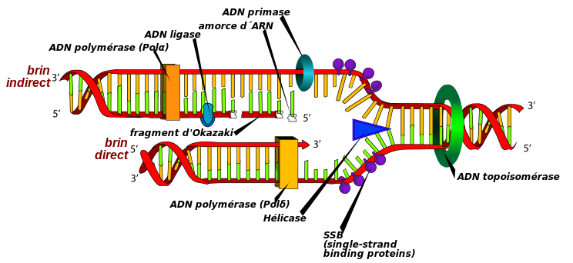
Fig. 18. DNA replication in eukaryotes.
II.2. Eukaryotic DNA polymerases
Eleven DNA polymerases have been identified; the main ones are:
- Pol α-primase (alpha) : synthesizes short RNA primers for both leading and lagging strands. No 3'→5' exonuclease activity.
- Pol β (bêta) : involved in DNA repair; no exonuclease activity. Equivalent to bacterial Pol II.
- Pol γ (gamma) : replicates mitochondrial DNA.
- Pol δ (delta) : main polymerase for nuclear DNA replication (with Pol ε); synthesizes both leading and lagging strands; possesses proofreading activity. Equivalent to bacterial Pol III.
- Pol ε (epsilon) : involved in replication and repair; synthesizes the telomeric region not handled by Pol δ.
II.3. Telomeres
Telomeres are the ends of eukaryotic chromosomes. They consist of repetitive, non-coding DNA sequences. At the 3' ends, the repeated sequence TTAGGG is found.
A major problem in replicating linear chromosomes is the removal of the outermost RNA primer, which could shorten the chromosome at each cycle. Protection is provided by telomerase.
Telomerase adds specific sequences to the 3' end of DNA (Fig. 19).
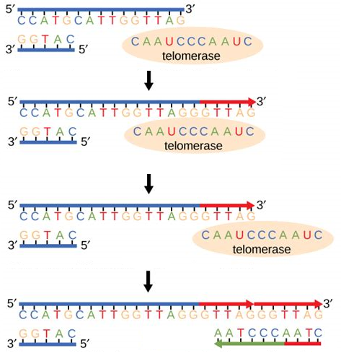
Fig. 19. The intervention of telomerase in DNA replication at the ends of chromosomes (telomeres) of eukaryotes.
Its actions include:
- Binding to the telomere.
- Extending the parental strand using its RNA template.
- Translocation (moving forward by 6 nucleotides: TTAGGG).
- Extension of the complementary strand by the replisome.

