TD2 of Molecular Biology
Given the following single-stranded nucleic acid sequence:
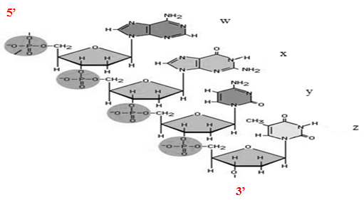
- Is it a DNA or an RNA sequence? Justify your answer and indicate the 5′ and 3′ ends on the structure.
- What types of molecules make up this complex structure? Which component gives this macromolecule its acidic character?
- What are the chemical bonds linking the constituent units of this macromolecule?
- Among the known nitrogenous bases, which one is absent from this structure?
- In the following table, give the nomenclature of components W, X, Y and Z in the case of DNA and RNA:
 | In DNA |  |  | In RNA
Nitrogenous base | nucleoside | nucleotide | Mono, di, tri phosphate | nucleoside | nucleotide | Mono, di, tri phosphate

- Give the name and the developed formula of the (triphosphate) form of component W for an RNA sequence, then indicate the chemical bonds that link it and which bond is the most energetic.
- Give the complementary sequence to this sequence.

