Climate change and biodiversity are closely connected.
- Climate change harms biodiversity. It directly and indirectly damages plants, animals, and ecosystems, and is expected to be a major cause of biodiversity loss in the future.
- Biodiversity loss makes climate change worse. When we lose species and healthy ecosystems, the planet becomes less able to cope with the effects of climate change.
- They share the same root problem. Other major threats to biodiversity—like habitat destruction, pollution, and invasive species—will all be intensified by climate change.
In short: Climate change accelerates the loss of nature, and the loss of nature accelerates climate change. They are two parts of the same crisis.

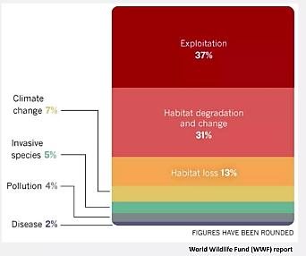
Main threats to biodiversity (according to the WWF report)
The diagram shows the breakdown of the main causes of biodiversity decline:
Breakdown of threats:
- Species exploitation (overfishing, hunting, etc.): 37%
- Habitat degradation and alteration (deforestation, urbanization, intensive agriculture, ecosystem fragmentation): 31%
- Climate change (rising temperatures, ocean acidification, extreme weather events): 7%
- Invasive species: 5%
- Pollution (chemical, plastic, eutrophication): 4%
- Disease (diseases affecting wildlife): 2%
- Other threats: 14%
Interpretation:
Nearly 70% of the threats are directly linked to the exploitation of natural resources and habitat destruction, highlighting the overwhelming impact of economic activities and land use.
Although climate change currently represents only 7%, its influence is growing and it acts as a risk multiplier, exacerbating other pressures (habitat loss, invasive species, diseases, etc.).
The figures show that conservation solutions must prioritize sustainable resource management and ecosystem preservation to have a significant impact.

