CHAPTER I: THE CARRIER OF GENETIC INFORMATION
- STRUCTURE OF NUCLEIC ACID
Nucleic acids are macromolecules that provide the information necessary for the development and maintenance of life, whose basic unit is the nucleotide. There are two types of nucleic acids: deoxyribonucleic acid (DNA) and ribonucleic acid (RNA). The former are mainly located in the cell nuclei, while the latter are found in the cell cytoplasm.
The function of nucleic acids is the transmission of genetic heritage from one generation to the next and the control of the synthesis of proteins necessary for life.
I.1. Nucleotides
I.1.1. Definition
Nucleic acids are composed of a chain of nucleotides. A nucleotide consists of three fundamental components: a sugar, a phosphate group, and a nitrogenous base.
a. Nitrogenous bases
They are classified into pyrimidine bases and purine bases. The main pyrimidine bases are uracil, cytosine, and thymine (5-methyluracil). The main purine bases are adenine and guanine (Fig. 1). Uracil is a pyrimidine base specifically found in RNA, whereas thymine is a pyrimidine base specifically found in DNA.
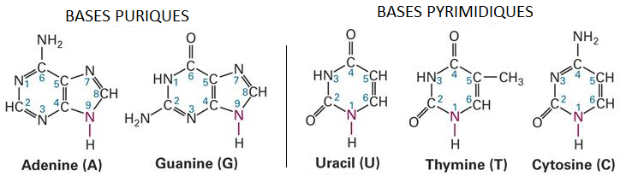

Fig. 1. The five main nitrogenous bases.
b. Sugar
Two types of sugars are present: ribose and 2′-deoxyribose. Both sugars are pentoses (sugars containing five carbon atoms) in cyclic form (Fig. 2). They are numbered using prime symbols to avoid confusion with the numbering of the bases. 2′-Deoxyribose is a ribose in which the OH group on the 2′ carbon is missing (replaced by an H).

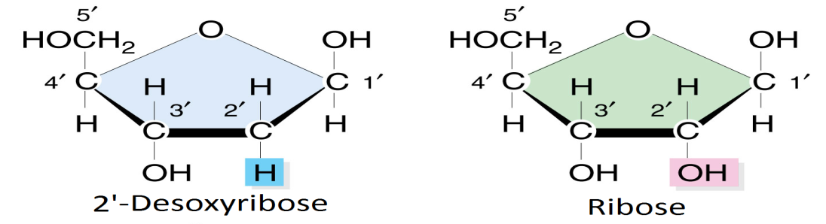
Fig. 2. Structure of the two sugars constituting nucleic acids
c. Phosphoric acid
The phosphate group (H₃PO₄) has three acidic functions. Two of these functions are esterified in DNA and RNA, while the third acidic function remains free (Fig. 3).
At pH 7, the phosphate group carries a negative charge.
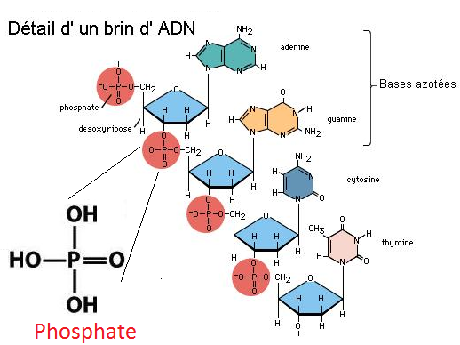
Fig. 3. Structure and position of phosphoric acid constituting nucleic acids.

I.1.2. Bonds in nucleotides
a. Sugar–base bond
The sugar–base bond is an N-glycosidic bond. It is formed by the elimination of a water molecule between the OH group of the carbon at the C1′ position of the sugar and the H of N9 of a purine base or N1 of a pyrimidine base. The sugar–base association is called a nucleoside.
N-glycosidic bonds exist in two conformations: anti and syn (Fig. 4). In the anti conformation, the sugar and the base are positioned away from each other. In contrast, in the syn conformation, the base and the sugar are close to each other.
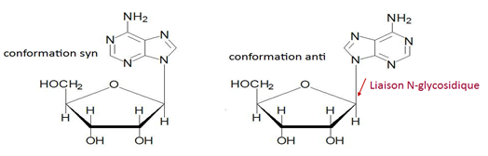
Fig. 4. Syn and anti conformations of nucleosides.
b. Phosphate–sugar bond
It is an ester bond (phosphoester bond). A water molecule is eliminated between an OH group of phosphoric acid and the H of the alcohol function at the 5′ position of the sugar (Fig. 5).
In nucleic acids, nucleotides exist in the monophosphate form.
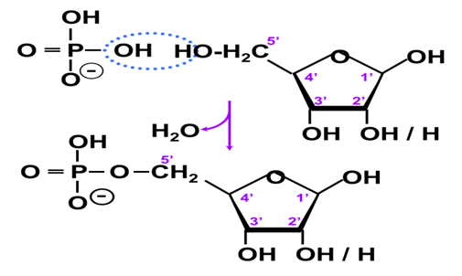
Fig. 5. Phosphoric acid–sugar bond.
I.1.3. Nucleotide nomenclature
For pyrimidine-based nucleotides, for example with the base uracil, the corresponding nucleoside and nucleotide are called uridine (suffix: -idine) and uridylic acid (suffix: -idylic), respectively. The designation is completed when the sugar is deoxyribose by preceding the nucleotide abbreviation with the letter “d” (for deoxy).
For purine-based nucleotides, for example with the base adenine, the corresponding nucleoside and nucleotide are called adenosine (suffix: -ine) and adenylic acid (suffix: -ylic), respectively (Table 1).
Table 1. Nomenclature of the main nucleotides
Nitrogenous base | Nucleoside | Nucleotide | RNA | DNA | Code
Adenine | Adenosine | Adenylic acid (adenylate) | AMP (adenosine monophosphate) | dAMP (deoxyadenosine monophosphate) | A
Guanine | Guanosine | Guanylic acid (guanylate) | GMP | dGMP | G
Cytosine | Cytidine | Cytidylic acid (cytidylate) | CMP | dCMP | C
Thymine | Thymidine | Thymidylic acid (thymidylate) | – | dTMP | T
Uracil | Uridine | Uridylic acid (uridylate) | UMP | – | U

I.2. Bonds linking nucleotides
Nucleic acids are polymers whose basic unit is the nucleotide. These nucleotides are assembled by ester bonds. A water molecule is therefore eliminated between an OH group of the phosphate and an H of the alcohol function located at the 3′ position of the sugar. When the phosphate has both acidic functions involved in ester formation, this is referred to as a phosphodiester bond (Fig. 6).
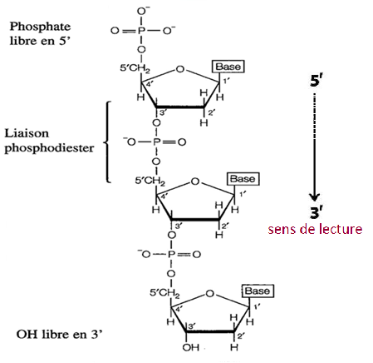
Fig. 6. Phosphodiester bonds link nucleotides in the ADN polynucleotide.
When a second, then a third molecule of phosphoric acid is added to the first, the nucleotide is referred to successively as a mono-, di-, or triphosphate nucleotide, and the bond formed is of the acid anhydride type.
A nucleic acid is always read in the direction from the 5′ end, which carries a free phosphate group, toward the 3′ end, which carries a free OH group (Fig. 6). Accordingly, DNA base sequences are written in the 5′ to 3′ direction.
Example: 5′ TGCA 3′ or TGCA
II. DEOXYRIBONUCLEIC ACID (DNA)
II.1. Structure of DNA
DNA contains all genetic information, called the genome, which enables the development, functioning, and reproduction of living organisms. In eukaryotes, it is located in the nucleus, whereas in prokaryotes it is found directly in the cytoplasm.
DNA is composed of two complementary strands of nucleotides twisted into a double helix (except in certain viruses).
DNA molecules exhibit several specific characteristics that distinguish them from RNA:
- The sugar: 2′-deoxyribose (replaced by ribose in RNA)
- The bases: A, C, G, and T. In RNA, T is replaced by U (uracil)
- Nucleotide polymers: DNA molecules consist of two chains (or strands) of nucleotides, whereas RNA molecules are most often single-stranded.
II.2. Characteristics of DNA strands
There are three main characteristics: antiparallel, complementary, and helical.
- Antiparallel: The two strands of a DNA molecule are arranged in parallel but in opposite directions. One strand is oriented in the 5′→3′ direction, while the other is oriented in the opposite direction.
- Complementary: Base pairing between the two strands of a DNA molecule follows the rule of complementarity: A pairs with T, and C pairs with G. This complementarity is based on steric considerations (spatial constraints) and on the formation of hydrogen bonds. Hydrogen bonds result from interactions between a hydrogen atom and another electronegative atom (O or N). Two hydrogen bonds form between A and T, and three between C and G (Fig. 7).
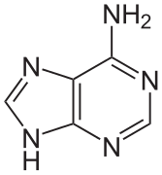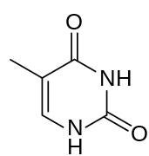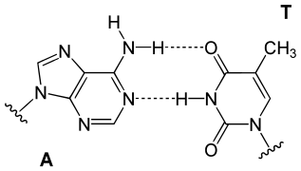
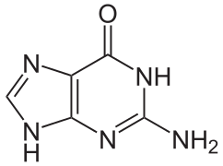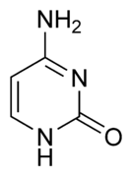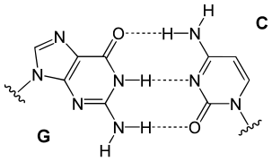

Fig. 7. Base pairing.
- Helical: In space, the two strands adopt a helical configuration. They wind around an imaginary axis to form a double helix with right-handed rotation (A-DNA and B-DNA) or, more rarely, with left-handed rotation (Z-DNA) (Fig. 8).
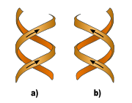
Fig. 8. Right-handed (a) and left-handed (b) double helices.
II.3. Forms of DNA
Many conformations of the DNA double helix are possible. To date, six forms have been described (A, B, C, D, E, and Z). The main forms are A-DNA, B-DNA, and Z-DNA.
B-DNA is the most common form of the double helix. It is a right-handed helix. One helical turn has a length of approximately 3.4 nm and contains an average of 10 base pairs, and the diameter of the helix is 2 nm. The bases are oriented in the anti conformation on the deoxyribose residues.
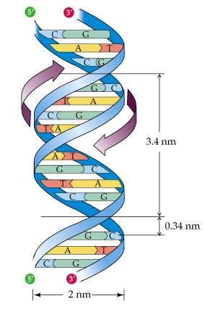
Fig. 9. Characteristics of the B-form DNA strand.
A-DNA is also a right-handed double helix. This helix is wider, with a diameter of about 2.3 nm, but shorter, with a length of only 2.8 nm for 11 base pairs per helical turn. The bases remain oriented in the anti conformation on the deoxyribose residues.
Z-DNA forms a left-handed double helix with 12 base pairs per helical turn. The helical length is greater (4.5 nm), and the helix diameter is smaller (1.8 nm). The bases are arranged with an alternation of conformations (anti and syn).
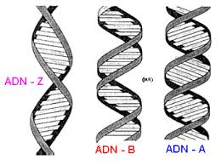
Fig. 10. Forms of DNA.
The size of the human genome is approximately 6.4 billion base pairs distributed across 23 pairs of chromosomes, corresponding to more than 2 meters of DNA per cell.
II.4. Physicochemical Properties of DNA
When a DNA solution is heated to a certain temperature (the melting temperature), the hydrogen bonds that ensure the cohesion of the two paired strands break, causing the two strands to separate. This process is inaccurately referred to as DNA melting and corresponds to DNA denaturation. This denaturation is reversible under certain conditions, as the two strands can reassociate according to the rules of complementarity. DNA denaturation is accompanied by physicochemical changes, including an increase in UV absorption, a decrease in viscosity, and an increase in density.
The melting temperature varies depending on the DNA studied. It increases as the percentage of (G + C) bases increases. This is related to the number of hydrogen bonds formed by G and C bases (three hydrogen bonds), compared with the two hydrogen bonds formed between A and T.
The presence of purine and pyrimidine bases allows nucleic acids (DNA and RNA) to absorb UV light at 260 nm. Proteins also absorb slightly at 260 nm but mainly at 280 nm. This UV absorption makes it possible to quantify nucleic acids and to estimate protein contamination during nucleic acid purification.

II.5. DNA Conformation
a. Topoisomers
Definition
Topoisomers are DNA molecules that have the same base sequence but differ only in the number of linkings (Fig. 10), that is, the number of times one strand winds around the other.

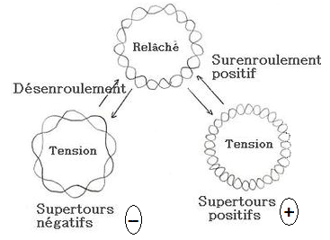
Fig. 11. Topoisomers of a circular DNA molecule.
Different topoisomer states
DNA supercoiling results from the presence of positive supercoils (supercoiling in the direction of the double helix) or negative supercoils (in the opposite direction) in a DNA double helix.
DNA supercoiling has important consequences:
- It makes DNA more compact, thereby reducing the volume it occupies within the cell.
- Changes in the degree of winding of the DNA double helix influence DNA interactions with other molecules (such as proteins and enzymes).
b. Topoisomerases
Topoisomerases are enzymes that modify the number of linkings. They are therefore able to increase or decrease the number of supercoils in double-stranded DNA molecules.
Two main types of topoisomerases can be distinguished (Fig. 12):
- Type I topoisomerases transiently cut and reseal a single strand of double-stranded DNA.
- Type II topoisomerases transiently cut both strands of DNA and then reseal them. These enzymes allow DNA to be unwound.
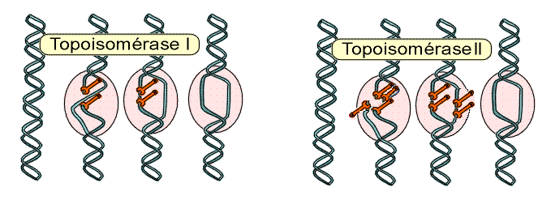
Fig. 12. Modes of action of topoisomerases on the DNA double helix.
Topoisomerases of both types have been identified in prokaryotes and eukaryotes, and their importance is crucial in DNA replication and transcription. These enzymes are also targets of therapeutic agents, such as antibacterial quinolones that inhibit bacterial gyrases, or anticancer drugs that act on topoisomerases.
III. NUCLEOSOMES AND CHROMOSOMES
In eukaryotic cells, nuclear DNA is tightly associated with proteins to form chromatin. The most classical representation is that of a “beads-on-a-string” structure. The DNA molecule links the “beads,” which are protein–DNA complexes called nucleosomes. A nucleosome contains approximately 200 base pairs of DNA associated with proteins called histones. Histones are low–molecular-weight proteins rich in basic amino acids. Within a nucleosome, there are eight histone proteins, with two copies of each histone: H2A, H2B, H3, and H4. Thus, at the level of a nucleosome, DNA (200 bp) is associated with a histone octamer (eight proteins). Histone H1 is not part of the nucleosome but is involved in the interaction between two nucleosomes (Fig. 13).
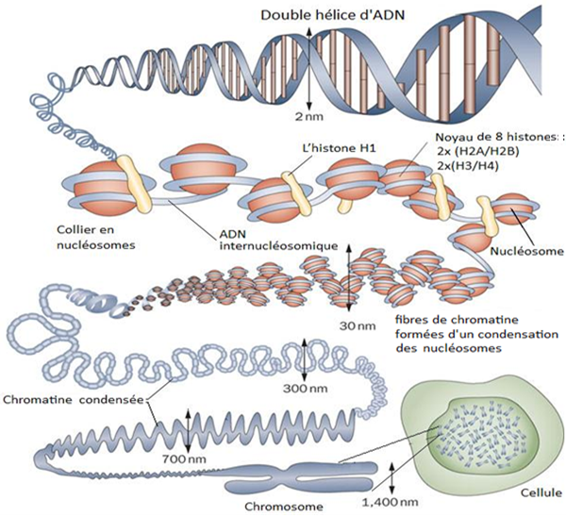
Fig. 13. Organization of chromosomes, and structure of nucleosomes and histones.

