Series of Practical Exercises No. 4

Exercise No. 1
Consider the following MCDs (or Entity-Association Models):
- Determine the cardinalities of the associations.
- Identify the attributes and keys.
- Derive the management rules.
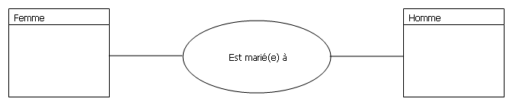
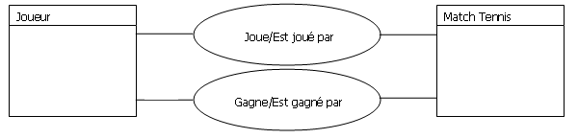

Exercise No. 2 (Exam 2020)
Draw the MCD for each of the following rules:

Rules I
- An employee can own one or more cars.
- A car can belong to one and only one employee.
- We are only concerned with the number of cars.

Rules II
- An employee can own one or more cars.
- A car can belong to one and only one employee.
- We are also interested in the make and year of circulation of the cars.

Rules III
- A teacher can teach at one or more universities.
- A university can include multiple teachers.
- A teacher can have multiple professional cards, depending on the universities.

Rules IV
- A teacher can teach at one or more universities.
- A university can include multiple teachers.
- A teacher has one and only one professional card.

Exercise No. 3
Given the following Conceptual Data Model (MCD):
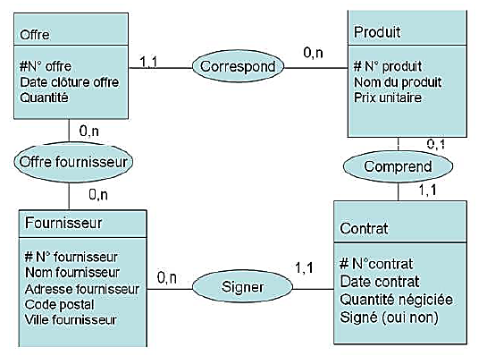
- Deduce the management rules, entities (with attributes and keys), associations, and cardinalities.
- Find the Functional Dependency Graph (FDG).

Exercise No. 4 - Part II (9 points) - MonBus Exercise
Every bus is driven by one or more drivers. For instance, the driver Mohammed drives buses 10 and 12, which go from Grarem to Mila. Bus 12 is also driven by Reda and Ammar.
- A bus has only one starting location (e.g., Zeghaia) but can have multiple destinations (e.g., university campus, research lab). The distance depends on the departure and destination locations.
- A student can either reside in one of the university dormitories (maximum of 10 per province) or not, but in both cases, they can take any bus or none at all.
- If the student is a resident, they register at the dorm office, bringing their residence and enrollment certificates. The file is then sent to the transportation office, where the student collects their card and pays the transport fees.
- If the student is not a resident, they register directly at the university's transportation office, bringing their student card, a photo, and a residence certificate. To collect the transport card, they must pay the fees at the accounting department and provide the payment receipt to the transportation office.
Questions
- Establish the corresponding Conceptual Data Model (MCD) and identify all entities/associations that will be Access tables (6 points).
- Establish the information flow for resident and non-resident students (3 points).

Problem
This exercise aims to design an information system for Gaza residents (Survivor System). The system is mainly focused on:
- Finding essential items: water, food, and other supplies.
- Accessing health services: medicines, hospital transfers, first aid, surgeries, health monitoring.
- Identifying safe areas.
For simplicity, we propose dividing residents into:
- Donor residents: those offering essential items, health services, medicines, etc.
- Needy residents: those searching for essential items and health services.
The system follows these management rules:
- Essential items are characterized by their name and type: water, food, or other supplies.
- Health services are characterized by their name, type, and address.
- A donor resident may be a health worker, a volunteer with first aid training, or a regular citizen with medicines or a means of transport. They can also provide essential items if available.
- A needy resident may require essential items or health services.
- Both types of residents can evaluate areas as: safe, unsafe, or unassessed.
- Areas are characterized by their name, boundaries, and current status (safe, unsafe, or unassessed).

Questions
- Draw the MCD (6 points).
- Where can we include the quantity of essential items needed by the needy resident? (1 point)
- Where can we include the quantity of essential items donated by the donor resident? (1 point)
 |  | جدول المواد الأساسية
NomEs | TypeEs | CodeEs

 |  | جدول الخدمات الصحية
AdrSs | TypeSs | CodeSs

- Complete the following tables (4 points).

Exercise No. 5
Given the following MCD, answer these questions:
- Identify and discuss the missing cardinalities in the MCD ((a,b)? (c,d)? (e,f)?).
- Can a driver hold multiple licenses?
- Can a driver operate multiple trucks?
- Can a truck have multiple drivers?
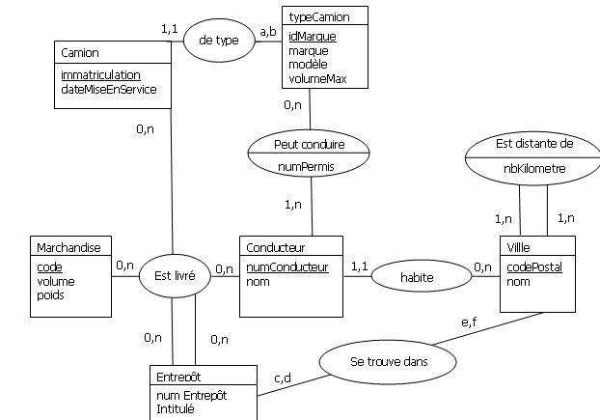

Exercise No. 7 (Supplementary)
The Essihha Surgical Clinic has five departments (Cardiology, Neurology, Urology, Rheumatology, and ENT). It employs 20 doctors, each with a specialty. During hospitalization, a patient may undergo medical procedures performed by doctors (e.g., consultations, radiology, imaging, tests). At the end of hospitalization, the patient receives a bill.
Management Rules
- A patient can undergo one or more hospitalizations at this clinic.
- Each hospitalization occurs in one and only one department.
- For each hospitalization, a bill is issued (one hospitalization concerns one and only one patient).
- A doctor can work in different departments but can head only one department.
- During hospitalization, a patient may or may not undergo medical procedures.
- Some medical procedures might never have been performed.
- Each medical procedure is associated with a tariff, depending on the patient.
Modifications to the Model
- A doctor can have multiple specialties.
- The system should cover multiple clinics.
- The system becomes national, covering 48 provinces.
- The system expands to an African level (max. 50 countries).

