Exercise No. 3
Given the following Conceptual Data Model (MCD CDM in english):
- Deduce the management rules, entities (with attributes and keys), associations, and cardinalities.
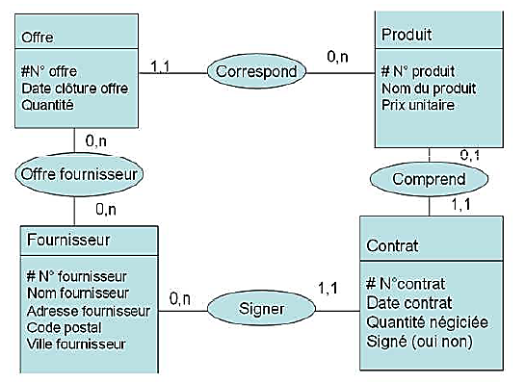
- Find the Functional Dependency Graph (FDG in English GDF: Graphe des Dépendances Fonctionnelles).
Answers :

Management Rules :
- Offre Correspond à un et un seul Produit
Eng : Offert Correspond to one and only one Product
- Produit Correspond à aucun ou plusieurs Offre
Eng : Product Correspond to none or multiple Offre
- Offre Offrir par aucun ou plusieurs Fournisseur
Eng. Offer is Offred by none or multiple Providers
- Provider Offer by none or multiple Offers
- Proivder signs none or mutilple contracts
- contract is signed by one and only one provider
- Contrat comprend un et un seul Produit
Eng. Contract contains one and only one Product
- Product is contained in none or one Contract

- Find the Functional Dependency Graph (FDG in English GDF: Graphe des Dépendances Fonctionnelles) Attributs

