CHAPTER 9: Metabolism of peptides and proteins
Each cell synthesizes the proteins it needs. Some cells can produce more than 10,000 different proteins. The amino acids required for this synthesis come from the digestion of dietary proteins. In the intestine, under the action of digestive juices, the proteins contained in food are broken down into amino acids, which are then transported to the cells via the bloodstream. Each cell draws from the blood the amino acids it needs to synthesize its own proteins.
The main pathways for the production and utilization of amino acids and proteins are shown in the following diagram (Figure 1).
Amino acids
Dietary proteins
Human proteins (cellular metabolism)

Protein synthesis
Cellular respiration or transformation into lipids

Muscle and blood proteins

Proteolysis Irreversible degradation of amino acids

Digestion of dietary protein intake

Figure 1. Main pathways for the production and utilization of amino acids.
- Catabolism of amino groups
The catabolism of amino acids is always accompanied by the removal of the amino nitrogen: either through transamination (most amino acids can undergo transamination, except lysine), or through oxidative (glutamate) or non-oxidative deamination (serine, cysteine, and threonine).
It leads to the production of a compound that is toxic to the central nervous system: ammonia (NH₃). This compound is eliminated from the body in the form of:
- Urea: hepatic ureagenesis (4/5 of the eliminated nitrogen),
- NH₄⁺: renal ammoniagenesis (1/5 of the eliminated nitrogen).

- Transamination reactions
Most amino acids cannot be directly deaminated; therefore, the first step of their catabolism is transamination. This reaction is common to all amino acids. It involves the transfer of an amino group from an amino acid to α-ketoglutarate (a member of the α-keto acid family), producing glutamate and another α-keto acid (depending on the amino acid being transaminated). Transamination is a reversible reaction catalyzed by a substrate-specific transaminase.
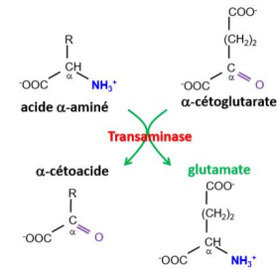
- Oxidative deamination of glutamate
Once glutamate is formed, it can undergo oxidative deamination by glutamate dehydrogenase, which ultimately removes the α-amino group in the form of NH₃, while producing α-ketoglutaric acid.
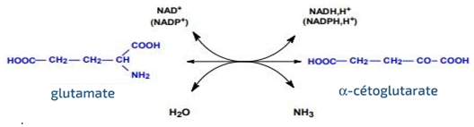
- Non-oxidative deamination
Certain amino acids bearing an –OH group on their side chain can be directly deaminated by dehydratases. Serine is deaminated to pyruvate, and threonine to α-ketobutyrate. Both reactions release ammonium (NH₄⁺), a toxic compound that must be eliminated.
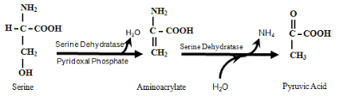
- Catabolism of carboxyl groups
The removal of the carboxyl (COOH) functional group from amino acids (decarboxylation) is catalyzed by decarboxylases, during which a molecule of carbon dioxide (CO₂) is released, leading to the formation of amines or polyamines.
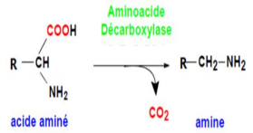
- Catabolism of the side chain
Once the amino nitrogen has been removed, a carbon skeleton is obtained, serving as a precursor for other biologically important molecules.
The catabolism of the side chain leads to the formation of seven intermediate compounds that can enter different metabolic pathways (Figure 2): gluconeogenesis (glucogenic amino acids), ketogenesis (ketogenic amino acids), and lipid synthesis.
- α-Ketoglutarate, oxaloacetate, fumarate, succinyl-CoA (intermediates of the Krebs cycle), and pyruvate: these compounds can be used for glucose synthesis (hepatic gluconeogenesis).
- Acetoacetyl-CoA en acetyl-CoA : these compounds can be used for the synthesis of ketone bodies (hepatic ketognesis) and for fatty acid synthesis.
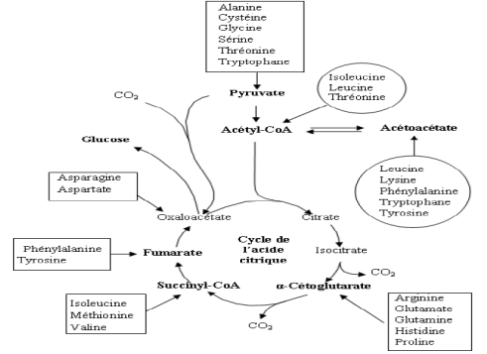
Figure 2. Catabolism of the amino acid side chain [1].
- Glucogenic and ketogenic amino acids
After the removal of the α-amino group in the form of ammonia, the 20 amino acids found in proteins each release their corresponding α-keto acid (carbon skeleton). Depending on the metabolic fate of these carbon skeletons, amino acids are classified into three groups:
- Glucogenic amino acids, whose carbon-skeleton degradation yields one of the following intermediates: α-ketoglutarate, oxaloacetate, fumarate, succinyl-CoA, or pyruvate. This class includes, among the non-essential amino acids: alanine, asparagine, aspartate, glutamate, glutamine, proline, glycine, serine, and cysteine; and among the essential amino acids: arginine, histidine, methionine, threonine, and valine.
- Ketogenic amino acids, whose carbon-skeleton degradation produces acetyl-CoA or acetoacetyl-CoA. This group contains two essential amino acids: leucine and lysine.
- Amino acids that are both glucogenic and ketogenic: tyrosine (non-essential), phenylalanine, tryptophan, and isoleucine (the latter three being essential).
- Biosynthesis of essential amino acids
Humans can synthesize only non-essential amino acids :
- Alanine, aspartate, and glutamate play a central role in amino acid metabolism. Their metabolism is closely linked to intermediates of the Krebs cycle. They are produced from their respective α-keto acids—pyruvate, oxaloacetate, and α-ketoglutarate (Figure 2)—and can be reconverted into them. These are reversible transamination reactions. Glutamate is synthesized in the mitochondria from α-ketoglutarate and free ammonia; it provides the amino groups required for the biosynthesis of alanine and aspartate.
- Proline is synthesized from glutamate. After phosphorylation of glutamate, proline is produced in three steps from glutamate semialdehyde.
- The two amides, glutamine and asparagine, are produced from their respective acids (Glu, Asp). The reaction catalyzed by glutamine synthetase, which irreversibly synthesizes glutamine from glutamate, serves to fix the ammonium nitrogen produced during amino acid catabolism. Asparagine is formed in a transamination reaction in which glutamate donates its amino group to aspartate.
- Serine biosynthesis branches off from a glycolysis intermediate. Serine is produced in three steps from 3-phosphoglycerate. Serine itself serves as the starting point for the production of glycine and cysteine (Figure 3). By elimination of the hydroxymethyl group, serine can be converted into glycine. This reaction is reversible, meaning serine can also be synthesized from glycine. In general metabolism, serine participates in the synthesis of phospholipids, purines, and cysteine.
- Arginine is produced from ornithine. Together with citrulline, ornithine is one of the two most important non-proteinogenic amino acids.
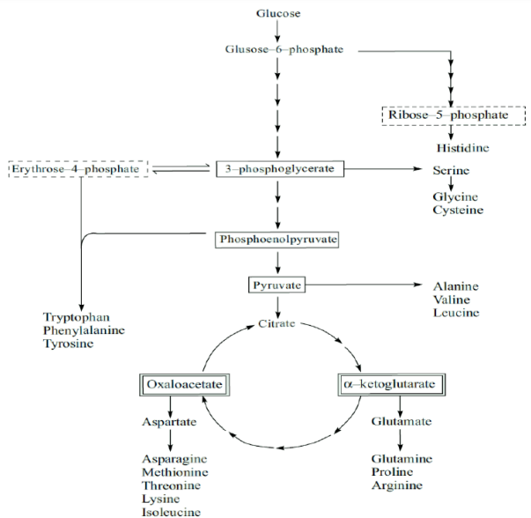
Figure 3. Amino acid biosynthetic pathways [1].
- Nitrogen elimination: the urea cycle
In humans, nitrogen cannot be eliminated directly as ammonia because of its toxicity. It is converted so that it can be excreted in the form of urea. Ammonia (NH₃) is a neurotoxic molecule: its lipophilic nature allows it to freely cross the blood–brain barrier and accumulate excessively in neuronal cells, which can lead to brain damage.
The elimination of ammonia resulting from amino acid degradation continues through the urea cycle, also called the ornithine cycle or ureagenesis. This cycle enables the formation of one molecule of urea and the regeneration of ornithine. In mammals, this cycle occurs exclusively in the liver.
The urea cycle consists of six reactions (Figure 4):
- Three reactions that take place in the mitochondrial matrix;
- Three reactions that occur in the cytosol.
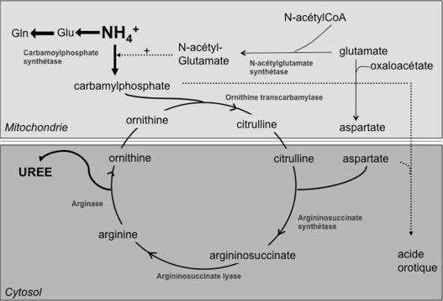
Figure 4. Urea cycle.
- The three mitochondrial steps
- The first reaction is not technically part of the urea cycle, but it is essential. It is a reaction between glutamate and acetyl-CoA, catalyzed by N-Acetylglutamate Synthase, producing N-Acetylglutamate.
- N-Acetylglutamate does not enter the cycle; it is an activator of Carbamyl Phosphate Synthetase I, an enzyme that catalyzes the formation of carbamyl phosphate from NH₃, HCO₃⁻, and ATP.
- Carbamyl phosphate is a simple but highly reactive molecule: it reacts with ornithine under the action of Ornithine Transcarbamylase to form citrulline.
- The three cytosolic steps
- Citrulline crosses the mitochondrial membrane through the citrulline–ornithine transporter and reaches the cytosol. There, it reacts with aspartate derived from glutamate transamination. Under the action of ASS (Argininosuccinate Synthase), an ATP-dependent enzyme, citrulline and aspartate form argininosuccinate.
- Argininosuccinate is then hydrolyzed by ASL (Argininosuccinate Lyase) to yield fumarate, an intermediate of the Krebs cycle, and arginine.
- Arginine is subsequently degraded by Arginase into urea and ornithine. Ornithine then returns to the mitochondrion through the citrulline–ornithine transporter and restarts the cycle by reacting with carbamyl phosphate.

