Abdelhafid BOUSSOUF University-Mila

Department of Foreign Languages
English
Level: 2nd year (BA/ LMD)
Study Skills

Critical Thinking

In a world filled with much information, diverse opinions, and attractive messages, we need to be equipped with the necessary thinking skills that help us pause for a while, question evaluate what we read and hear, and finally make thoughtful decisions and assessments rather than accepting ideas and taking them for granted. Critical thinking is a powerful tool in facing these disturbances.
1. Definition
Critical thinking has been defined from different perspectives. Following are some selected definitions:
- “…an investigation whose purpose is to explore a situation, phenomenon, question, or problem to arrive at a hypothesis or conclusion about it that integrates all available information and that can therefore be convincingly justified” (Kurfis, 1988; as cited in Sanders & Moulenbelt, 2011, p. 44))
- “Critical thinking is the use of those cognitive skills or strategies that increase the probability of a desirable outcome” (Halpern, 2003, as cited in Sanders & Moulenbert, 2011, p. 44)
- “Critical thinking then can also mean carefully selecting rules for finding truth that are appropriate for a context, place, and time. It also means demonstrating flexibility in approach so that we can apply rules that scrutinize beliefs in proper contexts” (Dayton & Rodier, 2024, p.14).
2. Components of Critical Thinking
Understanding the core components of critical thinking strengthens our problem-solving and decision-making abilities by helping us reason logically, assess evidence, recognize assumptions, and draw well-founded conclusions. The following figure illustrates key composing skills of critical thinking.
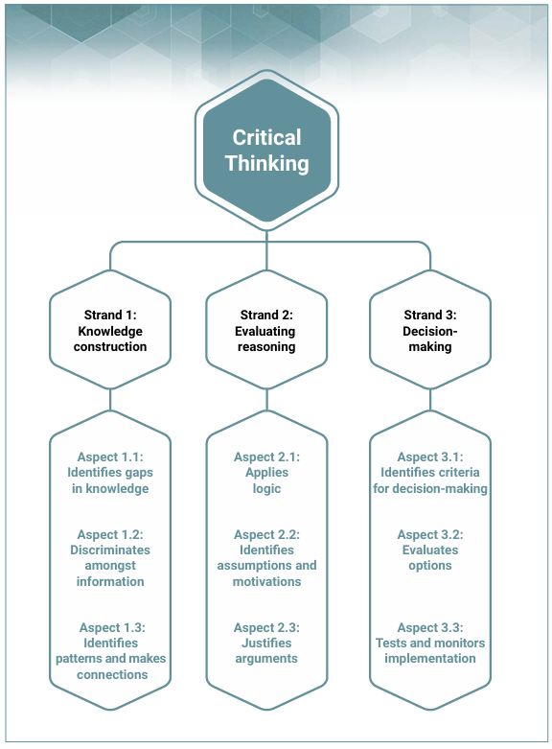
Figure: ACER’s Critical Thinking Framework (Heard, et.al, 2020, p. 3)
3. Characteristics of Critical Thinkers
Critical thinkers possess important traits that help them examine situations carefully and make thoughtful decisions. They tackle problems with curiosity and an open mindedness, analyzing information instead of simply accepting it as true. By challenging assumptions, assessing evidence, and exploring different viewpoints, they can reach logical and well-supported conclusions. These qualities are crucial for handling complex problems and making informed decisions in both academic settings and daily life.
According to Harnadek (1998), a critical thinker has many characteristics including:
1. He is open-minded about new ideas.
2. He does not argue about something when he knows nothing about it.
3. He knows when he needs more information about something.
4. He knows the difference between a conclusion which might be true and one which must be true.
5. He knows that people have different ideas about the meanings of words.
6. He tries to avoid common mistakes in his own reasoning.
7. He questions everything which doesn’t make sense to him.
8. He tries to separate emotional thinking from logical thinking.
9. He tries to build up his vocabulary so that he can understand what other people are saying and so that he can make his own ideas clear to other people. (p.2)

Bibliography
Dayton, E. & Rodier, K. (2024). Critical thinking, logic, and argument: An introduction. Remix.
Harnadek, A. (1998). Critical thinking book one: Problem solving, reasoning, logic, and arguments. CA: The Critical Thinking Co.
Heard J., Scoular, C., Duckworth, D., Ramalingam, D., & Teo, I. (2020). Critical thinking: Definition and structure. Australian Council for Educational Research. https://research.acer.edu.au/ar_misc/38
Sanders, M. & Moulenbelt, J. (2011). Defining critical thinking: How far have we come? Inquiry Critical Thinking across the Disciplines, 26(1), 38-46.

