Chapter 05: Anabolisme reactions

I. General Principles of Amino Acid Synthesis

A. Precursors and Metabolic Origin
All 20 amino acids are synthesized from six fundamental intermediate products of carbohydrate metabolism, specifically Glycolysis and the Krebs cycle (TCA cycle).
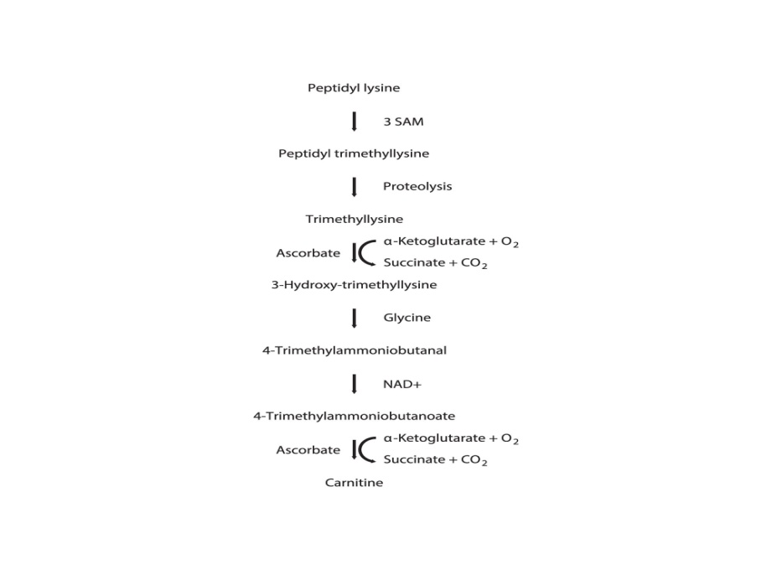
The main precursors are:
- From Glycolysis/Gluconeogenesis: Triose-P (3-Phosphoglycerate, Phosphoenolpyruvate), Pyruvate.
- From TCA Cycle: Acetyl-CoA, α-Ketoglutarate, Oxaloacetate.
- Other: Erythrose-P.

B. Nitrogen Incorporation
The most crucial step is incorporating nitrogen (N) into the carbon skeletons.
- Preferred Form: Ammonium (NH3​/NH4+​) is the form most easily utilized by the cell.
- Other Sources:
- Nitrates/Nitrites (NO3−​/NO2−​): These are first converted to ammonium by specific reductases before being incorporated.
- Molecular Nitrogen (N2​): This is a specialized process called Nitrogen Fixation, catalyzed by the Nitrogenase enzyme complex. It is restricted to a limited number of bacteria (e.g., Azotobacter, Rhizobium—symbiotic) and cyanophyceae.

II. Amino Acids Derived from Glutamate and α-Ketoglutarate
This group derives its carbon skeleton from α-Ketoglutarate, a five-carbon intermediate of the Krebs cycle.

A. L-Glutamate Synthesis (The Initial Incorporation)
Glutamate is the primary entry point for ammonium (NH3​) into many amino acids.
Industrial Production: High yields of L-glutamate are achieved through fermentation using strains like Micrococcus glutamicus (now Corynebacterium glutamicum). The key strategy is using a mutant that has lost the enzyme necessary to convert α-ketoglutarate into succinate, effectively damming the TCA cycle and forcing α-ketoglutarate to accumulate and be shunted into glutamate synthesis.

B. Branched Pathways
From glutamate, the synthetic pathways branch out:
- Glutamine: Formed by adding a second NH3​ to glutamate.
- Proline: Synthesized by the cyclization of 5-phosphoglutamate. (Low industrial interest).
- Ornithine → Citrulline → Arginine: These are crucial for the Urea Cycle and protein synthesis.
  - Industrial Strategy: Ornithine can be produced using M. glutamicus mutants that are auxotrophic (require supplementation) for citrulline or arginine, causing the precursor (Ornithine) to accumulate.

III. Amino Acids Derived from Aspartate
This group derives its carbon skeleton from Oxaloacetate, another four-carbon intermediate of the Krebs cycle.

A. L-Aspartate Synthesis
L-aspartate is formed by the amination of fumarate (a TCA cycle product) or through transamination of oxaloacetate.

B. Branched (Aspartate Family) Pathways
From aspartate, a crucial set of essential amino acids are derived:
- Lysine (in Bacteria):
- Methionine (Met)
- Threonine (Thr)
- Isoleucine (Ile)
Industrial Strategies (Auxotrophic Mutants): To force a precursor to accumulate, mutants are created that are blocked at a later step in the pathway:
- Lysine Accumulation: Achieved in mutants auxotrophic for methionine and threonine. This block prevents Met/Thr synthesis, pushing the carbon flux toward Lysine accumulation.
- Threonine Accumulation: Achieved in Escherichia coli mutants auxotrophic for lysine and methionine.
- Isoleucine Production: Often produced from a threonine-rich medium using species like Streptomyces rimosus, as threonine is a direct precursor to isoleucine.

IV. Synthesis of Leucine and Valine
The pathways for Leucine (Leu) and Valine (Val), as well as Isoleucine (Ile), are closely linked and share several initial enzymes.
- Precursor: These branched-chain amino acids (BCAAs) are derived from Pyruvate.
- Shared Enzymes: The conversion of threonine to isoleucine shares common enzymes with the initial steps of valine and leucine synthesis.
Industrial Strategy : Valine Accumulation: Achieved in mutants of strains like Aerobacter or M. glutamicus that are auxotrophic for both isoleucine and leucine. By blocking the synthesis of the downstream products, the precursor (Valine) is forced to accumulate.

2 – Lipid Biosynthesis
Microbial lipids are mainly composed of glycerides. Sterols may also be present (particularly in eukaryotic organisms), as well as glycolipids, phosphoglycerides, alkyl-1-enyl ethers, and sometimes alkyl ethers. The lipid and fatty acid composition depends not only on the species and strain but also on the physiological growth stage and, most importantly, the culture conditions: physical parameters (temperature, aeration) or chemical parameters (medium composition, C/N ratio), which can modify biological activities.
Glycerides are synthesized from glycerol and fatty acids (mono-, di-, and especially triglycerides). Glycerol is an intermediate product of carbohydrate metabolism, and fatty acids are synthesized from acetyl-CoA. Bacteria generally contain few fatty acids with more than 19 carbon atoms. The most abundant fatty acid is usually palmitic acid (a saturated C16 fatty acid), while the main unsaturated fatty acids are monoenic. Branched-chain fatty acids or cyclic fatty acids are also present. In yeast, the predominant fatty acid is palmitoleic acid (a mono-unsaturated C16 fatty acid).
Sterols are synthesized via a pathway common to that of terpenes. By condensation of two acetyl-CoA molecules, mevalonic acid is formed, which is converted into isopentenyl pyrophosphate or dimethylallyl pyrophosphate, the basic building blocks of terpene chains (geranyl C10, farnesyl C15, geranylgeranyl C20, geranylfarnesyl C25…), from which terpenes, steroids, carotenoids, and ubiquinones are derived. Steroids are formed from two farnesyl pyrophosphate molecules via squalene (C30). Microbial steroids include ergosterol and various other compounds (fucosterol, lanosterol, etc.). The formation of sterols and certain unsaturated fatty acids is sometimes only possible under aerobic conditions (yeasts). Under anaerobic conditions, these products must be present in the medium to allow growth.
Microbial lipid production is always carried out by biomass production followed by extraction and purification. Algae, yeasts, and molds can be important sources of lipids. Production can be increased (more than 20% of lipids relative to dry matter) by culturing under nitrogen or certain mineral limitations.

3 – Nucleotide Biosynthesis
Nucleotides, the basic components of nucleic acids, are synthesized:
- From inosine monophosphate, derived from ribose-phosphate, for purine nucleotides.
- From aspartate and carbamoyl phosphate via a common intermediate, uridylic acid, for pyrimidine nucleotides.
Their production is achieved by perturbing regulatory systems.

4 – Vitamin Biosynthesis
Prototrophic microorganisms are capable of synthesizing all growth factors, and in particular all the vitamins they need; some release significant amounts into the medium. By perturbing metabolism, microorganisms can be made to produce most vitamins or provitamins (pantothenate, pyridoxine, biotin, thiamine, folic acid, lipoic acid, nicotinamide, riboflavin, cyanocobalamin, precursors of vitamins A, C, D, vitamin K, coenzyme Q, inositol…). Some of these productions have significant industrial importance, such as vitamin B2 (riboflavin) and especially vitamin B12 (cyanocobalamin), whose only source is microbial. Additionally, β-carotene, a precursor of vitamin A, is often produced microbiologically.

5 – Hormone Biosynthesis
Molecules with hormone-like activity have been discovered in eukaryotic microorganisms, some of which are steroid in nature.

6 – Toxin Biosynthesis
Some bacteria and molds secrete toxins. In certain cases, industrial production of these toxins is of great interest because they are used in the production of antigens, vaccines, and antitoxins in medicine.

In bacteria, there are two types of toxins:
- Exotoxins: Protein in nature, highly active but thermolabile, usually secreted during growth, mainly in Gram-positive bacteria.
  - Examples include diphtheria toxin (Corynebacterium diphtheriae), staphylococcal enterotoxins (Staphylococcus aureus), tetanus toxin (Clostridium tetani), botulinum toxins (Clostridium botulinum), and Clostridium perfringens toxins. They are used as a source of antigens and, more importantly, as toxoids for vaccines.
- Endotoxins: More complex (glycolipid-protein) in nature, less active and thermostable, released upon cell lysis, mainly in Gram-negative bacteria.
  - Examples include cholera enterotoxin (Vibrio cholerae) and typhoid endotoxin (Salmonella).
Some products also play an important role in biological control (insecticides).
Various molds also secrete toxic substances:
- Ergot alkaloids: Produced by Claviceps purpurea, these substances have pharmacological properties and medical interest.
- Aflatoxins and other mycotoxins: Aflatoxins derived from coumarin are produced by Aspergillus flavus. Many other molds produce mycotoxins, though their industrial interest is limited.

7 – Antibiotic Biosynthesis
Antibiotics are substances produced by microorganisms that can inhibit or destroy other microorganisms. Their economic importance comes from their medical use in treating infectious diseases. Antibiotics are specific substances, not widely distributed among microorganisms, and are produced only by a limited number of species. The genus Streptomyces contains many antibiotic-producing microorganisms. Antibiotic production uses strains improved by mutation, recombination, and genetic engineering. Genetic engineering allows, for example, the transfer of the acyl-transferase gene (penicillin acylase) from Penicillium into various strains. Genes conferring resistance to aminoglycosides can also be transferred, allowing hyper-production without inhibition.
Different types of antibiotics exist according to their chemical structure, with different biosynthetic pathways.

A- β-Lactams: Penicillins and Cephalosporins
Penicillin
Natural penicillins (G and V) are β-lactam-thiazolidine heterocyclic compounds produced by Penicillium chrysogenum. Semi-synthetic penicillins are prepared chemically or enzymatically from natural penicillins, either by chemical hydrolysis or the action of microbial acylases (Escherichia coli, Bacillus megaterium, Kluyvera citrophila, Pseudomonas melagenum, Streptomyces spp.), yielding new active compounds (pheneticillin, methicillin, oxacillin, ampicillin, azidocillin, carbenicillin, ticarcillin, etc.).
Penicillins inhibit bacterial cell wall synthesis. They act on Gram-positive bacteria (e.g., Staphylococcus, Streptococcus), some Gram-negative bacteria (Neisseria), and Treponema (syphilis agent). Most penicillins can be inactivated by penicillinase-producing microbes (E. coli, Bacillus), converting them into inactive penicilloic acid.
Cephalosporin
Cephalosporins are very similar molecules to penicillins. They mainly act on Gram-positive bacteria by inhibiting cell wall synthesis. Cephalosporin N is also active against Salmonella. Cephalothin is a highly active, broad-spectrum derivative obtained by chemical modification of cephalosporin.

10 – Enzyme Biosynthesis
Many enzymes can be produced by microbial culture (often using hyper-producing and hyper-secreting mutants). These include enzymes recovered from the culture medium as well as intracellular enzymes that must be extracted from the microbial cells. They are used as biocatalysts in free or immobilized form, as additives, or as components of biosensors. Enzymes of major industrial importance include: cellulases, pectinases, amylases, lipases, proteases, invertase, glucose oxidase, glucose isomerase, dextran sucrase, penicillinase, and catalase.

