IV. the Laboratory Fume-hood
- Définition
A laboratory fume hood is a medical device that extracts toxic vapors from the products used during handling. Its primary function is to protect the operator.
A fume hood is an enclosure that safely contains and ventilates hazardous fumes, vapors, gases and dust generated by chemical processes performed in the fume hood. Sometimes called a chemical hood or a lab hood, a fume hood protects workers from inhalation of hazardous substances.
The clear sliding window on a fume hood, called the sash, also shields workers from spills and splashes that may occur in the chemical fume hood.
Fume hoods are the workhorse of laboratory exhaust systems and are the most widely used approach for local ventilation.
- Fume Hood Work
A fume hood works by pulling air away from the user into the enclosure with a blower. The fume hood then filters and vents the air to the outdoors through a facility exhaust system. Alternatively, a fume hood may filter the air to remove dangerous fumes and then return the air to the room. Most fume hoods are equipped with gauges or alarms that warn the user of low airflow and potential exposure to hazardous fumes.
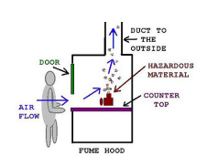
- Type of fume hood
- CHEMICAL FUME HOODS
Protect you from fumes you are working with. The fan sucks in the air toward the duct inside of the fume hood towards the outside. This system works only if you bring the hood's door down at least 2/3 of the way. The narrower the opening, the swifter the air.
Laboratory fume hoods are designed for specific use. Based on the configuration, fume hoods come in a variety of types.

- Bench-Top Fume Hood
A bench-top fume hood is generally placed on bench-top or above a storage cabinet. Bench hoods are set on a worksurface approximately 36″ above the floor and provide a convenient work area for the standing position.
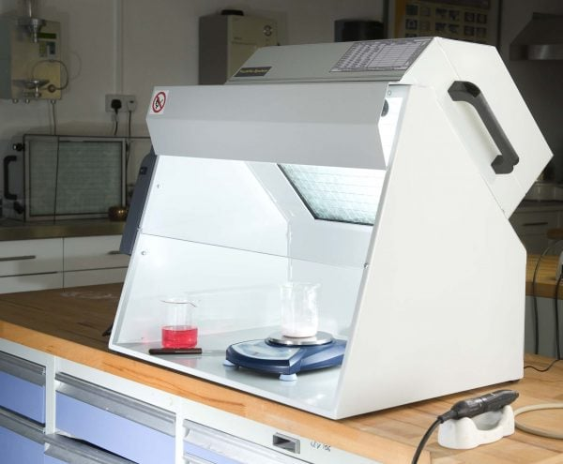
Fig 1: Bench-Top Fume Hood. @ https://www.totalextraction.co.uk/
- Distillation Fume Hood
A distillation hood has the same components as a bench-top hoods with the exception that the design provides a grater interior height. The grater interior height enables use of larger apparatus.
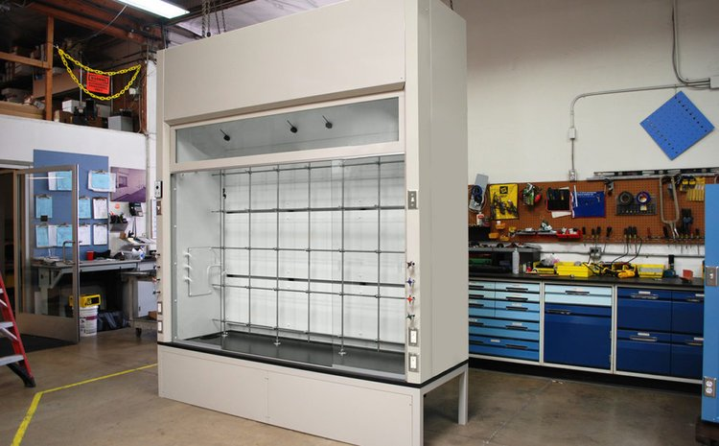
Fig 2: Distillation Fume Hood.@ https://www.geniescientific.com/
- Floor-Mounted Fume Hood
Floor-Mounted fume hoods(or walk-in hoods) are used where taller apparatus is required for equipment is rolled into the hood. These hoods provide a minimum 78″ of interior working height.
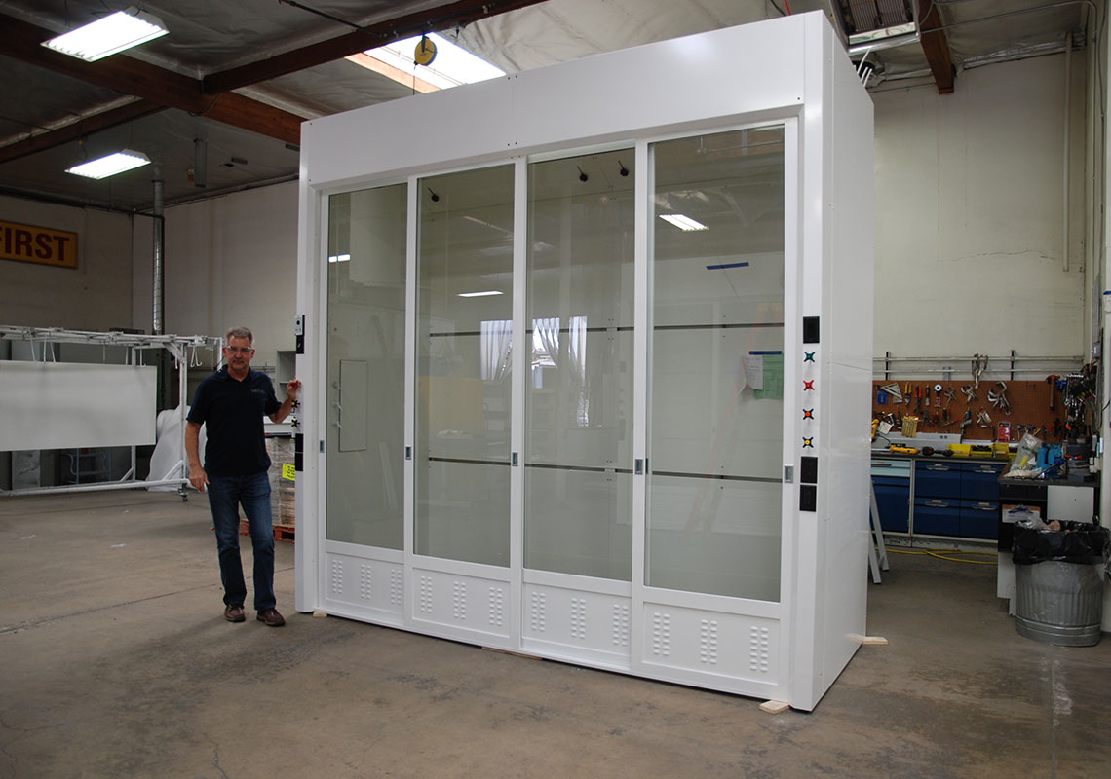
Fig 3: Floor-Mounted Fume Hood. https://www.geniescientific.com/
- Radioisotopes Fume Hood
Isotope hoods are designed for use with radioactive materials. The radioisotopes hods have type 304 stainless steel cove corner seamless welded construction – for easy cleaning and decontamination.
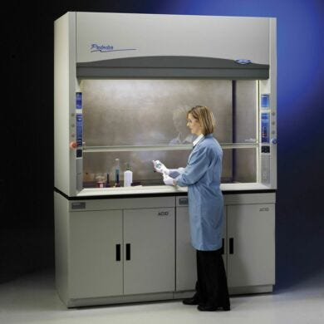
Fig 4: Protector Stainless Steel Radioisotope Laboratory Fume Hoods. https://www.laboratory-equipment.com/

- Perchloric Acid Fume Hood
A perchloric acid hood has the general characteristics of a bench-top hoods, but the interior lining is coved and welded seamless stainless steel.In perchloric acid hood non-reactive and corrosion-resistant material is extended all the way through the exhaust system.
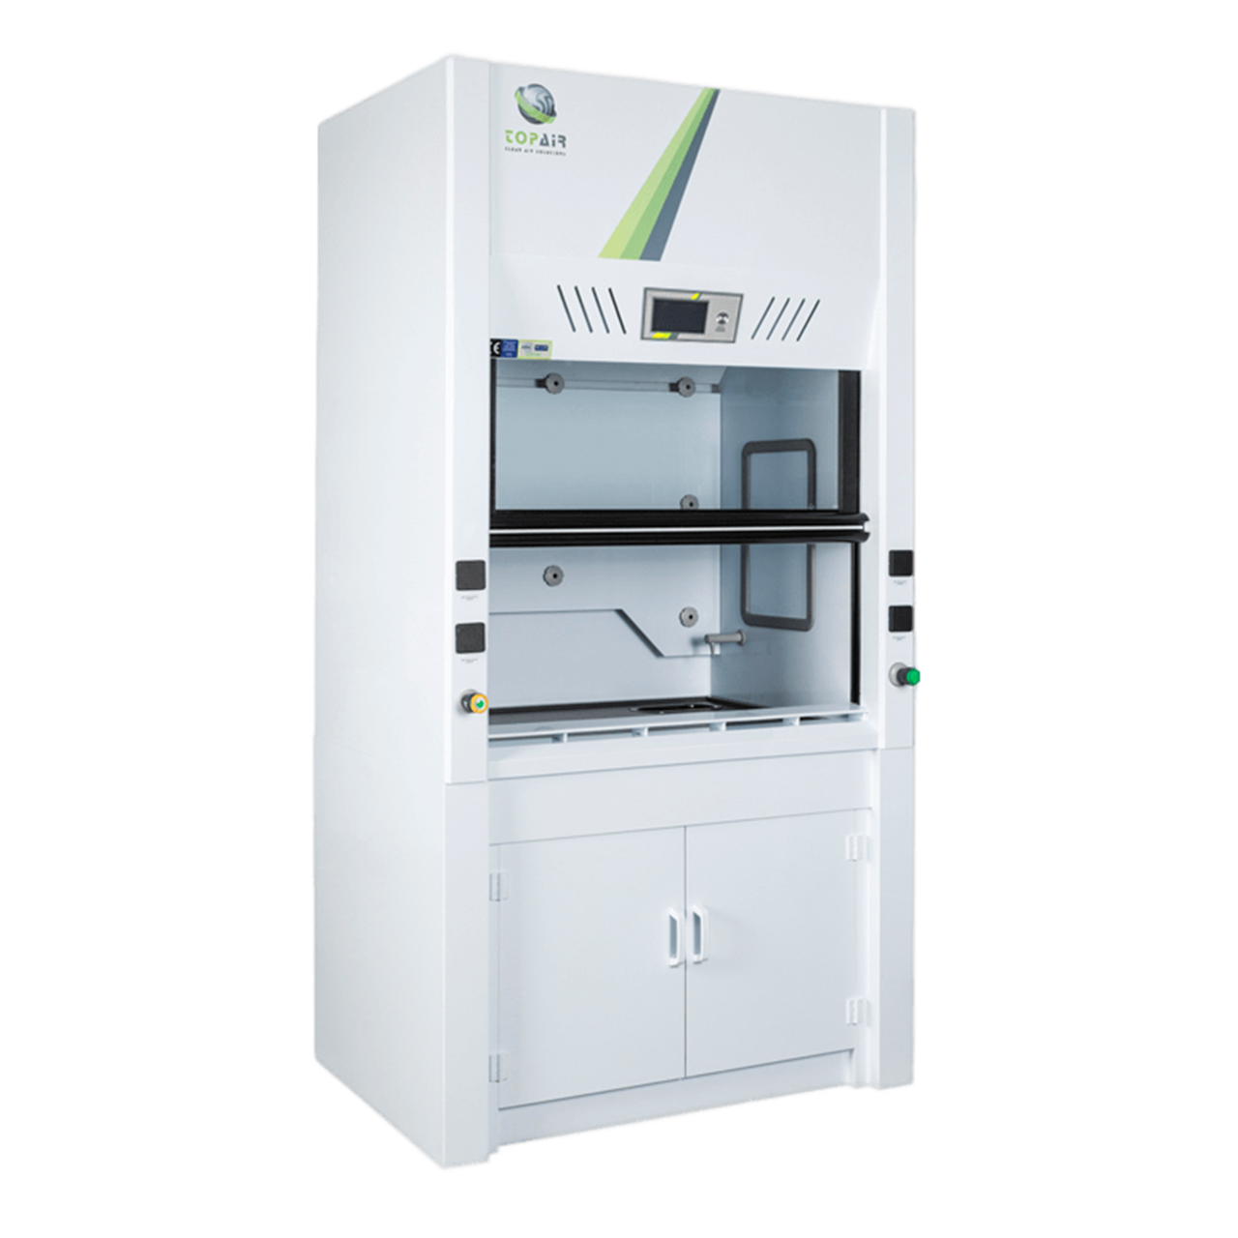
Fig 5: Perchloric Acid Fume Hood. https://topairsystems.com/

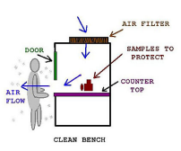
- LAMINAR FLOW
Cabinets Protect your samples from contamination coming from you and the room. The air is blown at you. Laminar flow hoods are designed to provide a controlled, clean environment by directing a unidirectional flow of filtered air over the work surface. This airflow helps to minimize airborne contamination and is particularly useful in applications requiring a sterile environment, such as tissue culture, microbiology, and pharmaceutical compounding. Laminar flow hoods come in two primary types: horizontal flow and vertical flow.

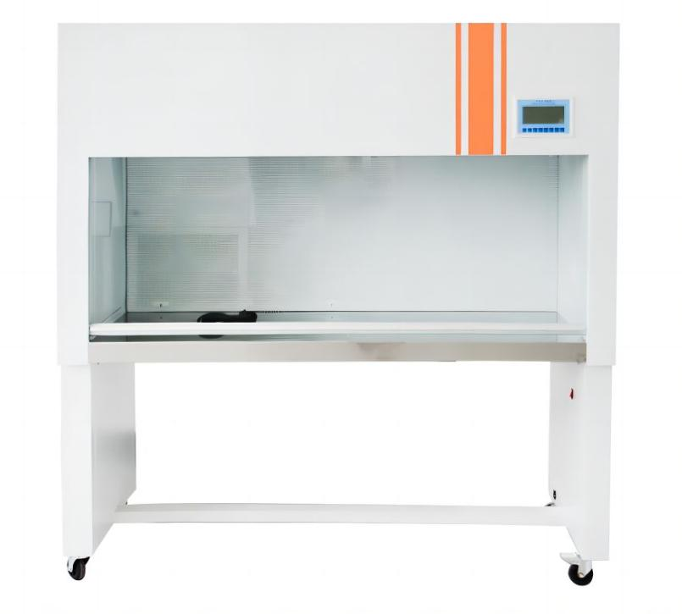
Fig 6 : Laminar Flow Hood. https://www.drawellanalytical.com/
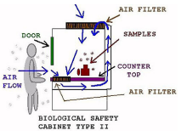
- BIOLOGICAL SAFETY CABINETS
type II Protect you, your samples and your environment from particulate contamination. They are not designed for harsh or radiolabelled chemicals. To be used for work with low to moderate risk agents not with high-risk pathogens. HEPA (High Efficiency Particulate Air) is the essential component of these cabinets.
A biosafety cabinet (also called a biological safety cabinet or BSC) uses HEPA filters to remove infectious organisms from exhaust air. Depending on the class and type, a biosafety cabinet may also use HEPA filters on intake air to protect the product from contamination. By contrast, a fume hood does not usually use HEPA filtering on exhaust air vented outdoors.
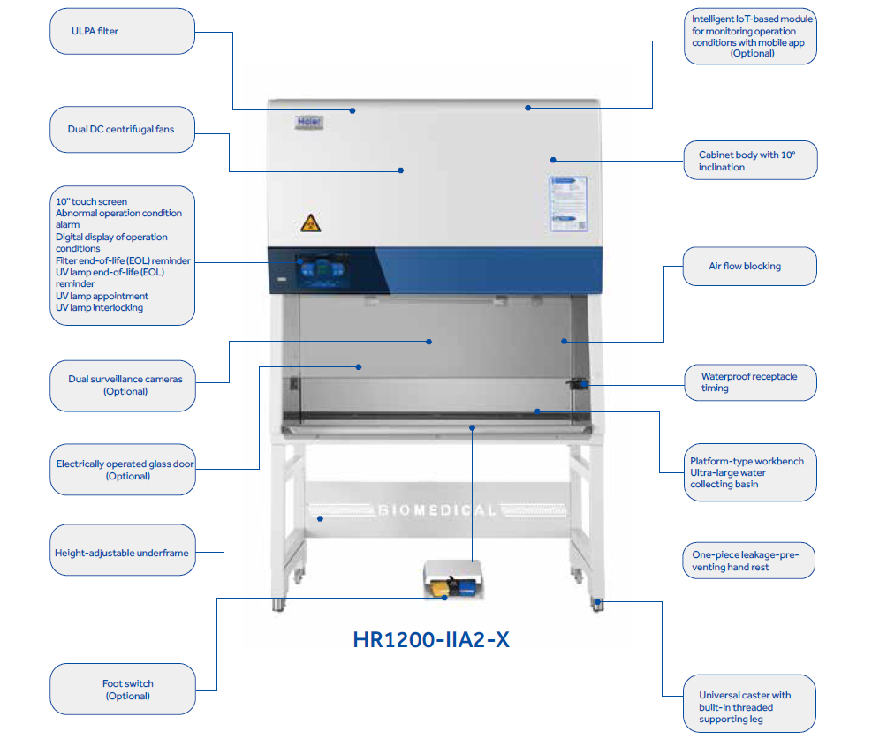
Fig 7: biological safety cabinet. https://fr.haiermedical.com/
Tables 1: Laboratory Enclosure Comparison. https://www.besttechnologyinc.com/
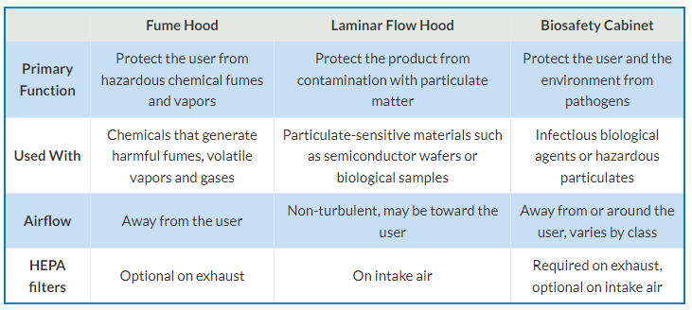

- Design Concept :
Depending upon the needs of a laboratory they are designed and manufactured in various types, sizes and Configurations.
Basically, a fume hood is just a large box on top of a lab workbench . This box has a large door or shutter at one side, and may or may not have glass or CRCA sheet walls on other sides. If you need to display some dangerous kind of experiment to an audience on top of an island-type lab table, then you need a glass-walled chamber; or else a wall-facing metal fume cabinet is fine.
As the fume hood needs to suck the air out of the box, it generally has an exhaust fan or air pump inside it above the work area, and a sealed vent pipe connected to it that goes to the outside atmosphere, or to a filter block. There are some types of fume hoods that don’t need a vent or air ducts; we’ll cover them soon.

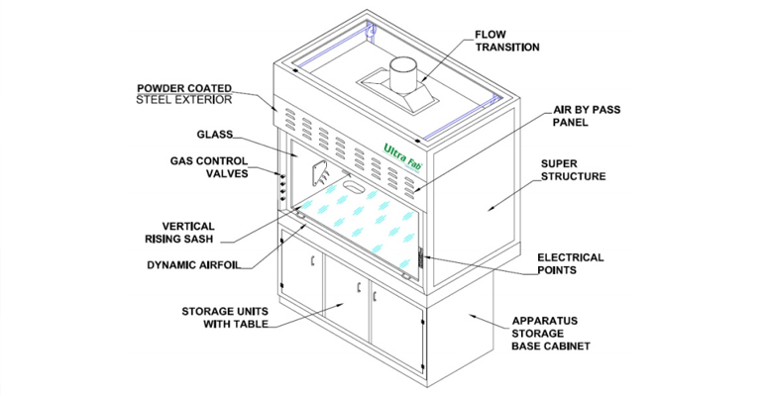
Fig 9 : Design Concept of Fume Hood. https://ultrafabindia.com/
- Working Principle of a Fume Hood
The functions of a fume hood are as follows:
- To protect the user from inhaling toxic fumes
- To protect the experiment or sample from contamination
- To protect the user from explosions or spills
- fume hood Preventive maintenance
To ensure the containment efficiency of a fume hood, it is recommended to have it calibrated and maintained at least once a year. American Standard ASHRAE 110-2016 and European Standard EN141751 are the basis of the following test procedures to check the fume hood’s ability to contain fumes and evaluate the hood’s performance.
- Face Velocity Measurement Test: Face velocity measurements determine the average velocity of air moving perpendicular to the hood face. The measurement is expressed in m/s or fpm. Face velocities will often provide information concerning the fume hood's ability to properly control contaminants.
- Airflow Visualization: Local and gross airflow visualization tests are conducted to observe airflow patterns inside the work area. This test qualitatively checks a hood’s ability to contain vapors. Airflow visualization, also known as smoke pattern test, can detect any leakages in the cabinet’s design if fumes can be seen escaping from the hood.
- Tracer Gas SF6 Containment Test (Optional with separate costs): Using Sulfur Hexafluoride, this test checks how efficient and effective the fume hood is for containing hazardous fumes. This test consists of 3 parts: static gas leak, face hood surface scan, and sash movement effect.
- Light Intensity and Noise Level Test (Optional, with separate costs): These tests check if the fume hood’s light intensity and noise level are within the acceptable range. This is to ensure that the fume hood is ergonomic and will not cause distractions to the operator.
- Carbon Filter Test (Applicable for Ductless Fume Hoods, Optional with separate costs): RAE meter is used to check if the carbon filter is still functional or if it is saturated and needs to be replaced. The RAE meter is placed at the exhaust of the ductless fume hood and will detect the concentration of VOCs present. A high concentration of signal indicates that the filter is saturated and must be changed.

