Computer mice can be categorized by connection type (wired or wireless), sensor type (optical, laser, or mechanical), and design/purpose (gaming, ergonomic, trackball, stylus, or 3D). Optical and laser mice use light to track movement, while mechanical mice use a physical ball. Ergonomic designs focus on comfort, and gaming mice often have extra features for performance.
By connection type
- Wired Mouse: Connects to a computer via a physical cable, most commonly a USB port. These are known for reliable, lag-free performance.
- Wireless Mouse: Connects without a cable, using either a small USB receiver or Bluetooth technology.
- Bluetooth Mouse: A type of wireless mouse that uses Bluetooth to connect directly to a computer's Bluetooth-enabled port.
By sensor type
- Optical Mouse: Uses an LED light to detect movement on a surface.
- Laser Mouse: Similar to an optical mouse, but uses a laser instead of an LED for higher precision, often allowing it to work on a wider range of surfaces, including glass.
- Mechanical Mouse: An older design that uses a large rubber or metal ball to track movement. It requires frequent cleaning to maintain performance.
By design and purpose
- Gaming Mouse: Features such as high DPI (dots per inch) for sensitive tracking, extra programmable buttons, and a more ergonomic design to support long sessions.
- Ergonomic Mouse: Designed to fit the hand and wrist in a more comfortable position to reduce strain. This category includes:
  - Vertical Mouse: A type of ergonomic mouse that holds the hand in a "handshake" position to reduce wrist strain.
- Trackball Mouse: Instead of moving the entire mouse, the user rolls a ball on the device with their thumb or finger to control the cursor.
- Stylus Mouse: Resembles a pen or stylus, often used for graphics tablets or touchscreens to provide precise control.
- 3D Mouse: A specialized mouse, often used in 3D design and engineering, for manipulating objects in a 3D space.

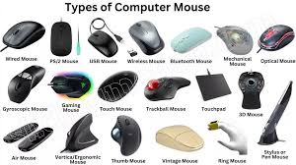
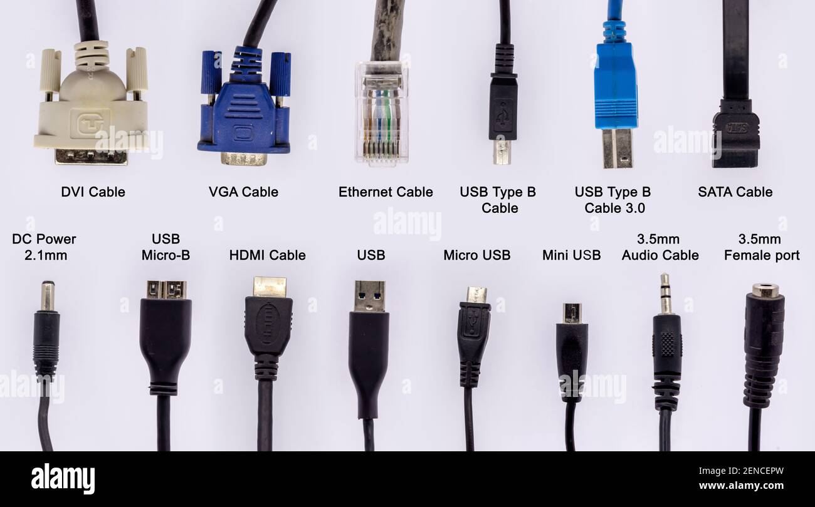

Common computer cable types include Ethernet for networks, USB for peripherals and charging, and various video cables like HDMI, DisplayPort, DVI, and VGA for connecting monitors. Other types are power cables for electricity, audio cables for sound, and internal cables like SATA for connecting components inside a computer.
Data and Networking Cables
- Ethernet: Connects a computer to a network or the internet.
- USB: The most common cable for connecting peripherals like mice, keyboards, and printers, as well as for charging devices. Different connector types exist, such as USB-A, USB-B, USB-C, and Micro-USB.
- Fiber Optic: Uses light pulses to transmit data over long distances at very high speeds.
- SATA: Connects internal storage devices like hard drives and solid-state drives to the motherboard.
- Thunderbolt: Offers high-speed data transfer and video signal transmission, often combining features of USB and DisplayPort.
Audio and Video Cables
- HDMI: Transmits high-definition digital video and audio signals to displays like monitors and TVs.
- DisplayPort: Similar to HDMI, used for sending digital video and audio signals.
- DVI: Transmits digital or analog video signals between a computer and a monitor.
- VGA: An older cable that transmits analog video signals to a monitor.
- Audio Jacks: Connect headphones, speakers, and microphones. Common types are 3.5mm audio cables.
Power and Other Cables
- Power Cables: Provide electricity to the computer and monitor from a power outlet.
- PS/2: Older cables used for connecting keyboards and mice, largely replaced by USB.

