Phylum Chordata

General characteristics of Chordates
- Chordates form a large and diverse phylum, largely comprising marine, freshwater, and terrestrial vertebrates.
- They are coelomates, triploblastic, and bilaterally symmetrical.
- At certain stages of their development, they possess a hollow dorsal nerve trunk, a dorsal skeletal element called the notochord, double pharyngeal gill slits, and generally a tail behind the anus (Figure 42).
- The nervous system is a closed tube dorsal to the notochord. They are epineurians.
- They possess segmented muscles throughout their body.
- They have a cartilaginous or bony endoskeleton.
- The circulatory system is closed and high-pressure, with a ventral heart.
- Chordate invertebrates are filter feeders, and most vertebrates are macrophages using toothed jaws. The digestive tract is complete.
- Invertebrate chordates lack distinct excretory organs (simple diffusion or via solenocytes). Vertebrates possess kidneys.
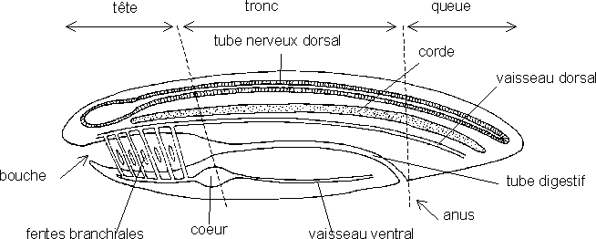
-The respiratory system consists of gills in aquatic chordates and lungs in terrestrial chordates.
-Reproduction is sexual.

Fig. 42: General organization of chordates

Systematic:
Chordates are subdivided into three subphyla.
A- Subphylum Tunicata:
- Tunicates or Urochordates are either fixed or mobile.
- The larva possesses a notochord in its tail, which disappears in the adult.
- The body is enclosed in a tunic, e.g., Ascidians (Figure 43).

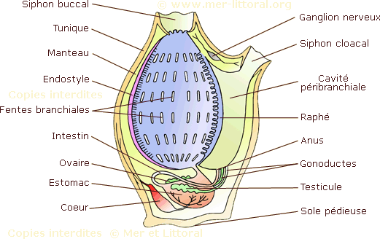
Fig. 43: Anatomy of a solitary ascidian

B- Subphylum Cephalochordata:
- Cephalochordates are mobile with an asymmetrical body architecture.
- The notochord develops to form the extremity of the body.
- They possess slight cephalization e.g., Amphioxus.
Tunicates and cephalochordates are sometimes called invertebrate chordates (or prochordates), and cephalochordates are acraniates.

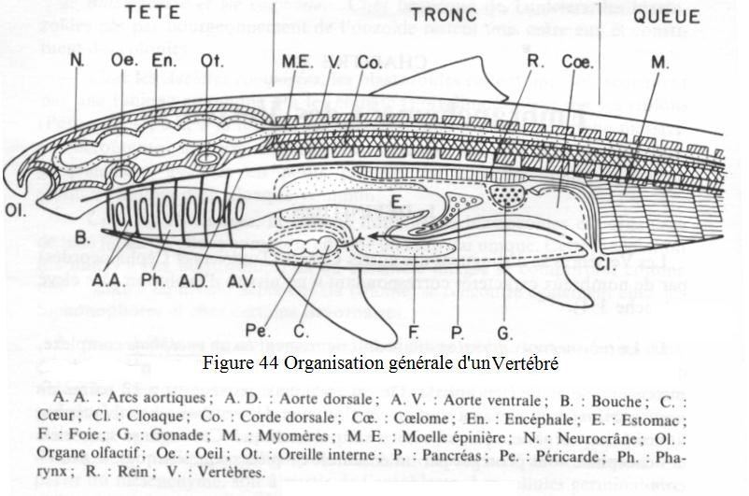
C- Subphylum Vertebrata (or Craniata):
Their dorsal nerve cord develops anteriorly to form a brain contained within a skull. And the notochord is generally replaced by cartilaginous or bony intersegmental units (vertebrae)

The subphylum Vertebrata comprises two infraphyla:
- Infraphylum Agnatha: These are jawless fish. They include two classes: Class Lampreys and Class Mexinae.
- Infraphylum Gnathostomata: These are jawed vertebrates. We distinguish:
- Class Acanthodii: Extinct fish with pairs of fins.
- Class Placodermi: Extinct shark-like fish with bony plates.
- Class Chondrichthyes (Cartilaginous fish)
- They have a cartilaginous skeleton and skin covered with placoid (tooth-like) scales.
- They are poikilothermic (variable body temperature) and gonochoric.
- Respiration is gill-based. Each of their gills has its own opening, and they also have a pair of blowholes.
- They do not have a swim bladder.
- They are divided into two subclasses.

Subclass Elasmobranchii: They are most often oviparous, e.g., sharks, rays.
Subclass Holocephali (Chimeras): They live on the seabed. Superclass Osteichthyes (Bone Fishes):
- They are characterized by a bony skeleton and an epidermis of bony scales.
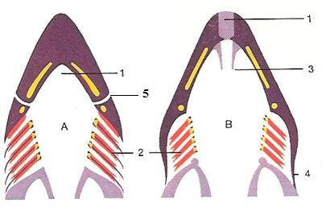
- They are poikilothermic and gonochoric.
- Their gill slits are covered by an operculum and gill arches articulated on a single bony piece.

Arrangement of gills in cartilaginous (A) and bony (B) fish 1. mouth; 2. gills; 3. mouth opening mechanism; 4. operculum; 5. Blowhole

- They possess a swim bladder (gas bladder).
- They are grouped into two classes

Class Actinopterygii (ray-finned fishes): This class includes the vast majority of fish species. It contains, in particular, the majority of fish of economic interest to humans, e.g., sturgeons, tuna.

Class Sarcopterygii (vertebrates with fleshy limbs), e.g., lungfish.

Superclass Tetrapoda
- They are characterized by the presence of two pairs of limbs
- The circulatory system is quite distinct in the larva and the adult.
- Tetrapods comprise 4 classes

Class Amphibia (Batras)
- These are non-amniote tetrapods with bare, moist skin.
- Respiration is cutaneous and pulmonary in the adult stage and gill-based in the larval stage.
- They are poikilothermic.
- They undergo metamorphosis.
- They comprise three orders distinguished by their lifestyle and appearance.

o Order Anura:
includes frogs and toads. They generally have long hind limbs folded under their bodies, shorter forelimbs, webbed toes without claws, no tail, large eyes, and moist glandular skin.

o Order Caudata (Urodela):
composed of salamanders and newts. They are highly dependent on aquatic environments. Their bodies are elongated with a long tail and four small legs.

o Order Gymnophiona (Apoda):
These are long, cylindrical, legless animals resembling snakes and worms.

Class Reptilia (Reptiles)
- These are terrestrial animals, often with elongated bodies covered in scales.
- They are amniotes. Most are oviparous, but some are ovoviviparous.
- They breathe via lungs.
- They are poikilothermic.
- Their legs are short, atrophied, or absent. They move by crawling. - The majority are carnivores.
- This class comprises four orders.

o Order Rhynchocephalia: These are primitive reptiles, e.g., Sphenodon
o Order Squamata: Their bodies are entirely elongated and covered in thin scales, e.g., lizards, snakes
o Testudines: Their bodies are covered with large horny plates fused to dermal bones, forming a shell, e.g., Turtles
o Order Crocodilia: They possess well-developed legs and movable eyelids, e.g., Alligators, Caimans, Crocodiles

Class Aves (Birds)
- These are bipedal, aerial, amniotic tetrapods.
- Their bodies are covered in feathers.
- Their forelimbs are modified into wings.
- They possess a beak.
- They are all homeothermic (maintain a constant body temperature).
- They are all oviparous.
- Modern birds form the subclass Neornithes, which includes two superorders:

o Superorder Paleognathae: They have reduced or atrophied wings. They do not fly, e.g., Ostrich, Cassowary, Kiwi.

o Superorder Neognathae: They have well-developed wings and can fly, e.g., Eagle, Parrot, Pigeon. With the exception of the Sphenicidae family, e.g., Penguins.

Class Mammalia (Mammals)
- They are amniotes
- Their bodies are covered entirely or partially with hair
- They possess mammary glands
- They are all homeothermic
- Their reproduction is generally viviparous.
- They comprise two subclasses

o Subclass Prototheria: These are primitive, oviparous mammals, but the young are fed milk after hatching. They include the order Monotremata (Monotremes), e.g., Echidna.
o Subclass Theria: This subclass comprises two infraclasses:

- Infraclass Metatheria: These are viviparous, but the development of the young is completed in a pouch. These are the Marsupials, e.g., Kangaroo.

- Infraclass Eutheria: These are viviparous, possessing a placenta. These are the Placental mammals. They include all other mammals, e.g., Whale, Bat, Monkey, Human

