Trigonometry:
It is the study of angle measurement
When you have a right triangle there are 5 things we can know about it
The length of the sides and the measures of the acute angles

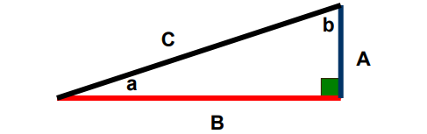
Some terminology:
The hypotenuse: will always be the longest side, and opposite from the right angle.
The opposite: side is the side directly across from the angle you are considering (angle a). The adjacent: side is the side next to angle you are considering.

