Shapes in english :
- Triangles :
An isosceles triangle is a triangle with two congruent sides and one unique side and angle.
Ex. 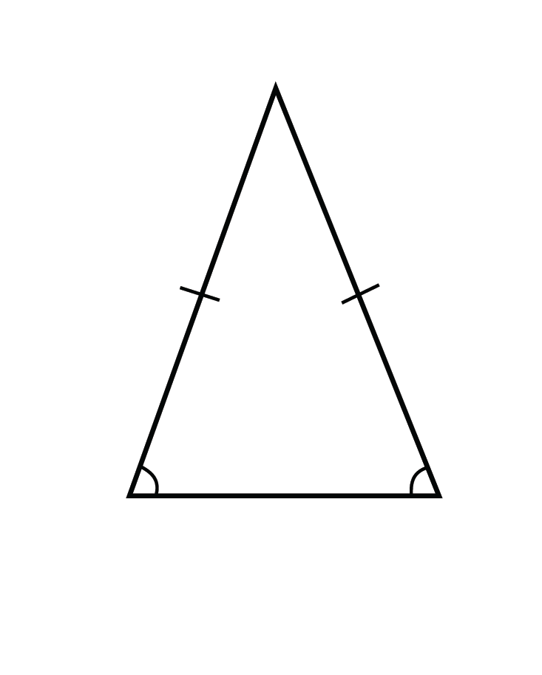
An equilateral triangle is a triangle with three congruent sides and three congruent angles.
Ex. 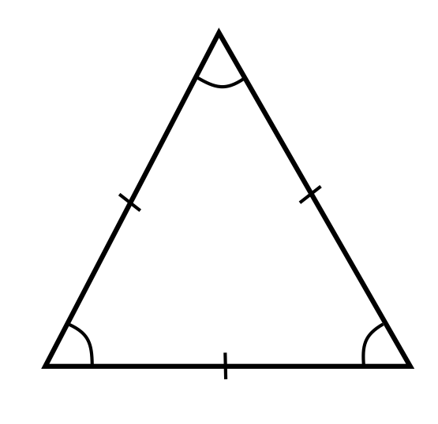
A right triangle is a triangle that has one right angle.
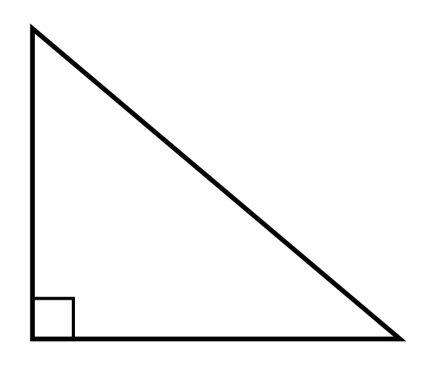

- Other shapes :
- Square : it has 4 equal sides and 4 equal angles
- Rectangle: it has 4 sides and 4 right angles
- Rhombuses: it has 4 equal sides
- Parallelogram: it has 2pares of parallel sides
- Trapezoid/ trapezium: it has one pair of parallel sides
- Pentagon: it has 5 sides and 5 angles
- Hexagon: it has 6 sides and 6 angles
- Circle: it has a point in the centre from which each point on the diameter is equidistant
- Ellipse: an oval shape
- Cube: it has 6 faces, 12 edges and 8 vertices

