Td 2 Effect of dominance, épistasie and valeurs sélectives
Exercice 1 – Dominance Effect
Question:
In a diploid plant species, two alleles (A and a) affect plant height.
- AA = 100 cm
- Aa = 90 cm
- aa = 80 cm
1-What is the additive effect (a)?
2-What is the dominance effect (d)?
3- What type of dominance is shown?

Exercise 2: Epistasis Type
Question:
In a dihybrid cross, the F₂ generation gives a phenotypic ratio of 9:7.
1- What type of epistasis is this?
2- Explain the interaction briefly.

Exercise 3: Expression of Variance
Question:
Total phenotypic variance (Vp) in a population is 20.
Genetic variance (Vg) = 12, and environmental variance (Ve) = 8.
Find the broad-sense heritability (H²).

Exercise 4: Absolute and Relative Selective Value
Question:
Three genotypes (AA, Aa, aa) have survival rates (absolute fitness, W):
AA = 1.0, Aa = 0.8, aa = 0.6
1️⃣ Calculate the relative fitness (ω) of each genotype.
2️⃣ Which genotype is the most fit?

Exercise 5: Selection Coefficient
Question:
Using the previous data (ω):
Calculate the selection coefficient (S) for Aa and aa.

Answers’

Exercise 1 — Dominance effect (additive a, dominance d)
Given: AA = 100, Aa = 90, aa = 80
Formulas
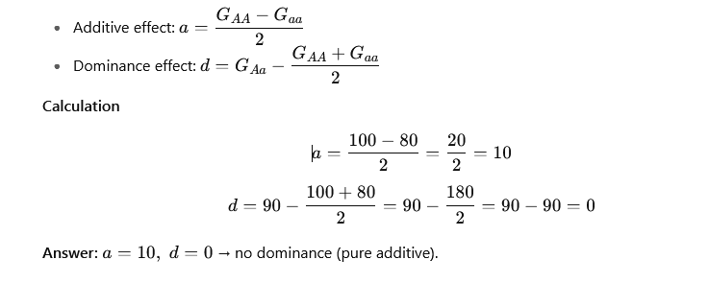

Exercise 2 — Type of epistasis (interpretation)
Given: F₂ phenotypic ratio = 9 : 7
Concept / Rule
- A 9:7 ratio in a dihybrid F₂ is characteristic of complementary gene action (complementary epistasis): both loci must carry at least one dominant allele to produce the phenotype.
Answer (brief): Complementary epistasis — both dominant alleles required.
Exercise 3 — Expression of variances & broad-sense heritability
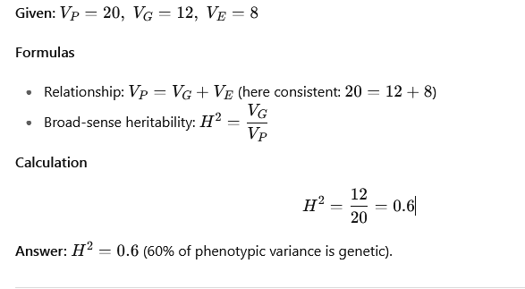
Exercise 4 — Absolute (W) and relative fitness (ω)
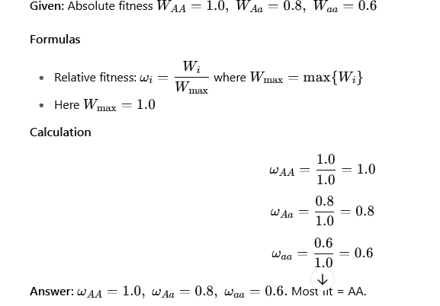
Exercise 5 — Selection coefficient (s)
