Part 1: Theoretical Foundations of Plant Breeding
1-1 Elusive genes: modalities and meaning of polygenic heritability
1.1.1. Average effect of a gene
According to Barrett et al. (2011), the average effect of a gene (a theoretical notion) is defined as the difference between the mean value of the individuals carrying that gene and the mean value of the population.
1.1.2. Dominance effect
According to Gallais (2011), the dominance effect corresponds to the difference between the mean of the values of the two homozygotes and the actual value of the heterozygote.

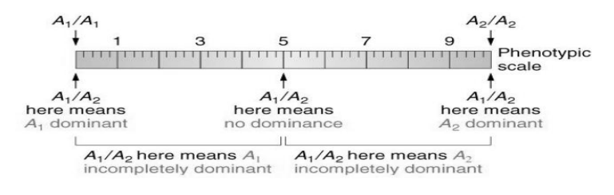
Figure 1: Dominance Effect
1.1.3. Forms of Epistasis
If one gene modifies the expression of phenotypes controlled by another gene, this interaction between two or more loci is called epistasis. According to Gallais (2011), it is reflected by a deviation between the observed value of a genotype and its expected value based on the additivity of the effects of the loci.
There are two forms of epistasis:
- Dominant epistasis, where a dominant gene influences the expression of another gene coding for a different phenotype.
- Recessive epistasis, where a recessive gene influences the expression of another gene coding for a different phenotype.
These two types of epistasis can be:
- Simple: a single gene influences another.
- Double: involving two complementary genes.
The gene whose expression is modified is called hypostatic, and the modifying gene is called epistatic.
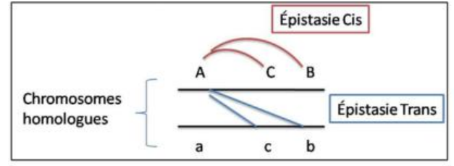
Figure 2 Effect of epitasis
1.1.4. Expression of Variances
The components of phenotypic variance (Vp) are of three types: genetic variance (VG), environmental variance (VE), and the covariance between genes and environment (VG·E).
Genetic variance (VG) is the sum of the effects of each gene.
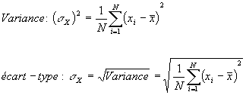
Var(G)=Var(D)+Var(A)+Var(I)
- Var(G): Genotypic variance
- Var(D): Variance due to dominance
- Var(A): Additive variance
- Var(I): Variance due to epistasis

Table 1: Estimation of variances for different traits in maize
Trait | Additivity (%) | Dominance (%) | Epistasis (%)
Number of tillers | 75 | 15 | 10
Number of ears | 65 | 25 | 10
Earliness to heading | 60 | 30 | 10
Plant height | 50 | 40 | 10

The more a trait is generally and physiologically complex, the less likely it is to show a strong additive variance. The increasing contribution of dominance interactions is due to the importance of heterozygosity in achieving high yield.
The relatively modest role of epistasis is difficult to explain; it represents about 10% of the total variance.
This type of table is of interest in designing strategies for selection methods of traits such as the number of tillers, number of ears, or earliness to heading, which can be improved in parental lines before hybridization.
1.2. Biological Significance of Additivity
1.2.1. Selective Values and Equilibria in Recombination Rates Between Two Genes
- The selective value (ω) (fitness, reproductive success, or adaptive value) describes the ability of an individual of a given genotype to reproduce.
- The selective value of a genotype depends mainly on its survival from the zygote (egg) stage to the adult stage, and on its fertility (the number of viable offspring capable of reproducing).
Selective value=Survival×Fertility\text {Selective value} = \text{Survival} \times \text{Fertility}Selective value=Survival×Fertility
- Absolute selective value (W).
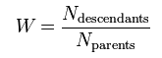
Relative Selective Value (ω)
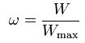 with

The selection coefficient (S) is the difference between the relative selective value and 1:

S=ω−1

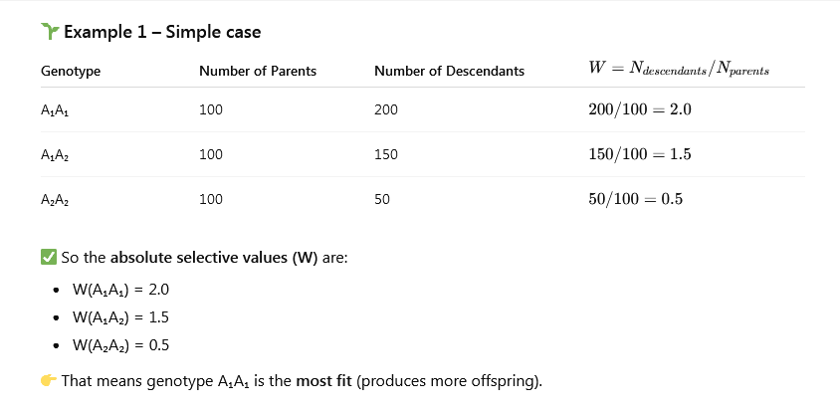
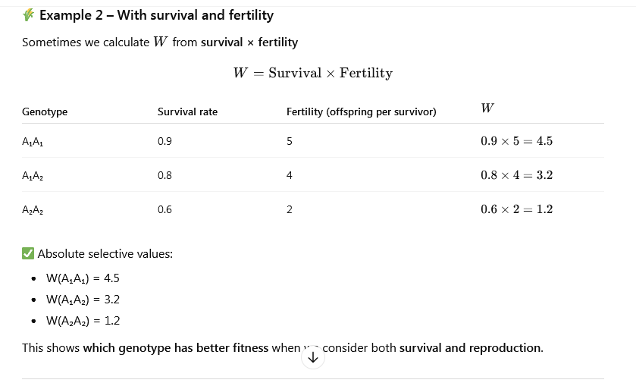

-Genetic Recombination: Genetic recombination is the exchange of genetic information between two different genomes or between two chromosomes. It generally involves an exchange of DNA fragments. Genetic reshuffling occurs during the sexual reproduction of species.
Genetic recombination involves the rearrangement between two different nucleic acid molecules, thereby creating two new genetic combinations.

-How It Happens (Steps):
- During meiosis I, homologous chromosomes pair up.
- They exchange segments of DNA (this is called crossing-over).
- After meiosis, the resulting gametes (pollen, ovules, sperm, or eggs) contain new combinations of alleles.
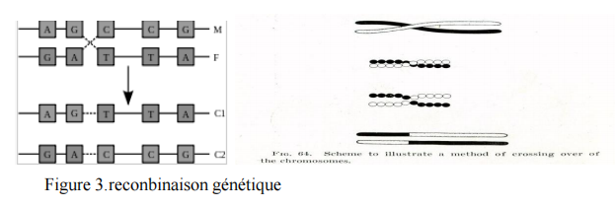
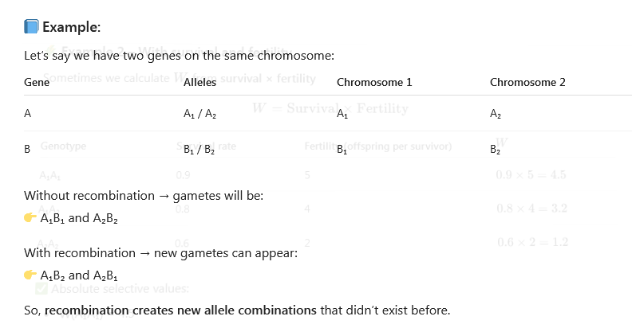

- Recombination Frequency (r):
It’s the percentage of recombinant gametes among the total gametes.
r=Number of recombinant gametesTotal number of gametesr = \frac{\text{Number of recombinant gametes}}{\text{Total number of gametes}}r=Total number of gametesNumber of recombinant gametes​
r=0 → genes are completely linked (no recombination).
r=0.5 → genes are independent (maximum recombination = 50%).

1.2.2. Linkats

1- Definition:
Genetic linkage means that two or more genes are located close to each other on the same chromosome, so they tend to be inherited together.
2- Types of Linkage:
2-1- Complete linkage:
No crossing-over occurs between the genes.
The genes are always inherited together.
Recombination frequency r=0
2-2 Incomplete linkage:
Sometimes crossing-over happens between them.
So we get both parental and recombinant combinations. 0<r<0.5
2-3 Independent assortment:
The genes are on different chromosomes or very far apart on the same one.
They segregate independently.r=0.5
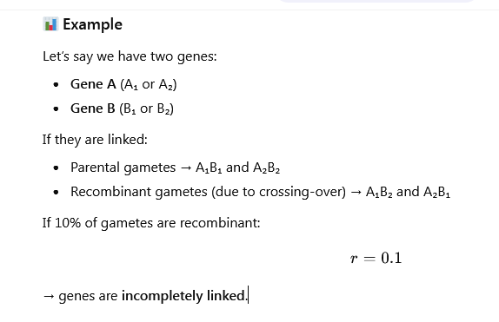
3 Chromosomal Level of Genetic Recombination and Linkage
which clusters within the same region of the chromosome several loci coding for forms or functions whose adaptive values are convergent.
3-1-Chromosomes and Genes
A chromosome is a long DNA molecule that carries many genes arranged in a specific order.
Each gene has a locus (position) on the chromosome.
During sexual reproduction, each parent passes on one copy of each chromosome.
- Chromosomal Recombination (Crossing-Over)
Recombination occurs at the chromosomal level during meiosis I, when homologous chromosomes (one from the mother and one from the father) pair up.
The chromosomes come together and form a structure called a bivalent.
Non-sister chromatids (one from each chromosome) cross over and exchange DNA segments.
This creates new combinations of alleles on each chromosome.
- Result of Chromosomal Recombination
New chromosomes are formed that mix maternal and paternal genes.
This leads to genetic diversity among offspring.
The closer two genes are on a chromosome, the less likely they are to be separated — this explains genetic linkage.
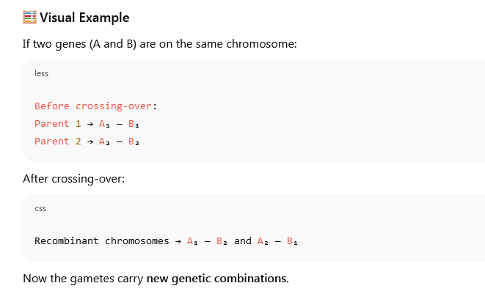

-The Finer (Molecular) Level of Genetic Recombination corresponding, for each of these loci, to the grouping of several coding units with nearly identical expression, forming batteries of genes.
1.3. Heterozygosity: Inbreeding and Heterosis

Heterozygosity

🧬 Definition:
Heterozygosity is when an individual has two different alleles for a gene. For example:
At one gene locus → Aa (A ≠ a)
It is a measure of genetic diversity within individuals or populations.

📊 Population level:
If many individuals are heterozygous, the population has high heterozygosity, meaning more variation and better adaptability.
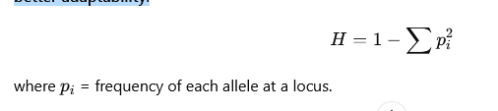
Inbreeding

Definition
Inbreeding is the reproduction between individuals that share a common ancestry, leading to an increase in homozygosity (AA or aa) and a decrease in heterozygosity (Aa) in a population.

Main effects
- Increase of homozygous genotypes → both dominant and recessive alleles become more frequent in pure form.
- Decrease of genetic variability → population becomes more uniform.
- Expression of deleterious recessive alleles → may cause inbreeding depression, leading to reduced vigor, fertility, or survival.

Inbreeding coefficient (F)
It measures the probability that two alleles at a locus are identical by descent.
- F=0 → no inbreeding (random mating)
- F=1 → complete inbreeding (self-fertilization)
Example:
After one generation of selfing (self-fertilization):
F=1/2
Each generation of selfing increases FFF until it approaches 1.

Inbreeding in plants
- Used intentionally in plant breeding** to produce pure lines** (e.g., wheat, rice).
- After several generations of selfing → a homozygous line is obtained → used for hybrid production.

🔹 Advantages
- Production of genetically uniform lines (stable, predictable traits).
- Useful for genetic studies and hybrid vigor (heterosis).

🔹 Disadvantages
- Inbreeding depression: reduced growth, fertility, or yield due to expression of harmful recessive genes.

Inbreeding Depression

🔹 Definition
Inbreeding depression is the reduction in biological fitness (vigor, fertility, yield, etc.) that occurs when closely related individuals mate or when a population undergoes repeated self-fertilization.
It is caused by the increase in homozygosity, which leads to the expression of harmful (deleterious) recessive alleles.

Mechanism
When two related individuals carry the same harmful recessive allele (a), their offspring can be aa, expressing the defect.

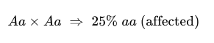

Homozygosity
→ Hidden recessive alleles become visible
→ Fitness ↓

Manifestations
- Decrease in growth rate
- Reduced fertility and yield
- Lower resistance to diseases
- Weakness or poor survival

Example
In self-pollinated crops like maize or tomato, continuous selfing causes smaller plants, poor fruit set, and lower productivity.

Heterosis (Hybrid Vigor)

🔹 Definition
Heterosis (or hybrid vigor) is the increase in vigor, growth, yield, or fertility observed in hybrid offspring (F₁) obtained by crossing two genetically different parents.

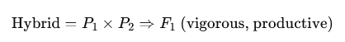

Mechanism
- Crossing restores heterozygosity (Aa) at many loci.
- Harmful recessive alleles are masked by dominant ones.
- Favorable combinations of alleles interact positively (dominance and overdominance effects).

Manifestations
- Higher yield and faster growth
- Better resistance to stress or disease
- Greater fertility
- Improved quality (e.g. fruits, grains)

Example
Hybrid maize (corn): F₁ plants are taller, more productive, and resistant compared to either parent.

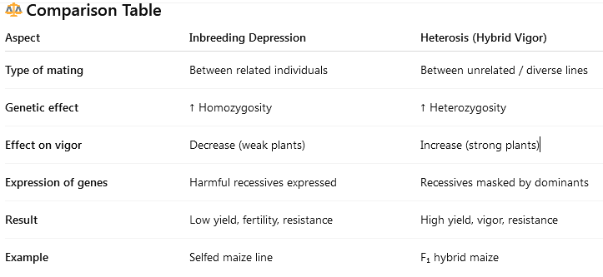

Components of Variance
The total phenotypic variance (VPV_PVP​) can be divided into:
VP=VG+VEV_P = V_G + V_EVP​=VG​+VE​
and the genetic variance (VGV_GVG​) is composed of:
VG=VA+VD+VIV_G = V_A + V_D + V_IVG​=VA​+VD​+VI​
where:
Symbol | Meaning
VAV_AVA​ | Additive genetic variance (transmitted to offspring)
VDV_DVD​ | Dominance variance (interaction between alleles at the same locus)
VIV_IVI​ | Epistatic variance (interaction between genes at different loci)
VEV_EVE​ | Environmental variance

Basic Concepts

🔹 Allele frequencies
Suppose we have a gene with two alleles:
- AAA (dominant) with frequency ppp
- aaa (recessive) with frequency qqq
By definition:
p+q=1
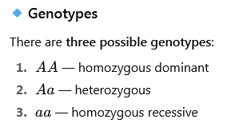

Hardy–Weinberg Principle
If the population is large and mating is random (no selection, mutation, or migration),
the genotype frequencies reach equilibrium and can be predicted from the allele frequencies:

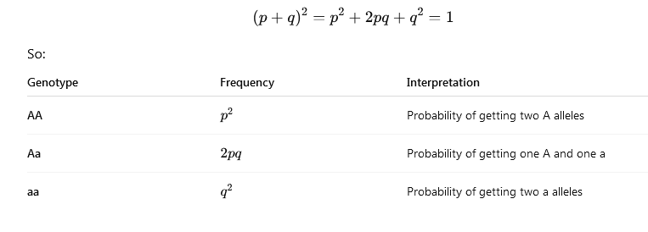Example Calculation
Let’s say in a population:
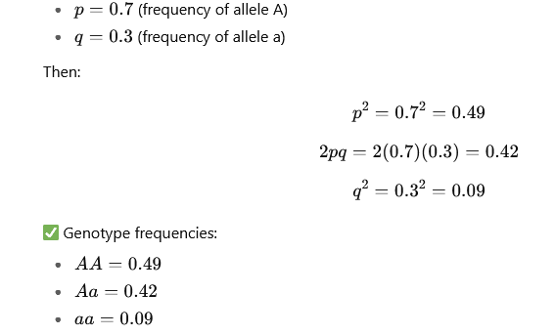
These add up to 1 (0.49 + 0.42 + 0.09 = 1).

Application in Inbreeding
If inbreeding occurs (inbreeding coefficient FFF), the expected genotype frequencies change:
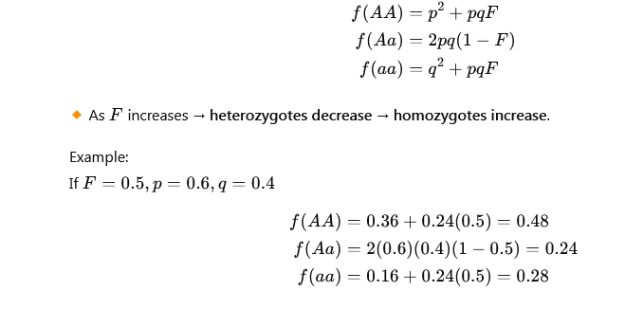
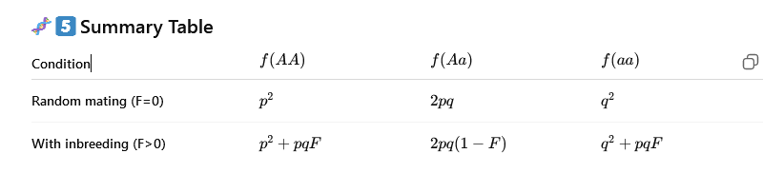
Value of an Individual in Crossing

Definition
The value of an individual in crossing is the genetic potential that an individual can transmit to its offspring when crossed with others.
It tells how good or bad that individual is as a parent for improving a trait (for example: yield, height, resistance…).
In other words, it’s the expected average performance of its progeny compared to the population mean.
Types of Genetic Value
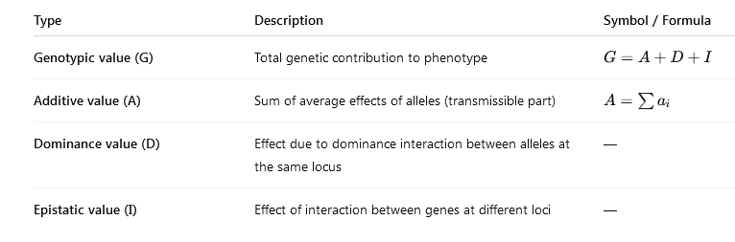
Only the additive value (A) is transmitted to offspring and determines the breeding value or value in crossing.

Mathematical Expression
If the phenotypic value (P) of an individual is determined by:
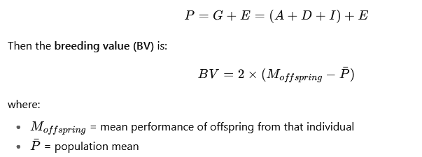
or equivalently, the expected deviation of the progeny mean from the population mean due to that parent’s genes.

Example
Let’s say we cross individual X with the population and obtain:
- Mean yield of population = 80 q/ha
- Mean yield of offspring from X = 88 q/ha
Then:
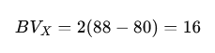
So, the breeding value (value in crossing) of X = +16, meaning it can increase yield by 16 units in its progeny.
Practical Meaning
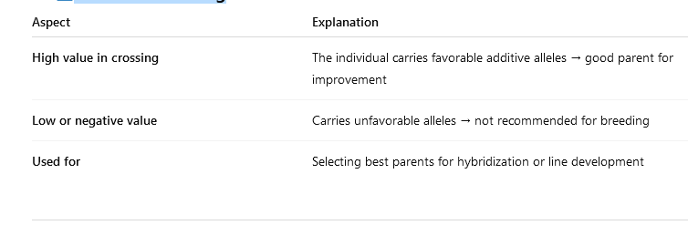

Relation with Heritability
The expected genetic gain from selection depends on:
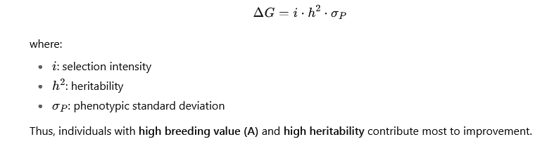
Heritability

Definition
Heritability measures how much of the variation in a trait (for example: height, yield, or resistance) is due to genetic factors, as opposed to environmental effects.
It tells us how reliably a trait can be passed from parents to offspring.
two types of heritability
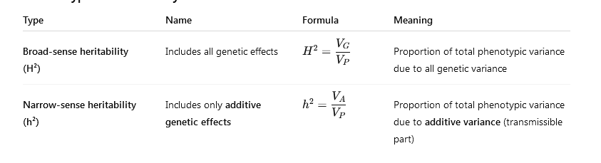

1.4. Value of an Individual in Crossing
The different genetic effects—additivity, dominance, and heterosis—allow us to understand the factors that determine the value of an individual in a cross.
It is empirically known that, for a given trait or a set of traits, certain individuals have the capacity to influence their offspring more than others.
The crossing value is defined by genetic balance, heritability, and combining ability.

1.4.1. Heritability
According to Nanson (2005), heritability is defined as follows:
- Broad-sense heritability: h² = genetic variance / phenotypic variance
- Narrow-sense heritability: h² = additive genetic variance / phenotypic variance

1.4.2. Genetic Balance
A genetic balance indicates the adaptation of an individual’s genetic constitution to a given environment.
When the functioning of the whole set of genes is considered good, the genotype is said to be well balanced.
The nature of the alleles present along The nature of the alleles present along a gene sequence on the chromosome determines the quality of the internal balance.
Heterozygosity at each locus may lead to a good equilibrium between alleles. This is referred to as a relationship balance.

1.4.3. Combining Ability
The general combining ability (GCA) of a parent is estimated by the average value of its offspring with different partners.
For a given trait:
Trait A = General ability of X + General ability of Y + Specific ability of XY
A line is said to have good general combining ability (GCA) if it produces more productive offspring with several partners. *
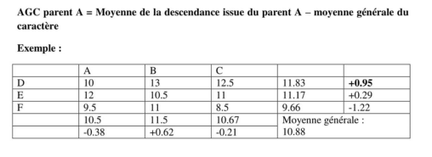
The best parent is the one with a high GCA (parent D).
In the product of a cross, we should find the sum of the GCAs of both parents.
For a given cross, there is always a deviation from this sum; this deviation is called the specific combining ability (SCA) of the cross. This is therefore not linked to a parent but to a precise combination.
SCA = observed trait value – expected (predicted) value
Expected value = mean + GCA p1 + GCA p2
1.5. Methods for Assessing the Value of an Individual in Crossbreeding
Several methods can be used to assess the value of an individual in crossbreeding:
- Open pollination (only for allogamous species): comparing the offspring of each genotype freely pollinated.
- Top-cross test: the same tester is used for all parents.
- Poly-cross test: the tester is composed of the pollen population of the structures under study.
- Hierarchical crosses: a certain number of parents are chosen at a first level and crossed with different groups that constitute a second level.
- Diallel crosses: these allow the simultaneous estimation of both SCA (Specific Combining Ability) and GCA (General Combining Ability).

1.6. Structure of Natural Populations
According to Pierce (2012), the Hardy–Weinberg law describes the relationship between genotypic frequencies and allelic frequencies.
In an infinitely large population, where mating occurs at random (panmixia), where there is no migration, no selection against a particular phenotype, and where the mutation rate is constant, the proportions of the different genotypes remain constant from one generation to the next.

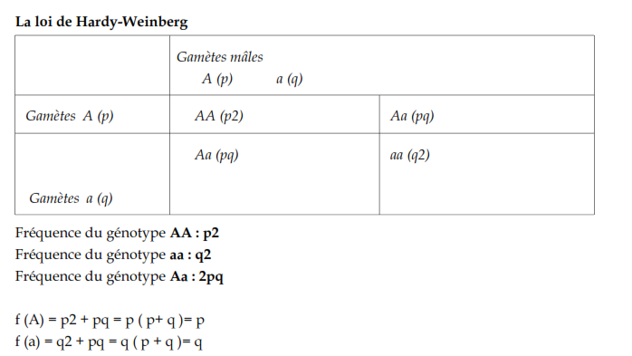
In an ideal theoretical population, allele frequencies and genotypic frequencies remain stable across generations.
Genotypic frequencies are determined by allele frequencies through a simple relationship:
(p+q)2(p + q)^2(p+q)2 for 1 gene with 2 alleles (Pierce, 2012).
This holds true if the population is ideal:
- A population of diploid organisms with sexual reproduction.
- Non-overlapping generations (no mating between individuals of different generations).
- An infinitely large population where matings are completely random (panmixia).
- A genetically closed population (no migration or gene flow).
- All individuals, regardless of genotype, have the same ability to reproduce and produce viable offspring (no selection).
- No mutation and no meiotic segregation distortion.
1.5.1. Structure of a natural population in a self-pollinating species
Wild populations of self-pollinating plants are composed mostly of homozygous individuals. These species possess a tolerance to inbreeding acquired through natural selection. The homozygous structures extracted by the breeder from such a population are pure lines. The selected varieties are stable, homogeneous, and easily reproducible.
Self-pollination does not modify allele frequencies but quickly leads to homozygosity, with:
- f(AA) = f(A) = p
- f(aa) = f(a) = q
The disappearance of heterozygotes occurs at all loci, leading to individuals that are homozygous across their entire genome (pure lines).
1.5.2. Structure of a natural population in a cross-pollinating species
In cross-pollinating species, heterozygosity is the rule, due to the reshuffling of alleles favored in each generation of crossing. These species are poorly adapted to inbreeding, since natural selection can only eliminate unfavorable recessive genes in the homozygous state.
A good variety must therefore optimize heterosis, while also being easily reproducible identically: this is the role of hybrid varieties.
Cross-pollination creates an excess of heterozygotes, but it concerns only the locus (or loci) that determine the phenotype, and not the whole genome..

