Practical work 03

Detection of Microbial Enzymatic Activities (Protease, Amylase, Gelatinase, Lipase)

1. Objective
To detect the extracellular enzymatic activities of microorganisms, including proteases, amylases, lipases, and gelatinases, using multi-substrate media.

2. Media Composition

A. Plate Medium (Protease, Amylase, Lipase)
- BN (Nutrient Broth base) + Agar: 1 L
- Skim milk: 10 mL
- Starch: 1% w/v
- Tween 80: 2% v/v
- Gelatin: 5% w/v
- Distilled water: up to 1 L
This medium allows the simultaneous detection of protease (milk), amylase (starch), lipase (Tween 80), and gelatinase (gelatin) activities on plates, except gelatinase is better assessed in tubes.

B. Gelatinase Medium (Tube)
- BN (Nutrient Broth): 1 L
- Gelatin: 10% w/v
- Distilled water: up to 1 L
This medium is used in tubes to detect gelatin liquefaction, indicating gelatinase activity.

3. Medium Preparation
A. Plate Medium
- Dissolve BN + agar in ~800 mL distilled water. Heat to dissolve.
- Cool to ~50–55 °C. Add:
  - Skim milk 10 mL
  - Starch 1%
  - Gelatin 5%
  - Tween 80 2%
- Adjust volume to 1 L. Mix gently to homogenize.
- Pour into sterile Petri dishes. Allow to solidify.

B. Gelatinase Tubes
- Dissolve BN + gelatin in water.
- Sterilize at 121 °C for 15 min.
- Dispense into sterile tubes and allow to solidify at room temperature.

4. Inoculation
A. Plate medium
- Label plates with strain name, date, and enzyme to be tested.
- Using a sterile loop, spot inoculate or perform a short streak of the microorganism in the center of the plate.
- Incubate inverted at 30–37 °C for 24–48 h.
B. Gelatinase tubes
- Stab inoculate with a sterile needle/loop (1–2 cm deep).
- Incubate at 25–30 °C for 24–72 h (below gelatin melting point).

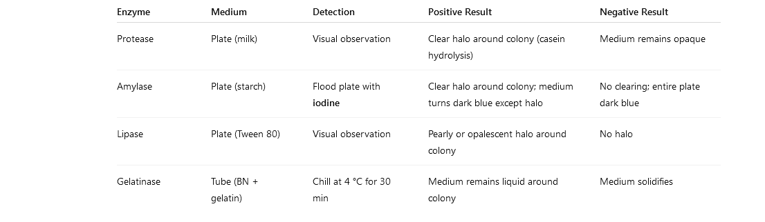

Questions
1- Why is it important to label plates and tubes clearly before inoculation?
2- How does the choice of substrate in the medium influence the type of enzymatic activity that can be detected?
3- How could you modify the TP if you wanted to test additional extracellular enzymes?
4- What is the significance of including a positive and negative control in this experiment?
5- Why is it important to use fresh cultures for inoculation rather than old or stored cultures?
6- How does the consistency (liquid vs solid) of the medium affect the detection of enzymatic activity?

