LW2 – COMPOUND PHYSICAL PENDULUM

I. OBJECTIVES:
- Experimental study of the movement of a compound Physical pendulum consisting of a rod and a disc.
- Determination of the gravity acceleration g.

II. INTRODUCTION:
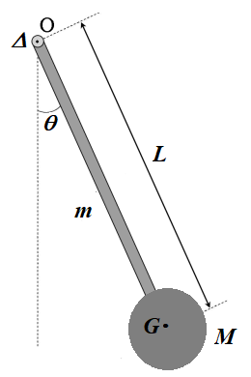
Compound physical pendulum is a solid which rotates, without friction, around a fixed horizontal axis (Δ), does not pass through its gravity center G and is placed in the field of gravity (see the opposite figure). The compound physical pendulum used in this study is made of a flat metal rod of homogeneous mass m relates to a solid disc of homogeneous mass M and radius R. The position of the pendulum is determined by the angle θ of the rod with the vertical.
In this experiment study, it will be admitted that m<< M and OG ≈ L.

III. HOME WORKS :
- Write the theoretical expression of the moment of inertia I_{ΔG} of a solid disc with homogeneous mass M and radius R relative to its axis Δ_{G} which passes through its gravity center G and then calculate its numerical value knowing: M = 1Kg and R = 4cm.
- Express the moment of inertia I_{Δ} of the previous solid disc relative to the rotation axis Δ parallel to its axis Δ_{G} which passes through its gravity center G depending on M, I_{ΔG} and the distance L separating the two axes Δ et Δ_{G}?
- Using the Lagrangian, find the motion equation of the previous physical pendulum in the case of small angles by neglecting the frictions and the rod mass m.
- Find the period expression T depending on the reduced length $L_{R}=\frac{I_{∆}}{M∙L}$
NOTES :
- L = E_{C} - E_{P} where E_{C} and E_{P} are respectively the kinetic and the potential energy of the system.
- For a one-dimensional motion x, the Lagrange equation is written as follows:
$$\frac{d}{dt}\left(\frac{∂L}{∂\dot{x}}\right)-\left(\frac{∂L}{∂x}\right)=0$$
- For a rotational motion θ, the Lagrange equation is written as follows:
$$\frac{d}{dt}\left(\frac{∂L}{∂\dot{θ}}\right)-\left(\frac{∂L}{∂θ}\right)=0$$
Full Name | Group | Assiduity (02 pts) | Report (18 pts) | Total Grades / 20
Date : …………………………………… ……………….…Time: ……………………………Lab. No.………………

IV. MANIPULATIONS :

- Displace the system to one side from the initial vertical position, not more than few degrees angular displacement (θ₀ ≤ 15°), and then release it gently without initial velocity. Afterward it begins to oscillate periodically. Measure the time t corresponding to 10 periods (t = 10 T), then record the results in the table below knowing that: M = 1 Kg and R = 0.04 m; the values of I_{Δ} and L_{R} are to be calculated.
$${\left[\frac{{ T}^{2}}{L_{R}}\right]}_{Average}\left[\frac{{ S}^{2}}{m}\right]$$ | $$\frac{{ T}^{2}}{L_{R}} \left[\frac{{ S}^{2}}{m}\right]$$ | $T^{2}$ (s²) | T (s) | t (s) | L_{R} (m) | I_{Δ} (Kg·m²) | L (m)

- Plot the graph T² = f (L_{R}) taking L_{R} along x-axis and T² along y-axis.
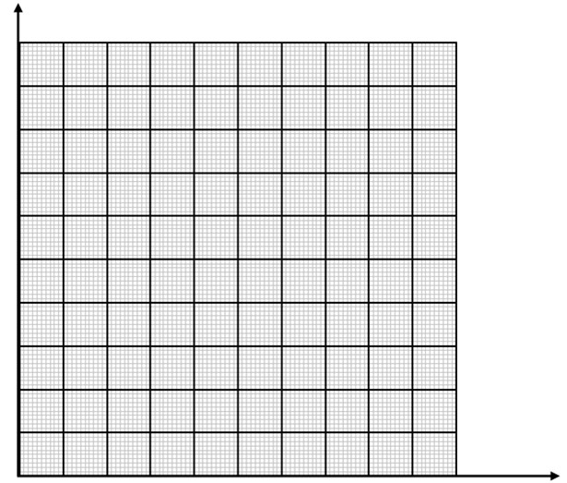
Title : ………………………………………………………………….
- Add a best-fit line to the plot and by using the graph, determine the slope (S) and its SI unit?

- Find the relation between slope S of the graph and the gravity acceleration g ?

- Deduce the gravity acceleration g_{exp} value and its SI unit?

- Determine the relative error $ε\left(\%\right)=100×\frac{| g_{exp} - g_{Average}| }{min (g_{exp }, g_{Average})}$
g_{exp} | g_{Average} | | g_{exp} - g_{Average} | | min (g_{exp} , g_{Average} ) | ε (%)

V. CONCLUSION :
VI. BIBLIOGRAPHY :
- https://www.phycats.plaf.org/docs/M4tp_pendule_pesant.pdf
- https://www.lehman.edu/faculty/anchordoqui/chapter24.pdf
- https://www.coursuniversel.com/systemes-mecaniques-oscillants/
- http://uel.unisciel.fr/physique/outils_nancy/outils_nancy_ch08/co/apprendre_ch08_18.html
- https://physique.cmaisonneuve.qc.ca/btardif/NYC/PhysiqueXXI-TomeC-Section-1.3.pdf
- https://www.techno-science.net/definition/1831.html
- Création d’un TP de Mécanique Analytique, Porée Victor, L2 Sciences et Propriétés de la Matière – Mention Physique, Bâtiment 30 - Travaux Pratiques de Physique, Université de Rennes, 2015
- 3B Scientific GmbH, Rudorffweg 8, 21031 Hamburg, Allemagne, www.3bscientific.com
- http://dessineux.pam.free.fr/Blog-Pages/P.F.D.enrotation_12CF5/MomentDinerties.png
- https://www.shutterstock.com/search/moment-inertia

VI. ANNEXES:
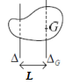
A1. HUYGENS-STEINER THEOREM:
The expression of the moment of inertia I_{Δ} of a mass solid M, relative to the rotation axis Δ parallel to its axis Δ_{G} which passes through its gravity center, as a function of the distance L separating the two axes Δ and Δ_{G}, is given as follows:

I_{Δ} = I_{ΔG} + M·L²

A2. USUAL SOLID MOMENTS OF INERTIA:

