LW3 - LRC SERIES FREE OSCILLATIONS
I. OBJECTIVES:
- Show that an LRC circuit can be an oscillation seat.
- Show that the capacitor (C) and inductor (L) are causing oscillations in an LRC circuit.
II. THEORY:
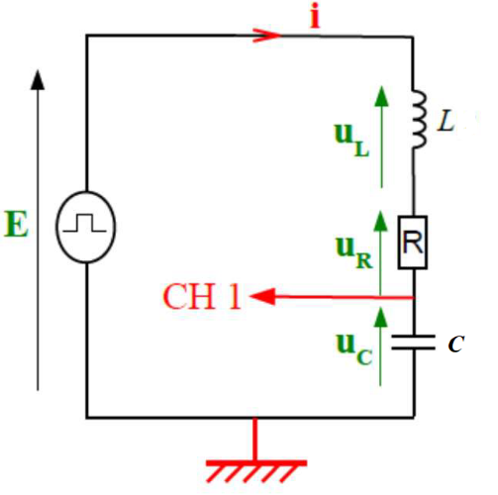
II. 1. Equations:
We consider the LRC circuit in series schematized in opposite figure 1. The Low Frequency Generator (LFG) produces a crenellated voltage equal to E. If we take the signal positive half-period, we get:

$\left\{\begin{aligned}u_{L}+u_{R}+u_{C}=E \\ \\ u_{R}= R·i \\ \\ u_{L}=L∙\frac{di}{dt}+r∙i\end{aligned}\right\} → \left(R+r\right)∙i+L∙\frac{di}{dt}+u_{C}= E$
Figure II. 1: Serial LRC Circuit

$$i=\frac{dq}{dt} →\left(R+r\right)∙\frac{dq}{dt}+L∙\frac{d^{2}q}{{dt}^{2}}+u_{C}=E$$
$$q=C∙u_{c} → \left(R+r\right)∙C\frac{{du}_{C}}{dt}+L∙C∙\frac{d^{2}u_{C}}{{dt}^{2}}+u_{C}=E$$
$$\left\{\begin{aligned}\frac{d^{2}u_{c}}{dt^{2}}+\frac{\left(R+r\right)}{L}\frac{du_{c}}{dt}+\frac{1}{L∙C}u_{c}=\frac{1}{L∙C}E \\ \\ 2λ= \frac{\left(R+r\right)}{L} , ω_{0}^{2}= \frac{1}{L∙C}\end{aligned}\right\} → {\ddot{u}}_{c}+2λ∙{\dot{u}}_{c}+ω_{0}^{2}{∙u}_{c}=ω_{0}^{2}∙E$$

Finally, we get the equation in the following form:
$${\ddot{u}}_{c}+2λ∙{\dot{u}}_{c}+ω_{0}^{2}{∙(u}_{c}-E)=0$$
If we set U_{C} = u_{c} - E, this last equation will take the following form:
$${\ddot{U}}_{C}+2λ∙{\dot{U}}_{C}+ω_{0}^{2}{∙U}_{C}=0$$
Which represents the free movement of the system. The quantity ω₀ is called the resonant frequency and λ is the damping factor.
For fixed L and C values, the term [$\frac{\left(R+r\right)}{L}\frac{dU_{C}}{dt}=2λ∙{\dot{U}}_{c}=2λ∙{\dot{u}}_{c}$] determines the regime type (periodic, pseudo-periodic, aperiodic, critical).
II. 2. Different regimes of the evolution of the voltage u_{c}(t):
II. 2. 1. Periodic Regime (Sinusoidal):
For very low or zero values of the total resistance R_{tot}, the voltage u_{C}(t) across the capacitor has undamped free oscillations, this is the periodic regime. In this case, the voltage u_{C}(t) periodically passes through zero values. The time between two successive passes through a zero value, with a slope of the same sign, is the eigenperiod T₀ of the undamped free oscillations. The amplitude of the oscillations remains constant over time (Figure 2-a).
$$U_{C}\left(t\right)=u_{C}\left(t\right)-E=U_{m}\cos\left(ω_{0}t+φ\right) =U_{m}\cos\left(\frac{2π}{T_{0}}t+φ\right)$$
The magnitude φ is called the phase at the origin of dates and is expressed in radians.

II. 2. 2. Pseudo-periodic regime:
For low values of the total resistance R_{tot}, the voltage u_{C}(t) across the capacitor has damped oscillations, this is the pseudo-periodic regime. In this case, the voltage u_{C}(t) periodically passes through zero values. The time between two successive passes through a zero value, with a slope of the same sign, is the pseudo-period T of the damped oscillations. In this case, the amplitude of the oscillations decreases over time (Figure 2-b).
$$U_{C}\left(t\right)=u_{C}\left(t\right)-E=\left(U_{m}∙e^{-λt}\right)\cos\left(ωt+φ\right)=\left(U_{m}∙e^{-λt}\right)\cos\left(\frac{2π}{T}ωt+φ\right)$$
Um is the amplitude of the oscillations and ω is the angular frequency given by: $ω=\sqrt{ω_{0}^{2}-λ^{2}}=\frac{2π}{T}$

II. 2. 3. Critical Regime:

For a particular value of ${ R}_{Tot}=R_{C}=2\sqrt{L/C } ,$ The regime is referred to as a critical aperiodic regime. In this case, the voltage U_{C}(t) across the capacitor tends more rapidly to zero. The critical regime is difficult to determine experimentally (Figure 2-c).

II. 2. 4. Aperiodic Regime
For very large values of R_{tot}, the voltage u_{C}(t) dampens very quickly, this is the aperiodic regime. The discharge is observed without the voltage uC(t) oscillating (Figure 2-c).
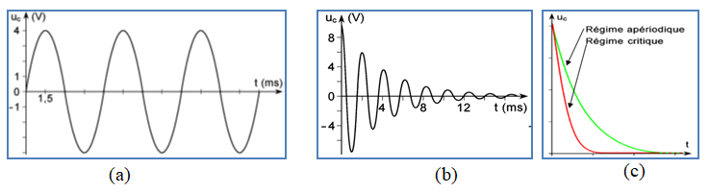
Figure II. 2: Different oscillation regimes

III. HOME WORKS:

Complete the following tables:

III. 1. The influence of C on voltage u_{C} (t):
$$R=10 Ω; L=1 mH=0.001 H, r=1.3 Ω$$

40 | 30 | 20 | 10 | C (nF)
 |  |  |  | C (F)
 |  |  |  | $ω_{0}(rd/s)=1/\sqrt{L\left(H\right)∙C\left(F\right)}$
 |  |  |  | λ(Ω/H) = (R + r)/2L
 |  |  |  | $$ω(rd/s) =\sqrt{ω_{0}^{2}-λ^{2}}$$
 |  |  |  | $$T_{cal}(s) =2π/ω(rd/s)$$
 |  |  |  | T_{cal} (µs)

III. 2. The influence of L on voltage u_{C} (t) :

$$R=10 Ω , C= 20 nF=20×{10}^{-9}F$$
4 | 3 | 2 | 1 | L(mH)
 |  |  |  | L(H)
 |  |  |  | $ω_{0}(rd/s)=1/\sqrt{L\left(H\right)∙C\left(F\right)}$
 | 3.5 | 1.9 | 1.3 | r(Ω)
 |  |  |  | λ (Ω/H) = (R + r)/2L
 |  |  |  | $$ω(rd/s) =\sqrt{ω_{0}^{2}-λ^{2}}$$
 |  |  |  | $$T_{cal}(s) =2π/ω(rd/s)$$
 |  |  |  | T_{cal} (µs)

III. 3. The influence of R on voltage u_{C} (t) :
$$L= 1 mH=0.001 H, r=1.3 Ω , C=20 nF=20×{10}^{-9} nF$$
40 | 30 | 20 | 10 | R(Ω)
 |  |  |  | $ω_{0}(rd/s)=1/\sqrt{L\left(H\right)∙C\left(F\right)}$
 |  |  |  | λ (Ω/H) = (R + r)/2L
 |  |  |  | $$ω(rd/s) =\sqrt{ω_{0}^{2}-λ^{2}}$$
 |  |  |  | $$T_{cal}(s) =2π/ω(rd/s)$$
 |  |  |  | T_{cal} (µs)

Full name | Group | Assiduity (02pts) | Report (18pts) | Grades / 20
Date: …………………………………… ……………….…Time: ……………………………Lab No.………………

IV. PROCEDURES AND DATA ANALYSIS:
- The serial LRC circuit diagrammed above (Figure 1) is constructed and the necessary connections are made to visualize the voltage u_{C} (t) across the capacitor on the oscilloscope channel 1.
- The inductor has an adjustable inductance L and an internal resistance r.
- The function generator is set to produce a peak-to-peak voltage of V_{PP} = 4V and frequency = 1 KHz.
IV. 1. The influence of C on voltage u_{C} (t):
1. Complete the following table:
$$R=10 Ω; L=1 mH, r=1.3 Ω$$

0.040 | 0.030 | 0.020 | 0.010 | C (µF)
 |  |  |  | $$\sqrt{C(μF)}$$
 |  |  |  | T_{meas} (µs)

2. Plot the graph $T_{meas}=f(\sqrt{C})$
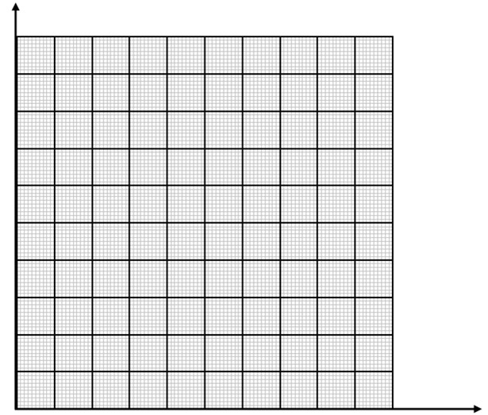

Figure IV. 1: …………………………………………………………………………
3. Determine graphically the slope (S_{C}) of the graph $T_{meas}=f\left(\sqrt{C}\right)$by specifying its SI unit?

IV. 2. The influence of L on voltage u_{C} (t) :
1. Complete the following table:
 | $$R=10 Ω , C= 0.020 µF$$
4 | 3 | 2 | 1 | L(mH)
 |  |  |  | $\sqrt{L\left(mH\right)}$
 |  |  |  | T_{meas} (µs)

2. Plot the graph $T_{meas}=f(\sqrt{L})$

Figure IV. 2: …………………………………………………………………………

3. Determine graphically the slope (S_{L}) of the graph $T_{meas}=f\left(\sqrt{L}\right)$by specifying its SI unit?
IV. 3. Determination of the pseudo-period expression:
1. Deducing from questions IV. 1 and IV. 2 above that the pseudo-period can be written in the following form T =k $\sqrt{L·C}$ where k is a constant.

2. By the dimensional analysis, verify that the constant k has no dimension and is simply expressed as a function of the number π.

IV. 4. The influence of R on voltage u_{C} (t) :
1. Complete the following table:
$$L= 1 mH, r=1.3 Ω , C=0.020 µF$$
30 | 20 | 10 | 0 | R(Ω)
 |  |  |  | T_{meas} (µs)

2. For a very large resistance R, are there oscillations, justify your answer?

3. Predict what would happen if R_{T} = 0 and how would call this type of circuit?

V. Recaps :
Indicate by YES or NO in the corresponding box about the influence of the different parameters?

Parameters | C | L | R
Period
Amplitude

VI. CONCLUSION:

VII. BIBLIOGRAPHY:
- https://www.subr.edu/assets/subr/ElectricalEngineering/TargetedInfusion/Files/ENGR-120_RLC-Circuits.pdf
- https://photonics101.com/basic-ac-circuits/serial-rlc-circuit
- https://www.owlnet.rice.edu/~phys102/Lab/RLC_circuits.pdf
- https://spinningnumbers.org/a/rlc-natural-response-derivation.html
- http://mokrini.e-monsite.com/medias/files/ph-tp8-rlc.pdf
- http://www.sciences.univ-nantes.fr/physique/perso/gtulloue/Elec/Transitoire/Condensateur1_flash.htm
- http://mokrini.e-monsite.com/medias/files/ts-phy-chap8-oscillations-libre-dans-le-dipole-rl.pdf
- http://www.physagreg.fr/CoursTS/Physique/Cours/Physique-C-chap8-oscillations-electriques.ppt
- http://montblancsciences.free.fr/terms/physique/cours/p10.htm
- http://e.guimberteau.free.fr/Site/TS/Physique/C3%20cours.htm
- https://docplayer.fr/22000964-Tp-8-oscillations-dans-un-circuit-rlc-correction.html

