LW1: VERTICAL ELASTIC PENDULUM
I. OBJECTIVES:
Determine the stiffness constant of a spiral spring by using the vertical oscillations method.
II. INTRODUCTION:
Spring constant (symbolized as k) is known as the spring stiffness constant and has an SI unit of newton per meter (N/m). Its value varies depending on the type of spring or material.

III. THEORY:
We consider a vertical elastic pendulum consisting of a solid mass m and a spring of a constant k, initial length ${ l}_{0 }$, and a negligible mass comparing to m (Figure 1). The spring stiffness reflects its response to its deformation. In the following, we consider the model of Hooke’s law for which the stiffness constant k does not depend on the load m: the spring’s upturn force F is then proportional to its extension $Δl$:
$\left\|\vec{F}\right\|=F=P=mg=k∙(l_{e}-l_{0})=k∙Δl$ (1)
where $l_{e}$ is the spring length at the equilibrium after loading (figure 1).
When the system is moved away from its equilibrium position, it oscillates between two symmetrical positions –X_{m} et X_{m} (see the figure 1)
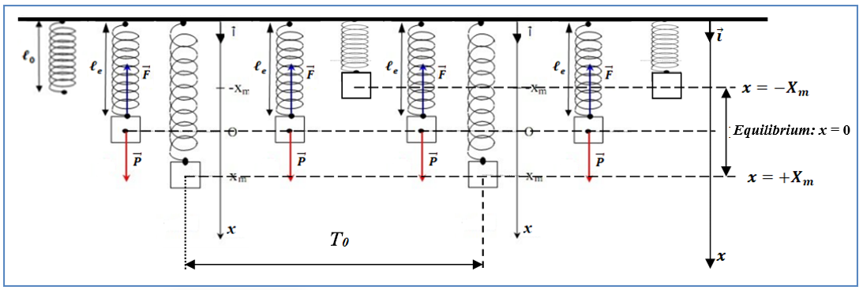
Figure 1: Vertical elastic pendulum diagram
By applying several Physical laws, we obtain the follows motion equation:
$\ddot{x}+\frac{K}{m}x=\ddot{x}+ω_{0}^{2}x=0$ (1)
The resulting motion is known as simple harmonic motion. This motion is periodic, meaning the displacement, velocity and acceleration all vary sinusoidally. The time required for the body to complete one oscillation is defined as the period, T₀, given by the following expression:
$T_{0}=\frac{2π}{ω_{0}}=2π\sqrt{\frac{m}{k}}$ (2)
It is noticeable that period T depends only upon the mass m of the oscillating body and the spring constant K. It should be noted also that the motion period T is independent of the amplitude X_{m}.
Full name | Group | Assiduity (02pts) | Report (18pts) | Total Grades / 20
Date: …………………………………… ……………….…Time: ……………………………Lab No.………………

IV. PROCEDURE AND DATA ANALYSIS:
IV. 1. STATIC DETERMINATION OF THE ELASTIC SPRING STIFFNESS K_{Stat}:
- Complete the following table knowing that: $F=m·g=K·Δl,$ and $g$ = 10 m/s².
$\left(\overline{F/∆l}\right)$ (N/m) | F/ $Δl$ (N/m) | $$Δl (m)$$ | $Δl (cm)$ | F(N) | m (Kg) | m (g)

- Plot the graph $F=f(Δl)$:
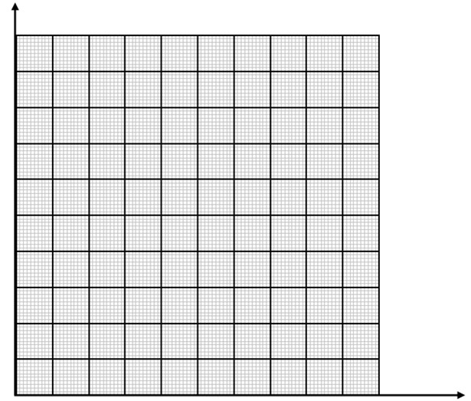

Title:……………………………………………………………………………………………….
- Determine graphically the slope (S) of the graph by specifying its SI unit?
- Find the relation between the slope (S) of the graph and the spring constant (symbolized as k)?
- Deduce the statistical spring constant (symbolized as k_{exp-Stat}) and its SI unit?

IV. 2. DYNAMIC DETERMINATION OF THE ELASTIC SPRING STIFFNESS K_{Dyn}:
- We place a mass m at the end of an elastic spring. When the system takes its equilibrium position, pull the mass down, make the spring oscillate and measure ten periods each time (t = 10T₀).
- Complete the following table knowing that: $T_{0}=\frac{t_{Average}}{10}=\frac{\overline{t}}{10}$
m (g) | m (Kg) | t₁(s) | t₂(s) | t₃(s) | $\overline{t }$(s) | $$T_{0}\left(s\right)$$ | $$T_{0}^{2}\left(s^{2}\right)$$ | $\frac{{ T}^{2}}{m} \left[\frac{{ S}^{2}}{Kg}\right]$ | $$\overline{\left[\frac{{ T}^{2}}{m}\right]} \left[\frac{{ S}^{2}}{Kg}\right]$$

- Plot the graph $T_{0}^{2}=f(m)$:
Title:……………………………………………………………………………………………….
- Determine graphically the slope (S) of the graph by specifying its SI unit?
- Find the relation between the slope (S) of the graph and the spring constant (symbolized as k)?

- Deduce the dynamic spring constant (symbolized as k_{exp-Dyn}) and its SI unit?

IV. 3. DETERMINATION OF THE RELATIVE ERROR:
Determine the relative error ε (%) = × 100 | K_{exp-Dyn} - K_{exp-Stat} | / min (K_{exp-Dyn,} K_{exp-Stat})
K_{exp-Dyn} | K_{exp-Stat} | | K_{exp-Dyn} - K_{exp-Stat} | | min (K_{exp-Dyn,} K_{exp-Stat}) | ε (%)

V. DISCUSSIONS

VI. BIBLIOGRAPHY:
- https://study.com/learn/lesson/spring-constant-formula-application.html
- https://studylib.net/doc/8128773/experiment-6-the-spring-constant-determination
- http://science.clemson.edu/physics/labs/labs/124/shm/index.html
- http://www.physics.umd.edu/courses/Phys260/agashe/S10/notes/lecture2.pdf
- https://studylib.net/doc/8128767/phys-1030l-spring-constant
- https://padasalaiplusonestudymaterials.files.wordpress.com/2018/10/11th-physics-practical-guide-study-material-english-medium.pdf
- https://physique.ensc-rennes.fr/tp_pendules_texteV2.php
- https://www.lerepairedessciences.fr/terminale_S/physique/chap12/PH_TP12b_oscill_vertical_correct.pdf
- https://fr.wikipedia.org/wiki/Syst%C3%A8me_masse-ressort

