LW4 - SIMPLE PENDULUM

I. OBJECTIVES:
- Highlight the movement of an elementary mechanical system: the simple pendulum.
- Study the influence of the wire length on the simple pendulum proper period.
- Determination of the experimental value of the Earth’s gravity acceleration g.

II. INTRODUCTION:
A simple pendulum consists of an inextensible wire to which a point mass m is attached. Moved away from its vertical position by an angle θ and abandoned to the gravity action, it begins to oscillate on either side of this position.

III. THEORY:
The simple pendulum which consists of a solid object M of mass m attached to a wire of negligible mass in front of m and length L much greater than the solid object dimensions. At equilibrium, the wire is vertical. The position of M in motion is indicated by the angle θ between the wire and its equilibrium position (distance or angular x-axis). The object is subjected to its weight W, the wire tension T, the force of the air friction and the Archimedean thrust. The work of the wire tension T is null because this force is perpendicular at each instant to the displacement vector (see Figure 1).

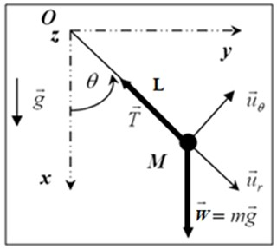
Figure 1: Simple Pendulum Schematic Diagram

Newton's second law is used to express the acceleration γ produced by a set of external forces ${\vec{F}}_{ext}$on an object of mass m:
$\sum{{\vec{F}}_{ext}}=m\vec{γ}$ (1)
Neglecting Archimedean thrust and air resistance, then decomposing these forces into radial and tangential components, Newton's second law gives:
${\vec{u}}_{r} : mgcosθ-T=mγ_{r}$ (2)
${\vec{u}}_{θ} : - mgsinθ=mγ_{θ}$ (3)
Generally, these motion equations cannot be solved analytically, and the period of the oscillations depends on the motion amplitude. However, an analytical solution can be found in the case where the oscillations amplitude is small (sinθ ≈ θ in radians).
In this study, we will focus on equation 3, which can be expressed as follows:

$\ddot{θ }+\frac{g}{L}∙θ=0$ (4)
We can write this equation as follows:
$\ddot{θ}+ω^{2}θ=0$ (5)
Thus, we find that the oscillation is harmonic whose pulsation is:
$ω^{2}=\frac{g}{L}$ (6)
which a solution of equation 5 (chosen so that θ = 0 for t = 0) is given by:
$θ=Acos(ωt)$ (7)
It is a sinusoidal harmonic oscillation whose period is:
$T=\frac{2π}{ω}$ (8)
Finally, the simple pendulum period T and its length L can be related by:
$T=2π\sqrt{\frac{L}{g}}$ (9)
We note that the period T of the simple pendulum does not depend on the mass m but only on the length L of the wire.
Full Name | Gr. | Assiduity / 2 | Report / 18 | Total Marks / 20
Date: …………………………………… ……………….…Time: ……………………………Lab No.………………

IV. PROCEDURE AND DATA ANALYSIS:
- Displace the bob to one side from the initial vertical position, not more than few degrees angular displacement (θ₀ ≤ 15°), and then release it gently without initial velocity. Afterward it begins to oscillate periodically. Make sure that the bob starts oscillating in a vertical plane. Measure the time t_{i} corresponding to 10 periods (t_{i} = 10 T_{i}). The process is repeated twice, and the results obtained are recorded in the table below, knowing that$T=\frac{t_{mean}}{10}$
$${\left(\frac{{ T}^{2}}{L}\right)}_{mean} (\frac{{ S}^{2}}{m})$$ | $\frac{{ T}^{2}}{L} (\frac{{ S}^{2}}{m})$ | T² (s²) | T (s) | t_{mean} (s) | t₂ (s) | t₁ (s) | L (m)

- Plot the graph T² = f (L) taking L along x-axis and T² along y-axis.

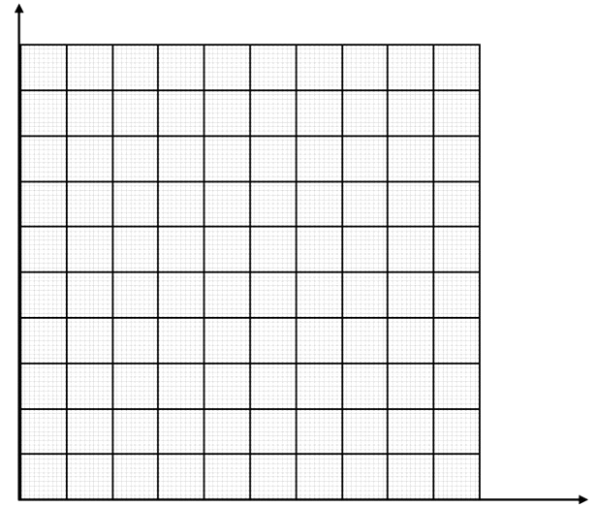
Title :………………………………………………………………….
- Add a best-fit line to the plot and determine the slope (S) of the graph and its SI unit?

- Find the relation between the slope (S) of the graph and the gravity acceleration ($g)$ ?

- Deduce the gravity acceleration g_{exp} value and its SI unit?

- Determine the relative error ε (%) = $100×\frac{| g_{the } - gexp | }{g_{the}}$
$g$_{the} $\left(m/{s^{2}}\right)$ | $$g_{exp}\left(m/{s^{2}}\right)$$ | | $g$_{the} –$g$_{exp} | $\left(m/{s^{2}}\right)$ | ε (%)
9.80

V. DISCUSSIONS:
VI. REFERENCES:

- https://ncert.nic.in/pdf/publication/sciencelaboratorymanuals/classXI/physics/kelm103.pdf
- https://fr.scribd.com/document/252542966/Simple-Pendulum-Lab-Report
- https://courses.lumenlearning.com/suny-physics/chapter/16-4-the-simple-pendulum/
- https://spark.iop.org/investigation-simple-pendulum
- https://www.trbtnpsc.com/2018/06/latest-plus-one-11th-study-materials-tamil-medium-english-medium-new-syllabus-based.html
- https://fr.scribd.com/document/665295574/MeasUncertLab-FAll13
- https://www.3bscientific.fr/dz/oscillations,pg_1409.html
- http://old.epst-tlemcen.dz/docs/cours/physique/S1/tp2.pdf
- http://www.phywe.fr/786/apg/4/pid/26209/Pendule-physique-et-pendule-a-g-variable.htm
- https://owl-ge.ch/IMG/pdf/Exp05_Etude_du_pendule.pdf
- http://res-nlp.univ-lemans.fr/NLP_SC_M16_G03/co/Contenu_21b.html
- https://www.unine.ch/files/live/sites/physique/files/TP/Exp%C3%A9riences_avec_FM/Exp09%20-%20Pendules%20mecaniques.pdf
- https://www.lyceedadultes.fr/sitepedagogique/documents/PC/PCTermS/09_cours_oscillateurs_mesure_temps.pdf

