PW 1: Extraction of an organic product
(Extraction of caffeine from COCA COLA drink)


- Introduction
Extraction is a separation process used in chemical engineering laboratories that consists of separate specific compounds from a mixture, in other word, taking one or more chemical species of a solid or liquid mixture. There are a lot of extraction methods such as: liquid-liquid extraction, Soxhlet extraction, Ultrasonic Extraction etc.
Considering two immiscible solvents: S1 and S2, liquid-liquid extraction is based on the difference in solubility of a solute in two immiscible phases (i.e. they form two distinct phases), and a molecule A which will be able to distribute between the 2 solvents.
In organic chemistry, we usually use an aqueous phase and an organic phase. The most common method of liquid-liquid extraction is performed using a separatory funnel.
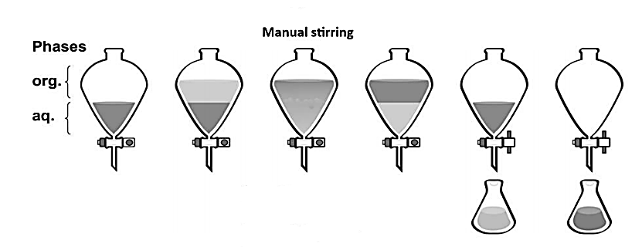
Following the principle of “like dissolves likes” the closer the structure of a molecule is to that of the solvent the more soluble in it. Thus, nonpolar molecules are well soluble in solvents apolar and little in water which is polar and vice versa. Here are some classic solvents:
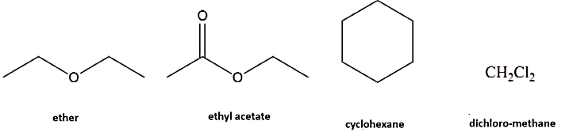
Coca-Cola© is a soft drink first manufactured in Atlanta in 1886. It contains: dissolved carbon dioxide, phosphoric acid, leaf extracts “decocainized” coca and kola nuts, the latter contains caffeine (C₈H₁₀N₄O₂). Caffeine was extracted from coffee by Runge in 1820. It is a solid crystallized in needles, with a bitter flavor, with a melting point T_{m} = 237 °C.
Slightly soluble in water at temperature ordinary, caffeine is more soluble in hot water, and above all very soluble in dichloromethane or in chloroform (CHCl₃) in basic medium.
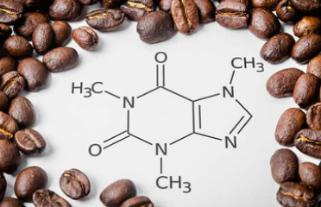
Figure 1. Caffeine molecule.
- Objectives of the manipulation

- Become familiar with the extraction technique,
- Isolate caffeine from Coca Cola drink,

- Equipment and chemicals
Equipment | Chemicals
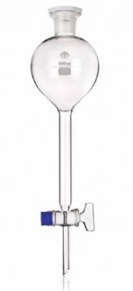  Separating funnel | Coca Cola drink
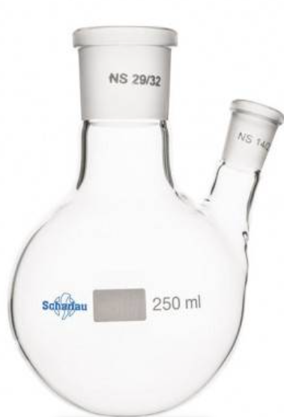  Double necked flask | Calcium carbonate CaCO₃
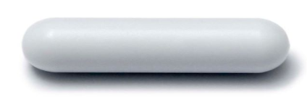  Magnetic bar | Sodium sulfate  Na₂SO₄  Or MgSO₄  Or CaSO₄
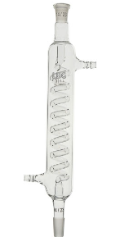  Refrigerant | Dichloromethane or Chloroform
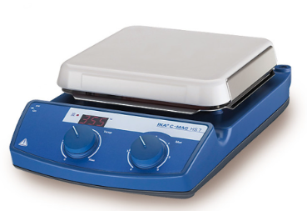  Heating magnetic stirrer | Distilled water
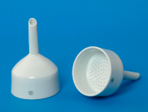
Büchner
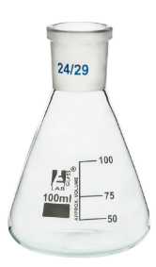
100ml Erlenmeyer
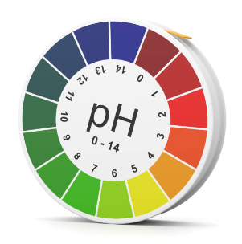
pH paper

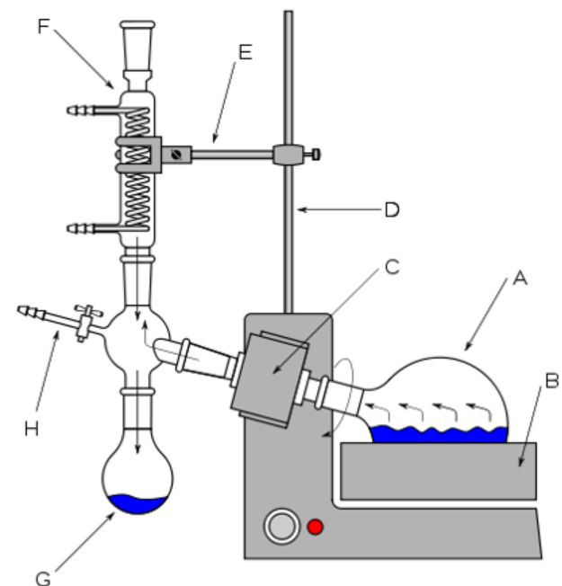
Figure 2. Rotary evaporator.
A) Round bottom flask B) Water bath C) Rotary motor F) Water condenser G) Receiving flask/collecting reservoir H) Tap connecting vacuum pump.
- Operating mode
Before starting, check if the glassware is clean and dry.
- Place 100 ml of Coca-Cola© previously degassed in an Erlenmeyer.
- add gradually (drop by drop) a saturated solution of sodium carbonate (base) until the pH is approximately equal to 9.
- Pour the sample into a 250 mL beaker and then add 100 mL of dichloromethane.
- Stir under a fume hood with a magnetic stirrer.
- Transfer the mixture into a separatory funnel.
- Shake well everything (remember to degas from time to time).
- Let it settle (let it rest for 30 seconds).
- We recover the organic phase (colored dichloromethane, this is the bottom phase).
- Dry the organic phase with sodium sulfate. There are no defined quantities to add.
- Filter everything using a funnel containing a piece of cotton.
- Retrieve the juice and evaporate the solvent using a rotary evaporator.
- At the bottom of your flask, there remains a powder, which is almost pure caffeine.

- Questions
- Is caffeine a natural or artificial substance?
- Why aqueous phase is at the bottom of the separating funnel?
- What’s the goal of shacking manually the separating funnel?
- Why could we degas the Coca Cola drink?
- What is the interest of adding sodium sulfate (Na₂SO₄/MgSO₄ /CaSO₄)?
- What is the interest of adding calcium carbonate (CaCO₃)?
- What it the role of the rotary evaporator? does it replace the heating magnetic stirrer?

