University center of Abdelhafid Boussouf- MILA
INSTUT SNV
Production of plants and seeds
PW 3. Nursery propagation: grafting fruit trees and vines (different methods)

Purpose :
The meaning of Grafting of fruit trees and vines,and diffrents methods of grafting.
Definition
Grafting or graftage is a horticultural technique whereby tissues of plants are joined so as to continue their growth together.
The upper part of the combined plant is called the scion while the lower part is called the rootstock.
The success of this joining requires that the vascular tissues grow together. The natural equivalent of this process is inosculation. The technique is most commonly used in asexual propagation of commercially grown plants.
In most cases, the stock or rootstock is selected for its roots and the scion is selected for its stems, leaves, flowers, or fruits. The scion contains the desired genes to be duplicated in future production by the grafted plant.
In stem grafting, a common grafting method, a shoot of a selected, desired plant cultivar is grafted onto the stock of another type. In another common form called bud grafting, a dormant side bud is grafted onto the stem of another stock plant, and when it has inosculated successfully, it is encouraged to grow by pruning off the stem of the stock plant just above the newly grafted bud.
For successful grafting to take place, the vascular cambium tissues of the stock and scion plants must be placed in contact with each other. Both tissues must be kept alive until the graft has "taken", usually a period of a few weeks. Successful grafting only requires that a vascular connection take place between the grafted tissues. does not fuse.

Factors for successful graft
Compatibility of scion and stock: Because grafting involves the joining of vascular tissues between the scion and rootstock, plants lacking vascular cambium, such as monocots, cannot normally be grafted. As a general rule, the closer two plants are genetically, the more likely the graft union will form. Genetically identical clones and intra-species plants have a high success rate for grafting. Grafting between species of the same genus is sometimes successful. Grafting has a low success rate when performed with plants in the same family but in different genera, and grafting between different families is rare.
Cambium alignment and pressure: The vascular cambium of the scion and stock should be tightly pressed together and oriented in the direction of normal growth. Proper alignment and pressure encourages the tissues to join quickly, allowing nutrients and water to transfer from the stockroot to the scion.
Completed during appropriate stage of plant: The grafting is completed at a time when the scion and stock are capable of producing callus and other wound-response tissues. Generally, grafting is performed when the scion is dormant, as premature budding can drain the grafting site of moisture before the grafting union is properly established.
Proper care of graft site: After grafting, it is important to nurse the grafted plant back to health for a period of time. Various grafting tapes and waxes are used to protect the scion and stock from excessive water loss. Furthermore, depending on the type of graft, twine or string is used to add structural support to the grafting site. Sometimes it is necessary to prune the site, as the rootstock may produce shoots that inhibit the growth of the scion.
7 steps of graft fruit tree
Step 1. Collect scionwood in the winter. The cuttings are collected in the dormant season because this is when the plant stops growing and therefore requires far less energy.
Step 2. Ensure the scionwood is disease and pest-free
Step 3. Label the scion with the name of the tree and the date of the cutting.
Step 4. Store scionwood safely. The cutting should be wrapped in a damp paper towel and then tucked into a plastic bag. Then place the package in the refrigerator until spring to maintain dormancy. Remove any fruit that is ripening in the refrigerator. Certain fruits produce ethylene as they ripen which can kill the scionwood.
Step 5. Preorder rootstock. Preorder early as rootstock sells out quickly.
Step 6. In the spring, grafting fruit trees can begin. This is the perfect time for spring fruit tree grafting.
Step 7. Use one of the grafting methods below.
Grafting methods
- Whip and tongue grafting:
Suitable for rootstock and scions of similar diameter, this method is very stable and is often done on the bench during the dormant season.
- Cleft grafting:
Used when the rootstock is much larger than the scion, this method involves making a V-shaped split in the rootstock to receive scions with a matching cut. It is best performed just before new growth starts.
- Budding:
This technique involves grafting a single bud from a scion onto the rootstock. Common methods include T-budding and chip budding, and it is typically done in the summer when the bark is slipping.
- Inlay grafting:
In this method, a V-shaped notch is made in the rootstock to fit the scion, and it is best done in the spring when the bark is slipping.
- Approach grafting:
This technique grafts two whole plants together while they are still attached to their individual root systems.
- Bark grafting:
A variation where scions are inserted into vertical slits between the bark and wood of the rootstock, and it is often used for evergreens and grafting onto large branches.
- Crown grafting:
A type of bark grafting that allows multiple varieties to be grown on a single tree by grafting them onto the same rootstock.
- Side-veneer grafting:
A method where a scion is inserted into a cut on the side of the rootstock, which is useful when the rootstock is too large to be worked by other methods.
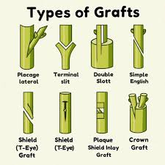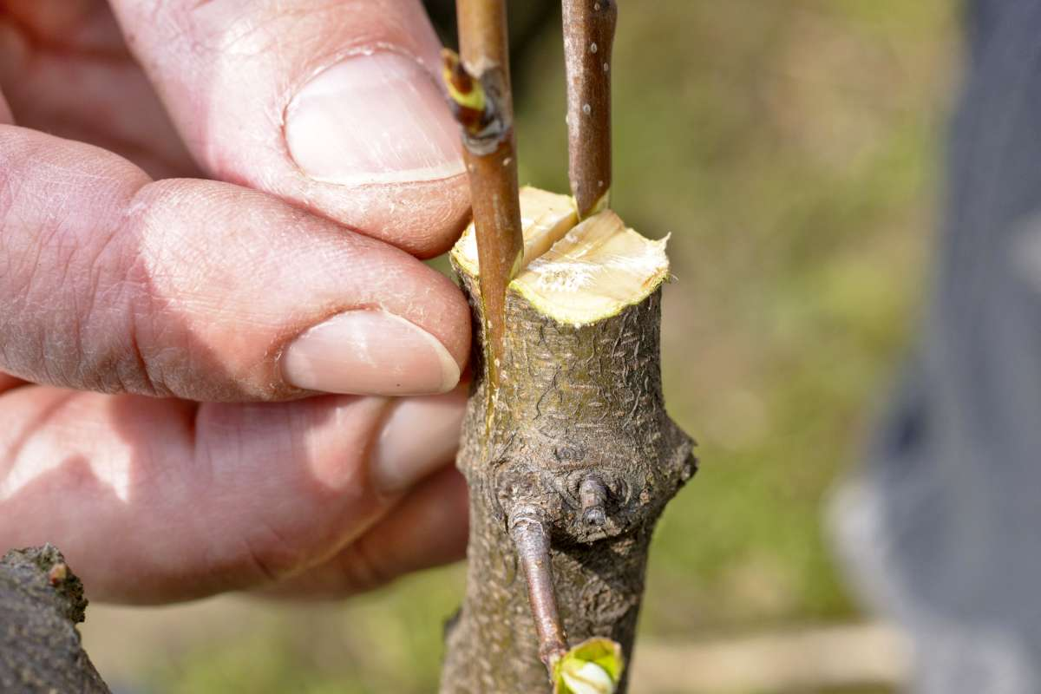

WORK TO DO
- Draw two grafting methods and explain each one.

