Anaerobic Metabolism of Pyruvate
Different microorganisms, particularly strict or facultative anaerobic bacteria, metabolize pyruvate under anaerobic conditions through various pathways.

1. Alcoholic Fermentation
This type of fermentation is very common among yeasts (Saccharomyces, Kluyveromyces, Brettanomyces, etc.). Few bacteria are capable of performing alcoholic fermentation (Zymomonas mobilis). Glycolysis constitutes the first major step in the alcoholic fermentation of yeasts. In the case of Zymomonas mobilis, glucose is degraded via the Entner–Doudoroff pathway. Both pathways lead to pyruvate, which is decarboxylated to acetaldehyde and CO₂. Reduction of acetaldehyde generates ethanol.
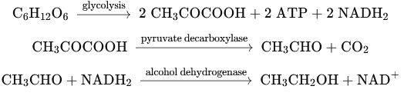
Other compounds can be produced in small quantities (especially glycerol and acetic acid).
The conversion of one molecule of glucose to ethanol by yeasts results in the synthesis of two molecules of ATP. Under anaerobic conditions, yeasts do not transform all glucose into ethanol and carbon dioxide; small amounts of pyruvate and NADH₂ are used for cellular maintenance. The reoxidation of NADH₂ is essential for alcoholic fermentation to proceed. This is achieved via the reduction of acetaldehyde, which is initially absent.
In this case, dihydroxyacetone phosphate (DHAP) acts as a hydrogen acceptor, converting into L-α-glycerol phosphate, which is subsequently transformed into glycerol:
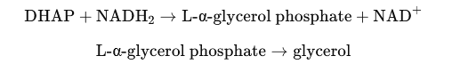
Theoretically, alcoholic fermentation yields 51.1% ethanol from the catabolized glucose. However, even though anaerobiosis is not favorable for biomass synthesis, some cell growth still occurs (about 2% of the carbohydrates used).
Ethanol and CO₂ are not the only products formed: besides glycerol, organic acids (succinic, acetic), higher alcohols, aldehydes, and ketones are also produced. Altogether, these compounds represent about 2.7% of the fermented sugar, so the actual ethanol yield reaches about 47–48% of the sugar converted.
The conversion efficiency of sugar to ethanol is typically between 91 and 95% of the theoretical yield, depending on medium factors such as the quality and quantity of utilizable nitrogen sources.

2. Homolactic Fermentation
Lactic acid is the main product of this type of fermentation (>90% of total products), unlike heterolactic fermentation (25–90% lactic acid).
Lactic acid results from the reduction of pyruvic acid catalyzed by lactate dehydrogenase (LDH):
Lactic acid can be in the D-, L-, or DL-form, depending on the stereospecificity of LDH and the presence or absence of racemase (the microorganism may have L-LDH, D-LDH, or both).
Homolactic fermentation is performed by all members of the genera Streptococcus, Pediococcus, and Microbacterium, by many Lactobacillus species, and by some Bacillus and certain molds (Phycomycetes: Oomycetes).
Lactic acid is widely used as a food additive. Homo- and heterolactic fermentations are involved in the production of numerous food products (cheese, sauerkraut, cured meats, vegetable brines, etc.).

3. Fungal Heterolactic Fermentation
Among molds, Rhizopus oryzae is a special case. When cultivated aerobically, it produces a mixture of lactic acid, acetic acid, and CO₂; under anaerobic conditions, it produces a mixture of lactic acid, ethanol, and CO₂. These products are identical to those obtained during the heterolactic fermentation of Leuconostoc species, but the mechanism differs: glucose degradation proceeds through glycolysis.
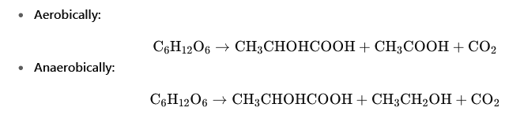

In both cases, the lactic acid produced is the D-form.
4. Mixed Acid and Butylene Glycolic Fermentations
Mixed acid fermentation is carried out by enterobacteria belonging to the genera Escherichia, Salmonella, Proteus, Shigella, and Yersinia. It also occurs in Vibrio and some Aeromonas species. It is characterized by the production of ethanol and several organic acids: lactic, acetic, succinic, and formic acids. Some species (Escherichia coli, Proteus, certain Salmonella) possess formate hydrogen lyase, which decomposes formic acid into H₂ and CO₂ at neutral or acidic pH:
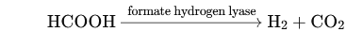

Butylene glycol fermentation is performed by members of the genera Enterobacter, Klebsiella, Serratia (enterobacteria), and also by some Aeromonas and Bacillus.
It produces the same acids as mixed acid fermentation but also forms 2,3-butanediol (or 2,3-butylene glycol), which, along with ethanol, is the main product.

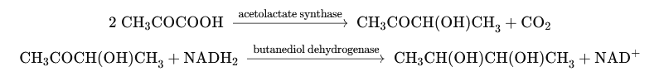
The first product (acetoin or acetylmethylcarbinol) and diacetyl are formed under aerobic conditions.

5. Butyric and Acetone-Butylic Fermentations
Certain Clostridium species (C. butyricum, C. perfringens), Butyribacterium, some Serratia, and Zymosarcina produce butyric acid, along with acetic acid, CO₂, and hydrogen. Butyric acid is formed through the condensation of two molecules of acetyl-CoA into acetoacetate, which is then reduced to β-hydroxybutyrate and finally converted to butyrate. Part of the acetyl-CoA, formed from pyruvate, is used to produce ATP and acetic acid.
In Clostridium, pyruvate decarboxylation occurs through the phosphoroclastic reaction as follows:
Pyruvate + CoA → acetyl-CoA + CO₂ + H₂
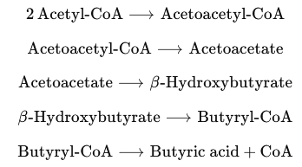
In addition to the products of butyric fermentation, certain Clostridium species can also produce alcohols (butanol, ethanol, isopropanol) and acetone.

6. Propionic Fermentations
Various strict or facultative anaerobic bacteria (Propionibacterium, certain Clostridium, Corynebacterium, Neisseria, Veillonella, etc.) produce propionic acid, acetic acid, CO₂, and succinic acid through fermentation. Propionic acid is formed by the reduction of pyruvate, with lactic acid acting as an intermediate. However, it can also be produced by the decarboxylation of succinic acid, as in Propionibacterium pentosaceum. Propionic fermentation can also occur starting from lactate, with pyruvate serving as an intermediate — except in Clostridium propionicum, where the intermediate is acrylic acid. Propionibacterium species play an important role in the digestive tract of ruminants. They also participate in the production of cooked-curd cheeses, such as Swiss-type cheeses, where their metabolism is responsible for the formation of CO₂ bubbles that create the characteristic holes and flavor.
