Fifth directed work of biochemistry
Structure and physicochemical properties of lipids

Exercise1: Which of the following statements regarding glycerophospholipids is (are) correct ?
- Phospholipids are simple lipids.
- These are energy lipids.
- They all derive from phosphatidic acid.)
- These are amphiphilic molecules.
Exercise 2: Give the name of each of the following lipids, specifying the lipid class to which it belongs.
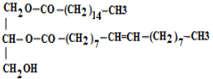
(1) (2)
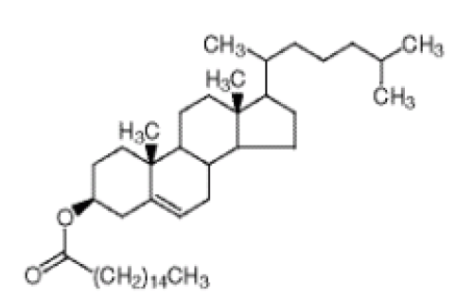(3)
Exercise 3.
Consider the following lipid:
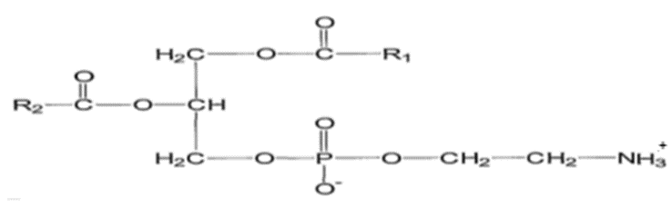

- What class does it belong to?
- Give the name of the alcohol to which the phosphatidyl radical is linked.
- What do we obtain after alkaline hydrolysis.
Exercise 4. Give the structure of a lipid containing in its structure:
- A fatty acid having 18 carbon atoms. (Stearic acid)
- An amino alcohol. (sphingosine)
- Galactose.

